The issue focused on the delay profile settings in TX7332 cores of SWAROOP board (part number: TIDA-010057). First, I connect the SWAROOP board with a L7-4 transducer to test its function of transmitting and receiving (illustrated in Figure 1).
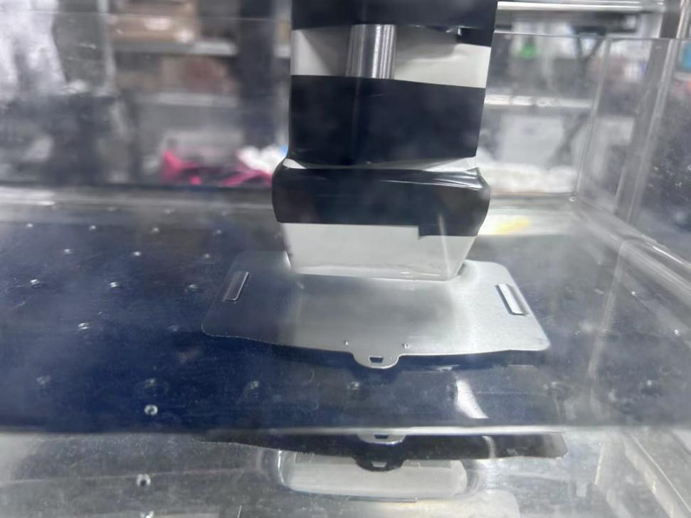
Iron slice
L7-4 Transducer
Figure 1. Device diagram

When I set 300 in all DEL reg (1.5us delay, see Figure 2), AFE should detect the acoustic echoes reflected from the iron slice. But it cannot receive any acoustic echos and only receiving 0s after capturing(see Figure 3).
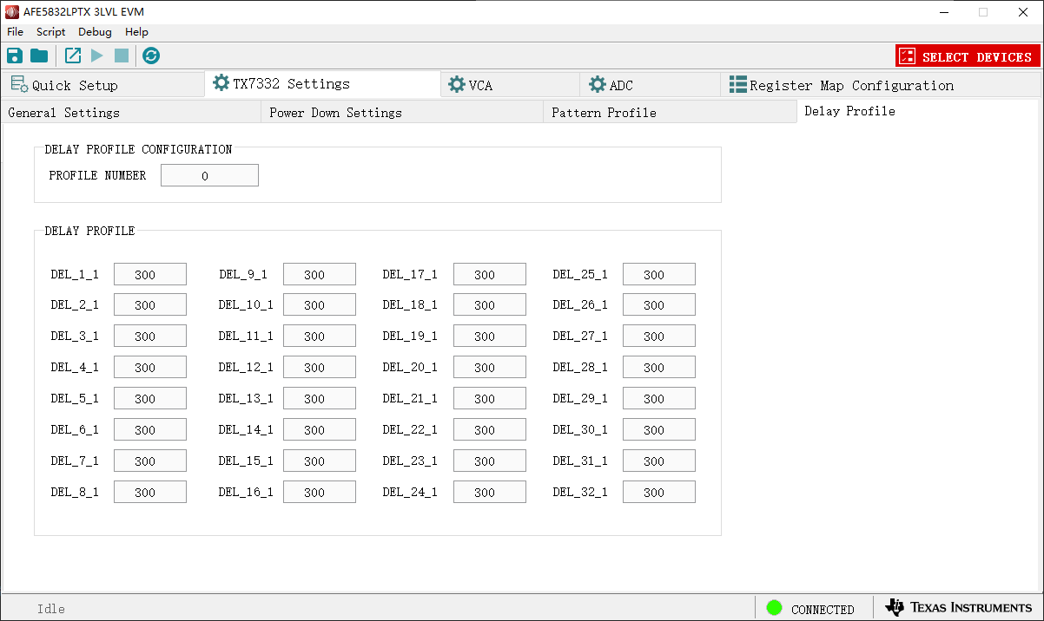
Figure 2. DEL profile settings
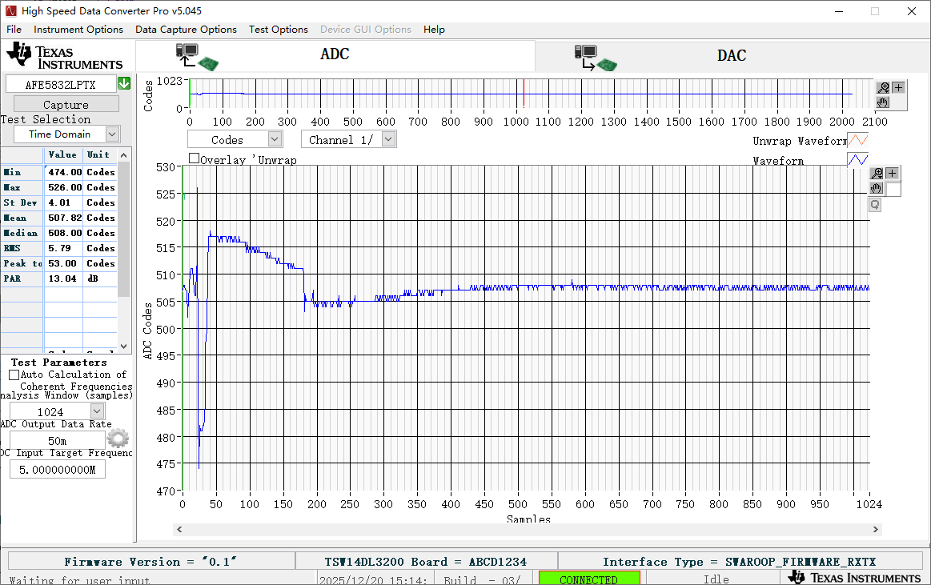
TR switch enable

Figure 3. Channel 1 signal when the delay for all channels is set to 1.5 µs.

First, I doubted if TX7332 transmitted the waveform or not. Therefore, I observed the transmit waveform and its delay using an oscilloscope. Channel 2 was set to 0 delay (yellow signal on the oscilloscope), and Channel 1 was set to a 1.5 µs delay (blue signal on the oscilloscope). The observation results confirm the transmit function is correct, and the delay is accurate (see Figure 4).
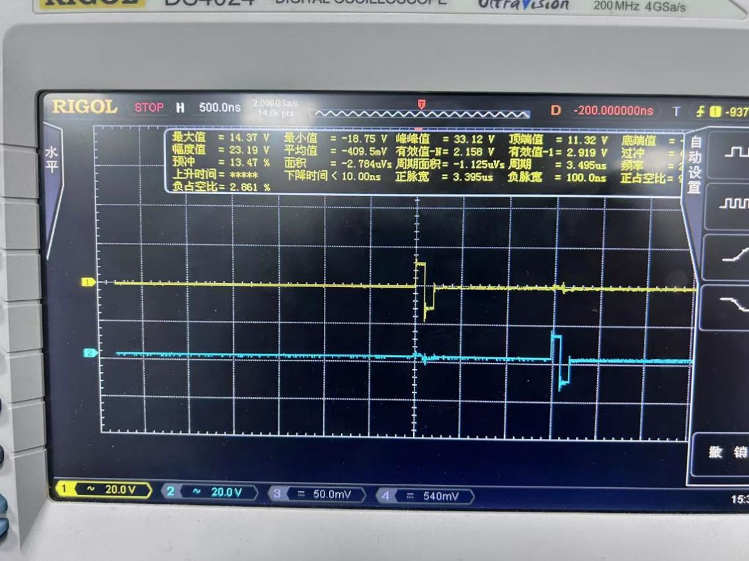
Figure 4. Transmitted wave from CH1(blue line) and CH2(yellow line) of TX7332. the delay between two signals is around 1.5us, which is same as the settings
The previous test confirmed the function of transmitting is correct. So I set lower delay in DEL profile to test whether receiving function is correct. I set 0 delay and 100 delay (0.5us) and captured these signals. Those echoes can be captured correctly only when delay value is under 300 (see Figure 5 and 6). However, I find the AFE can only receive 0s and cannot detect any echoes when delay is over 300(see Figure 3).
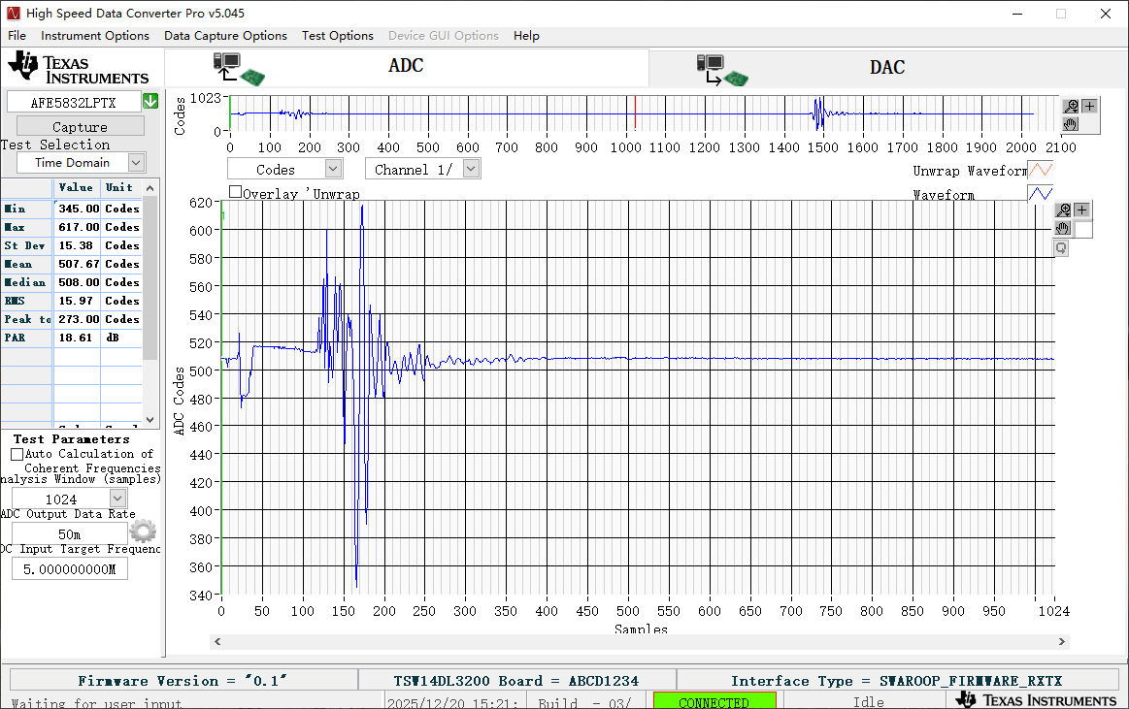
Echoes reflected by iron slice

Transducer-inside echoes

TR switch enable

Figure 5. Channel 1 signal when the delay for all channels is set to 0 µs.

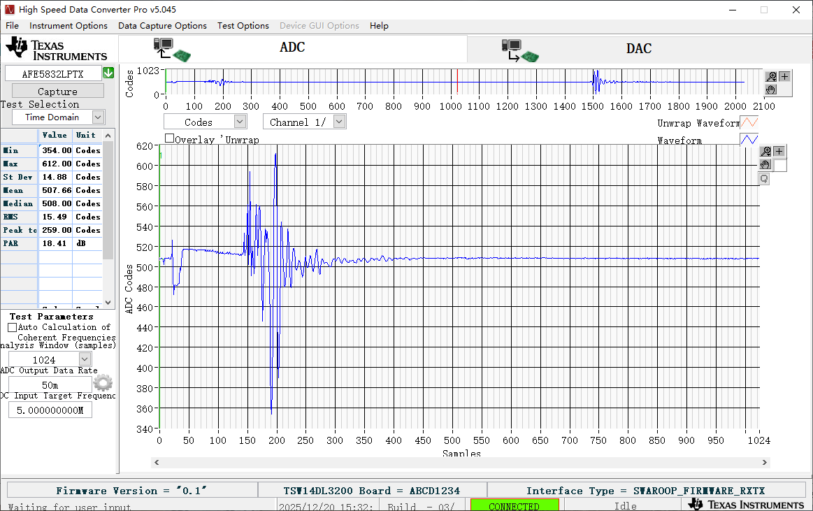
Figure 6. Channel 1 signal when the delay for all channels is set to 0.5 µs.

I wonder how to fix this problem so that AFEs can detect the right echoes with over 300 delays. I doubt it is caused by the wrong setting in TR switch related reg. Do you have any advice? I also attach all the reg settings in 300delay.docx. Thank you for your any useful advice.

