To check for proper SYSREF timing, run the DAC in NCO only mode and synchronize the NCO blocks to SIF.
NOTE: For this test, the SYSREF frequency cannot be a whole integer multiple of the NCO frequency for this test.

- Program the NCO frequency and the NCO data rate, use SIF for the SYNC source and create a single output tone.

Set 0x2 to 0x2050 (Offset binary, mixer and NCO enabled)
Set 0x2F to 0x05 (constant input)
Set 0x14 – 0x19 with NCO frequency and phase value to be used

For 100MHz,
Set 0x14 to 0x38E4
Set 0x15 to 0xE38E
Set 0x16 to 0x22B8
Set 0x17 to 0x00
Set 0x18 to 0x00
Set 0x19 to 0x00

- Issue a SIF SYNC by writing the following:

Set 0x1F to 0x8080
Set 0x1F to 0x8082
Set 0x1F to 0x8082

- There should now be a solid output at the NCO frequency.

- Set the LMK to send continuous SYSREF pulses.

- Set the NCO to use SYSREF as a SYNC source

Set 0x1F to 0x8020

- The output should now be many pulses as the NCO will constantly reset as shown below.

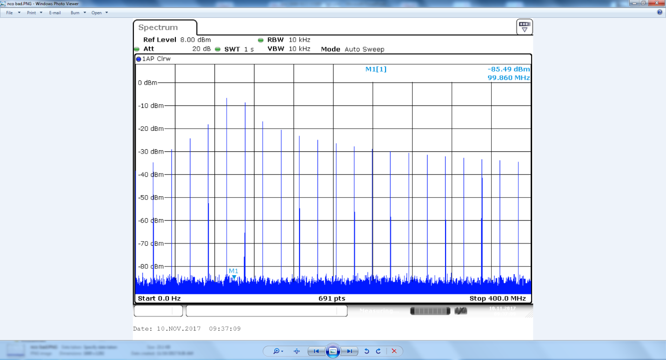
If the SYSREF input is not received properly by the DAC, the output in this test will look as a single tone, as shown below. In this case the problem is usually there is only one SYSREF pulse (AC coupled SYSREF), or the amplitude of SYSREF is too low and or the common mode is wrong (DC coupled SYSREF).
