Dear sir,
When using the ADS1248IPWR in our application, we can not get the reasonable explication about the aliasing. Our external analog filter and circuits are show as below.
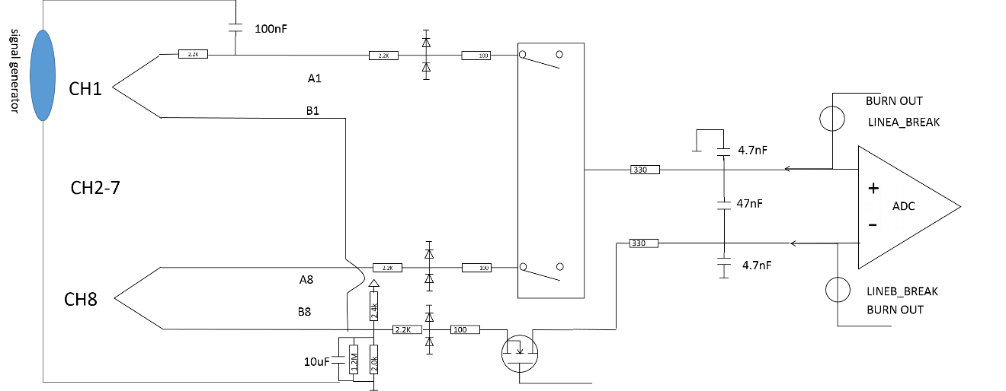
Fig 1. External analog filter and circuits
And $f0=\frac{1}{2πRC}≈\frac{1}{2π*5.2*10e3*50*10e-9}=0.6KHz$,
But when we add the noise signal by signal generator from 32K, 64K, 96K, 128K…800K（400mvpp）. we got the temperature fluctuation as flow.(PS: ADS1248 work @20 sps,16 gain, and S type TC @800℃)
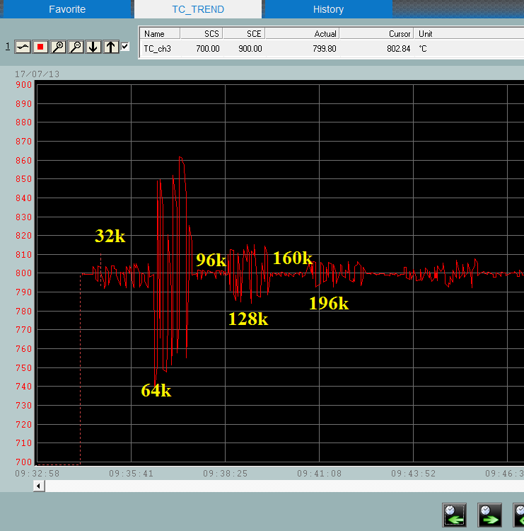
Fig 2. temperature fluctuation
According to the signal attenuation, the noise @64KHz and 128KHz has much smaller amplitude than @32KHz, but they have greater temperature fluctuation. @64K, it similar has 0.33mV voltage change.
My question are:
Is there any character inside ADS1248 cause the issue? Is there any reasonable explication for the issue?

