# ADS54J60 EVM Quick Startup Guide

## ADS54J40/60/69 GUI Installation Instructions

1. Extract the files from the zip file named *ADS54J40 Customer Package.*

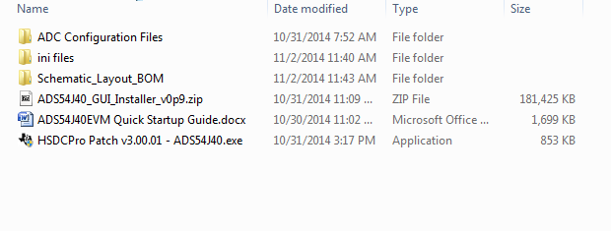

1. Unzip the file called “ADS54J40_GUI_Installer_vxpx.zip.
2. Run the file called *setup.exe* and follow the installation prompts.
3. Start the GUI by going to **Start Menu** → **All Programs** → **Texas Instruments ADCs** → **ADS54J40 GUI**.
4. When plugging the board into the computer for the first time through the USB cable, you are prompted to install the USB drivers.
   * Windows® XP: If Windows XP does not automatically install the drivers, follow the prompts on the screen to do so. Do not let Windows XP search Microsoft Update for the drivers, but do let Windows XP install the drivers automatically.
   * Windows 7: After installing the GUI, Windows 7 should automatically be able to install the drivers for the ADS54J40EVM with no input from the user.

## HSDC Pro GUI Installation Instructions

1. Install version v3.0 of HSDC Pro GUI.
2. After the GUI is installed, run the file called *HSDCPro Patch v3.00.01-ADS54J40.exe.*
3. The following GUI opens. Click on “Next”.

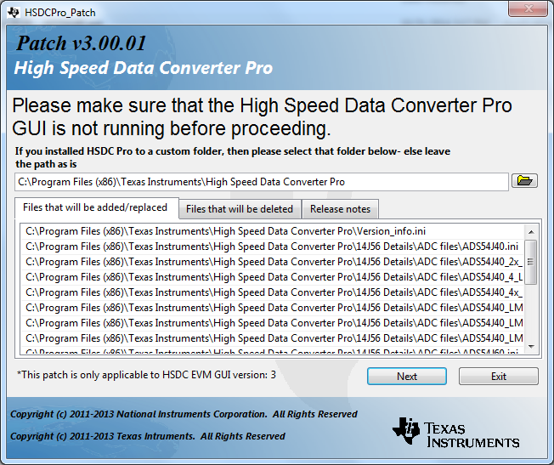

1. Click on “Exit” after the patch is loaded.

## Software Operation

The following sections detail the operation of the ADS54J40 GUI.

### ADS54J40 Tab

The ADS54J40 controls can be found on the ADS54J40 tab. These controls can be used to access the register controls in the ADS54J40. Figure 2 below shows the ADS54J40 tab.

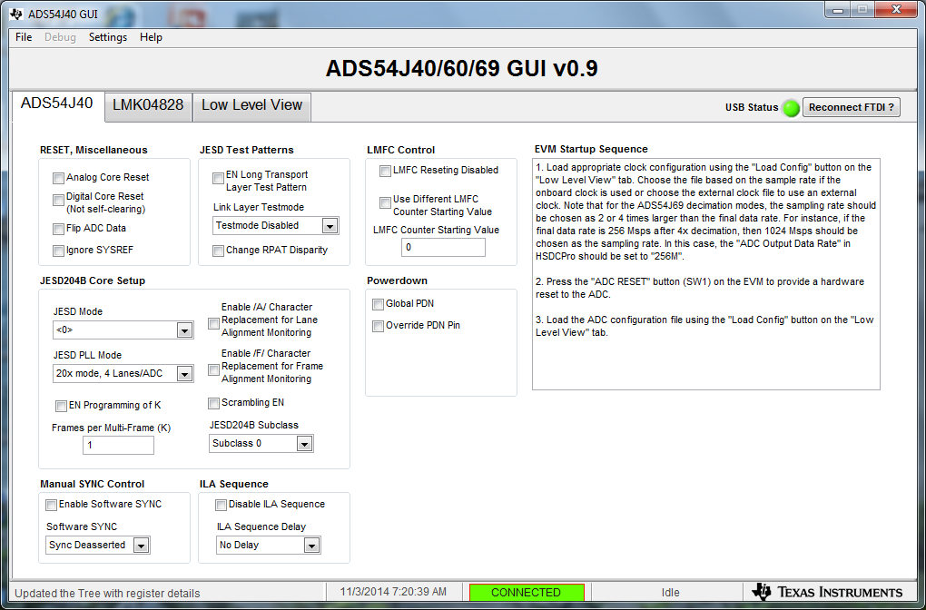

**Figure 2:** ADS54J40 Tab

# Typical Demo Setup

## 

## ADS54J60 Quick-Start Procedure

### TSW14J56

1. Connect a 5-V power supply to connector J11 (+5V IN)
2. Connect a USB cable to the USB connector (J9)
3. Flip the power switch (SW6) to the “ON” position

### ADS54J60 EVM

1. Connect a 5-V power supply to connector J14
2. Connect a USB cable to the USB connector (J13)
3. Connect the 170-MHz signal source box to the 170MHz filter which feeds AINM SMA connector (J1). Connect the 170MHz power supply to the 170MHz source box and AC power.

### ADS54J40 GUI

1. Open the ADS54J40 GUI by going to *Start Menu 🡪 All Programs 🡪 Texas Instruments ADCs 🡪 ADS54J40 GUI*
2. Verify that the green *USB Status* indicator is lit. If it is not lit, click the *Reconnect USB* button and check the *USB Status* indicator again. If it is still not lit then verify the EVM is connected to the computer through USB.
3. Click on the “Low Level View” tab then click on “Load Config”. Navigate to C:\Program Files(86)\Texas Instruments\ADS54J40 GUI\Configuration Files and select the file called “*LMK_Config_Onboard_983p04_MSPS.cfg”*. This will provide a 983.04M sample clock to the ADC.

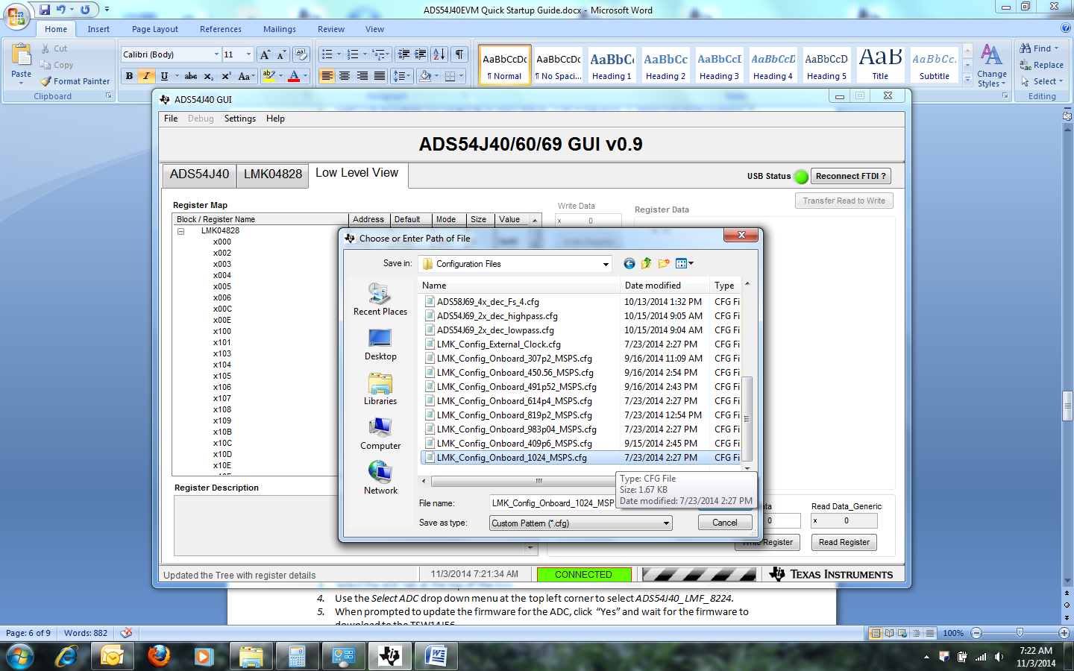

1. Verify that the LMK04828 PLL is locked by checking that the “PLL2 LOCKED” LED (D3) is lit. If the LED is not lit, please check the hardware setup and make sure that JP2 (XO PWR) has a jumper installed. Then try to reload the clock configuration file.
2. The “PLL1 LOCKED” LED will be lit if a 10-MHz reference clock is connected to the CLKIN SMA connector (J12), which is not required.
3. Once the LMK04828 PLL is locked, press SW1 (*ADC RESET*) to provide a hardware reset to the ADC. This switch is located in the middle of the EVM.
4. In the “Low Level View” tab, click “Load Config”. Load the file called “ADS54J60_LMF_8224*.cfg”*. The ADS54J60EVM is now configured for bypass mode using 8 lanes.

### High Speed Data Converter Pro (HSDCPro)

**Channel 1 Setup for bypass Test**

1. Open High Speed Data Converter Pro v3.00.01 by going to *Start Menu* 🡪 *All Programs* 🡪 *Texas Instruments* 🡪 *High Speed Data Converter Pro*
2. Click “Ok” to connect to the TSW14J56.
3. Select the *ADC* tab at the top of the GUI.
4. Use the *Select ADC* drop down menu at the top left corner to select *ADS54J60_LMF_8224*.
5. When prompted to update the firmware for the ADC, click “Yes” and wait for the firmware to download to the TSW14J56.
6. Enter “983.04M” into the *ADC Output Data Rate* field at the bottom left corner.
7. Click the *Instrument Options* menu at the top of HSDC Pro and select *Reset Board*.
8. Click “Capture” in HSDC Pro to capture data from the ADC.
9. Channel 1 should look as shown below:

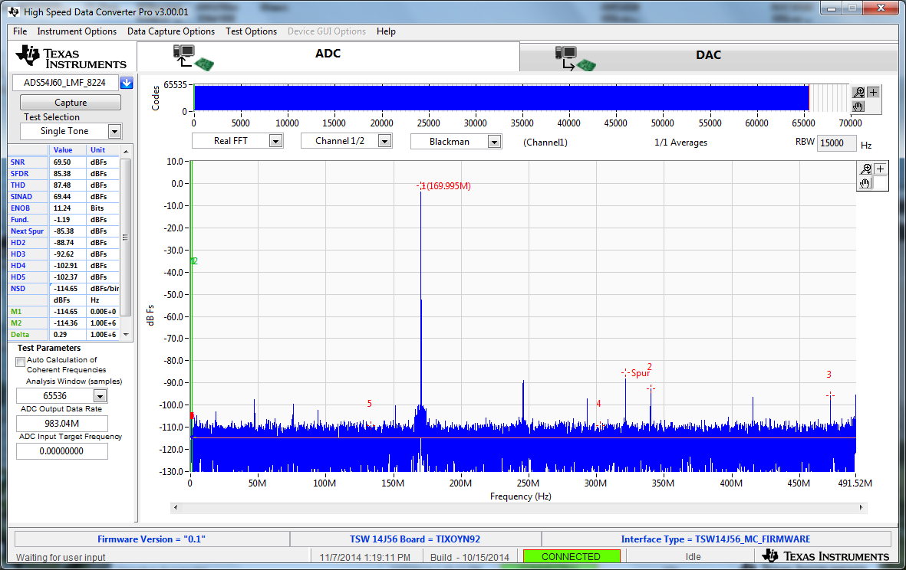

Channel 1 Data Capture Results

**Setup for Decimate by 2 Test**

1. Press SW1 (*ADC RESET*) to provide a hardware reset to the ADC.
2. On the ADS54J40 GUI, in the “Low Level View” tab, click “Load Config”. Load the file called “ADS54J60_2x_Dec_LowPass *cfg*.
3. On the HSDC Pro GUI, s*elect ADC* drop down menu at the top left corner to select *ADS54J60_2x_Dec*.
4. Enter “491.52M” into the *ADC Output Data Rate* field at the bottom left corner.
5. Click the *Instrument Options* menu at the top of HSDC Pro and select *Reset Board*.
6. Click on “Capture”. The output should look as shown below:

## 

Channel 1 Data Capture Results

**Setup for Decimate by 4 (Real data) Test**

1. Press SW1 (*ADC RESET*) to provide a hardware reset to the ADC.
2. On the ADS54J40 GUI, in the “Low Level View” tab, click “Load Config”. Load the file called “ADS54J60_4x_dec_Fs_4. *cfg*.
3. On the HSDC Pro GUI, s*elect ADC* drop down menu at the top left corner to select *ADS54J60_4x_Dec*.
4. Enter “245.76M” into the *ADC Output Data Rate* field at the bottom left corner.
5. Click the *Instrument Options* menu at the top of HSDC Pro and select *Reset Board*.
6. Click on “Capture”. The output should look as shown below:

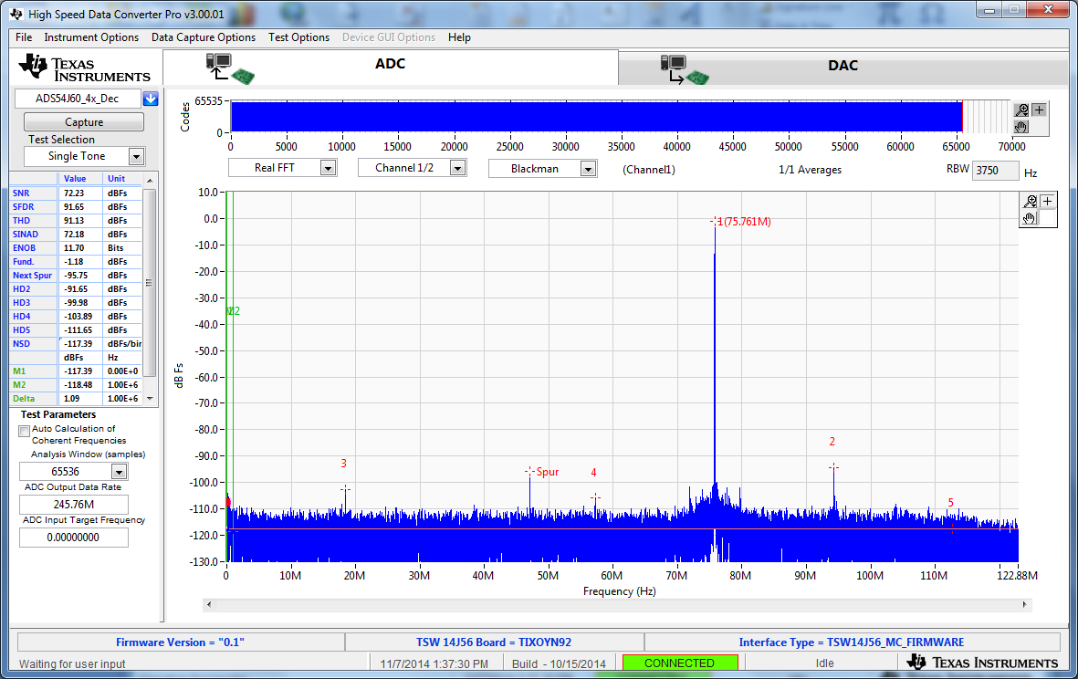

Channel 1 Data Capture Results

**Setup for Decimate by 4 (IQ data) Test**

1. Press SW1 (*ADC RESET*) to provide a hardware reset to the ADC.
2. Click on the “Low Level View” tab then click on “Load Config”. Navigate to C:\Program Files(86)\Texas Instruments\ADS54J40 GUI\Configuration Files and select the file called “*LMK_Config_Onboard_983p04_MSPS.cfg”*. This will provide a 983.04M sample clock to the ADC.
3. On the ADS54J40 GUI, in the “Low Level View” tab, click “Load Config”. Load the file called “ADS54J60_4x_dec_Fs_4_IQ_4421. *cfg*. This will set the ADC to IQ output mode with the LMFS setting = 4421.
4. On the HSDC Pro GUI, s*elect ADC* drop down menu at the top left corner to select *ADS54J60_4x_4421_IQ*.
5. Enter “245.76M” into the *ADC Output Data Rate* field at the bottom left corner.
6. Click the *Instrument Options* menu at the top of HSDC Pro and select *Reset Board*.
7. Se the capture display mode to “Complex FFT”. This will display the results of the I and Q data for the channel selected.
8. Click on “Capture”. The output should look as shown below. In the GUI, channel 1/4 and 2/4 will display the results if the display mode is set “Complex FFT”. If the mode is set to “Real FFT”, Channel 1/4 will display the I data for channel A, channel 2/4 will display the Q data for channel A, Channel 3/4 will display the I data for channel B, and channel 4/4 will display the Q data for channel B.

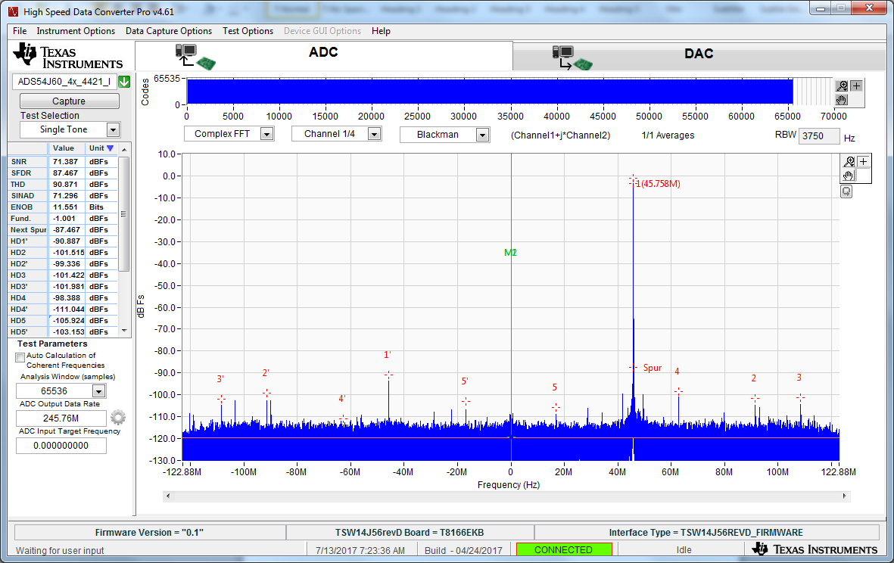

Channel 1 Complex FFT Data Capture Results with 200MHz input tone.