Data 1 Data 2

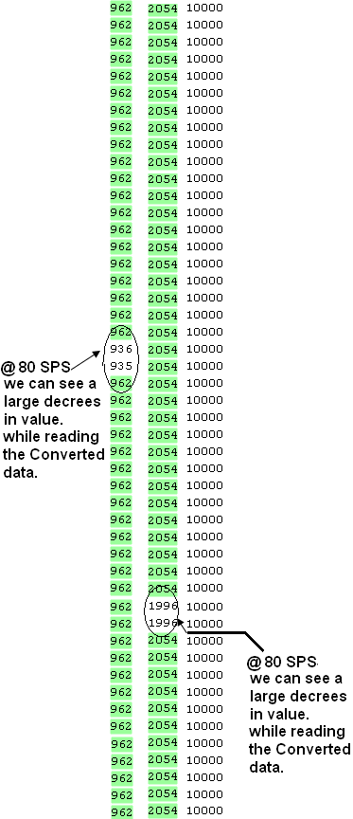

Data 1 Data 2

