**ADC Range Configured**

*(0 – 5V for all channels except channel 3 (it is configured +/- 10))* ADC Raw and Float readings

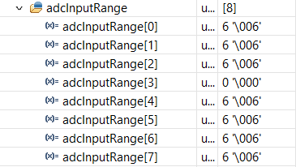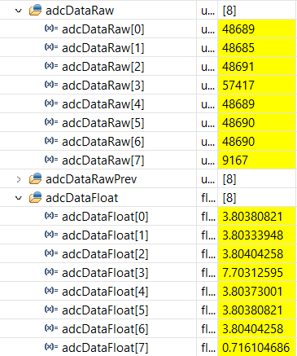

**ADC Range Configured**

*(0 – 5V for all channels)* ADC Raw and Float readings

(Channel 3 got saturated)

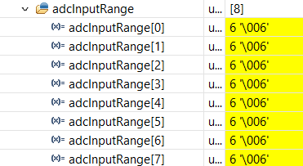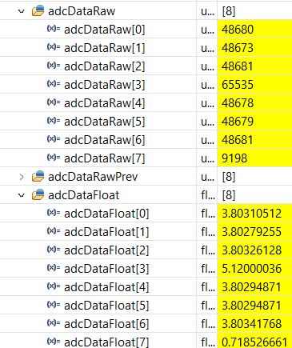

**After 1.6sec Reading changes as shown below:**

*(0 – 5V for all channels)* ADC Raw and Float readings

(All Channel reading got changed)

( Floating point values are calculated with respect to 0-5V range)

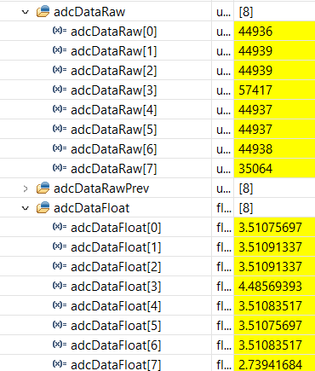

**It is found that after 1.6sec ADC changes its internal PGA for +/- 10V instead of earlier configure 0 – 5V:**

*(0 – 5V for all channels)* ADC Raw and Float readings

(All Channel reading got changed)

(Floating point values are now calculated with respect to +/-10V range)

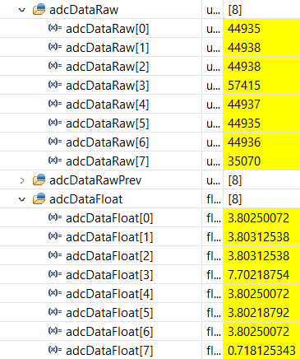

**Read Value of Input Range Register After 1.6sec:**

