3/5/2020

RReeder

ADC12D1600RF Crosstalk

Conditions: Fsample = 1600MSPS

The *Fund Amplitude* reading on the left = crosstalk of the open channel. ~65dBFS on average across the band of interest.

The red trace is the aggressor channel, the green trace is the open channel.

Results across the band:

IF = 750MHz

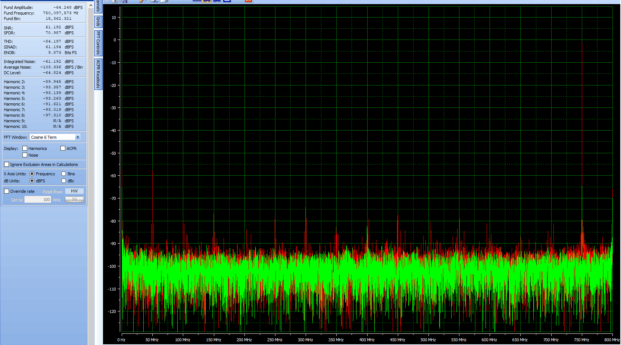

IF = 760MHz

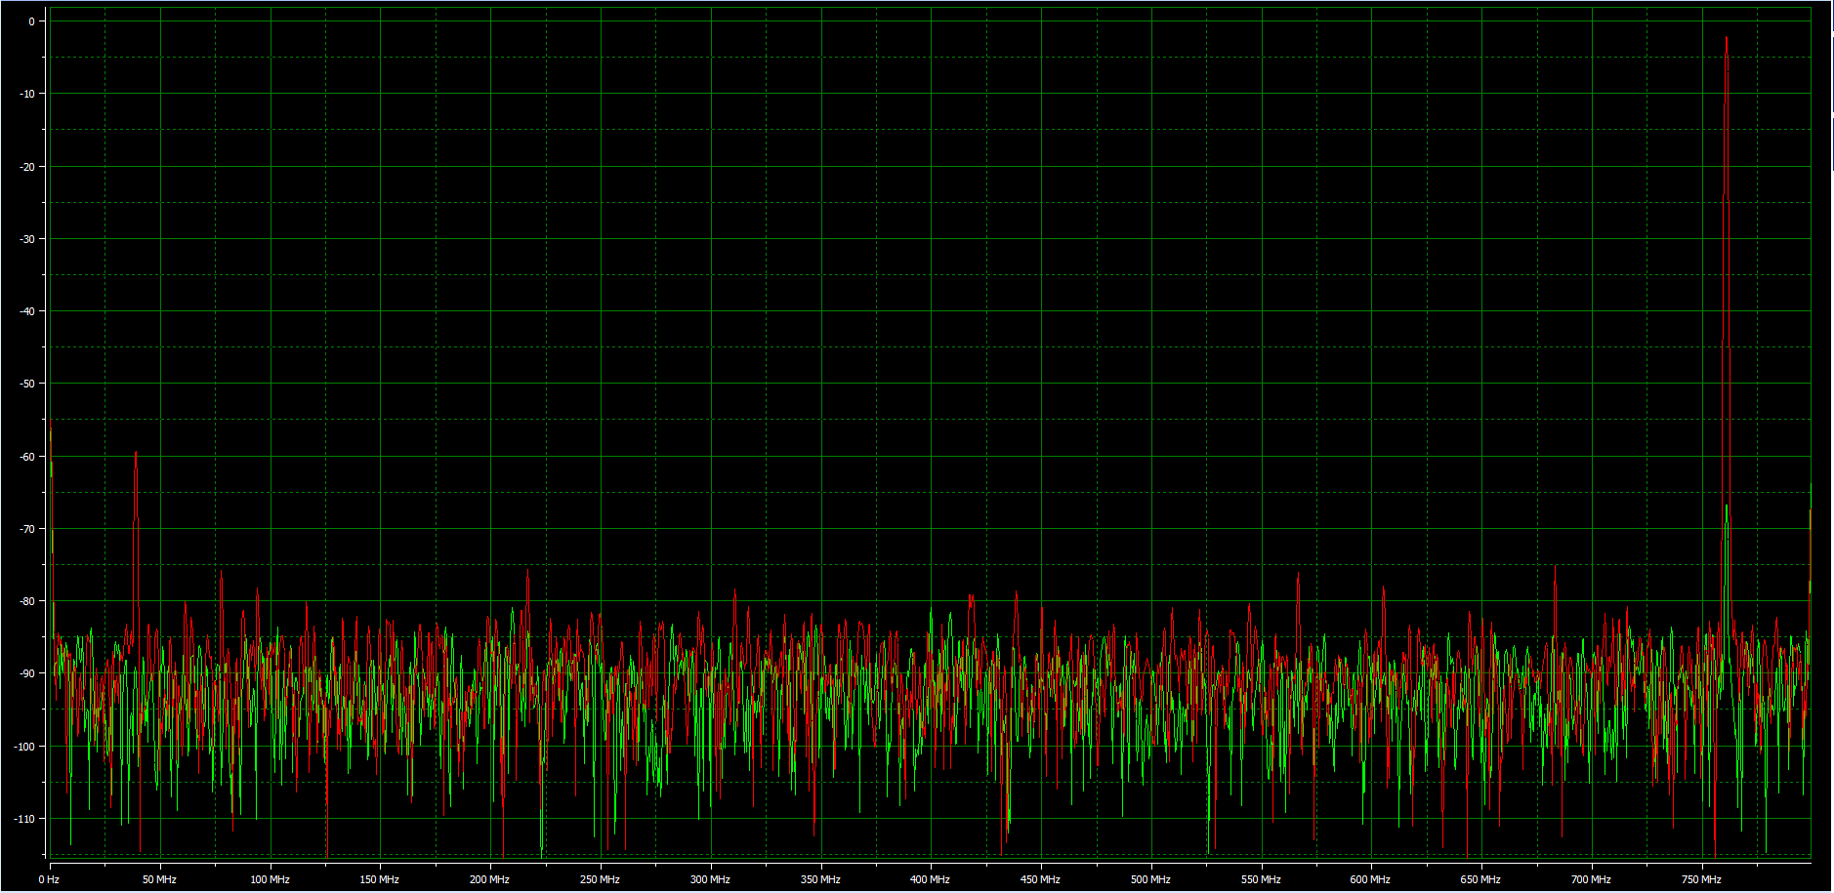

IF = 811MHz

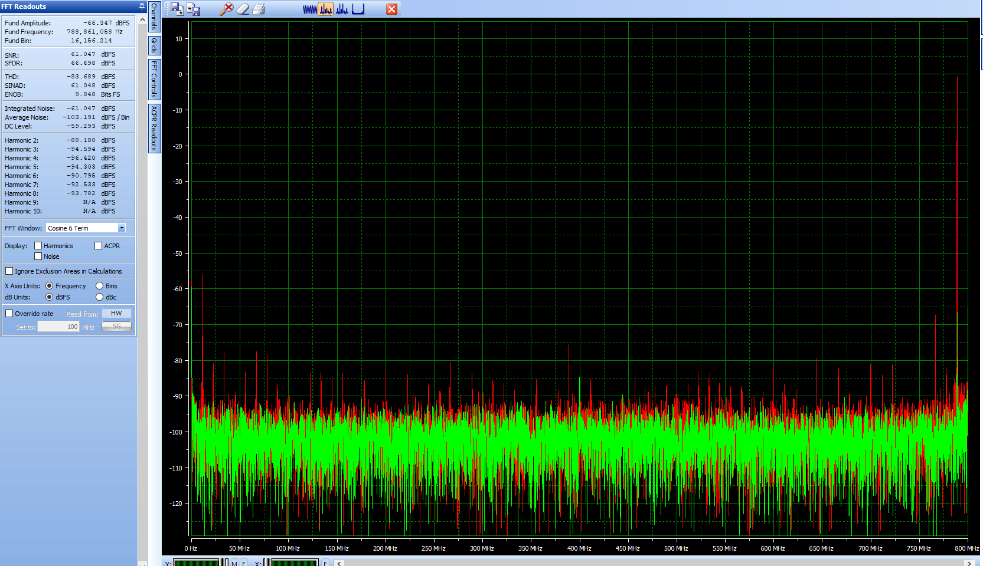

IF = 851MHz

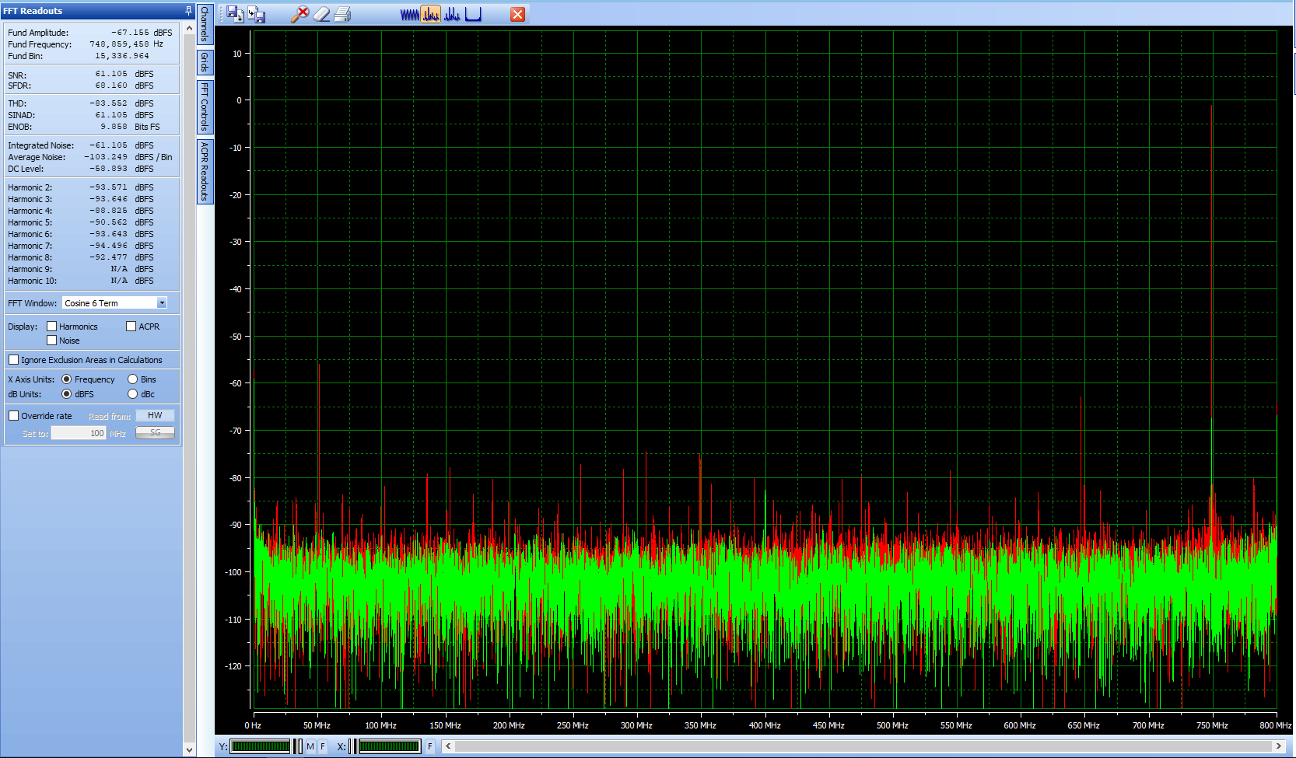

IF = 901MHz

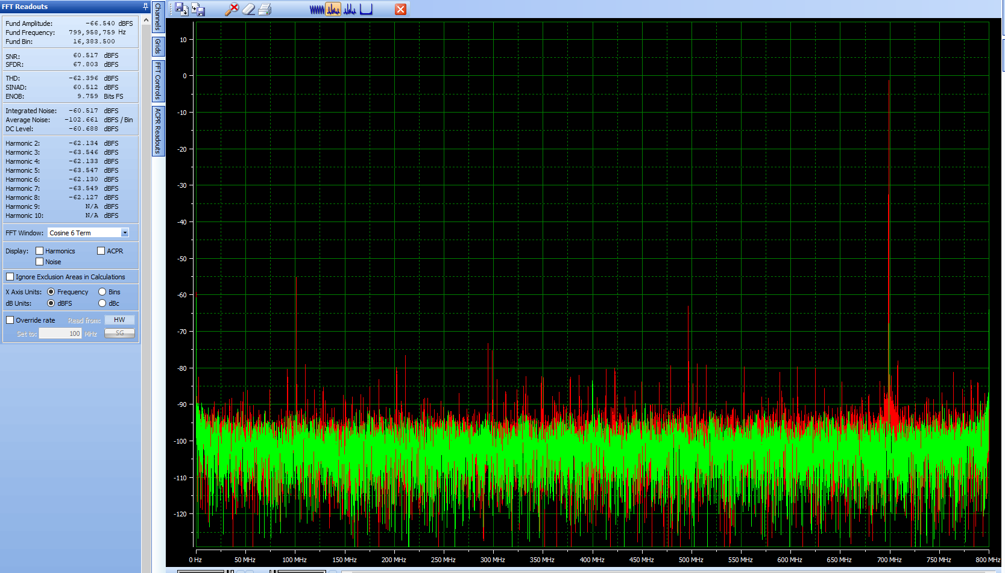

IF = 951MHz

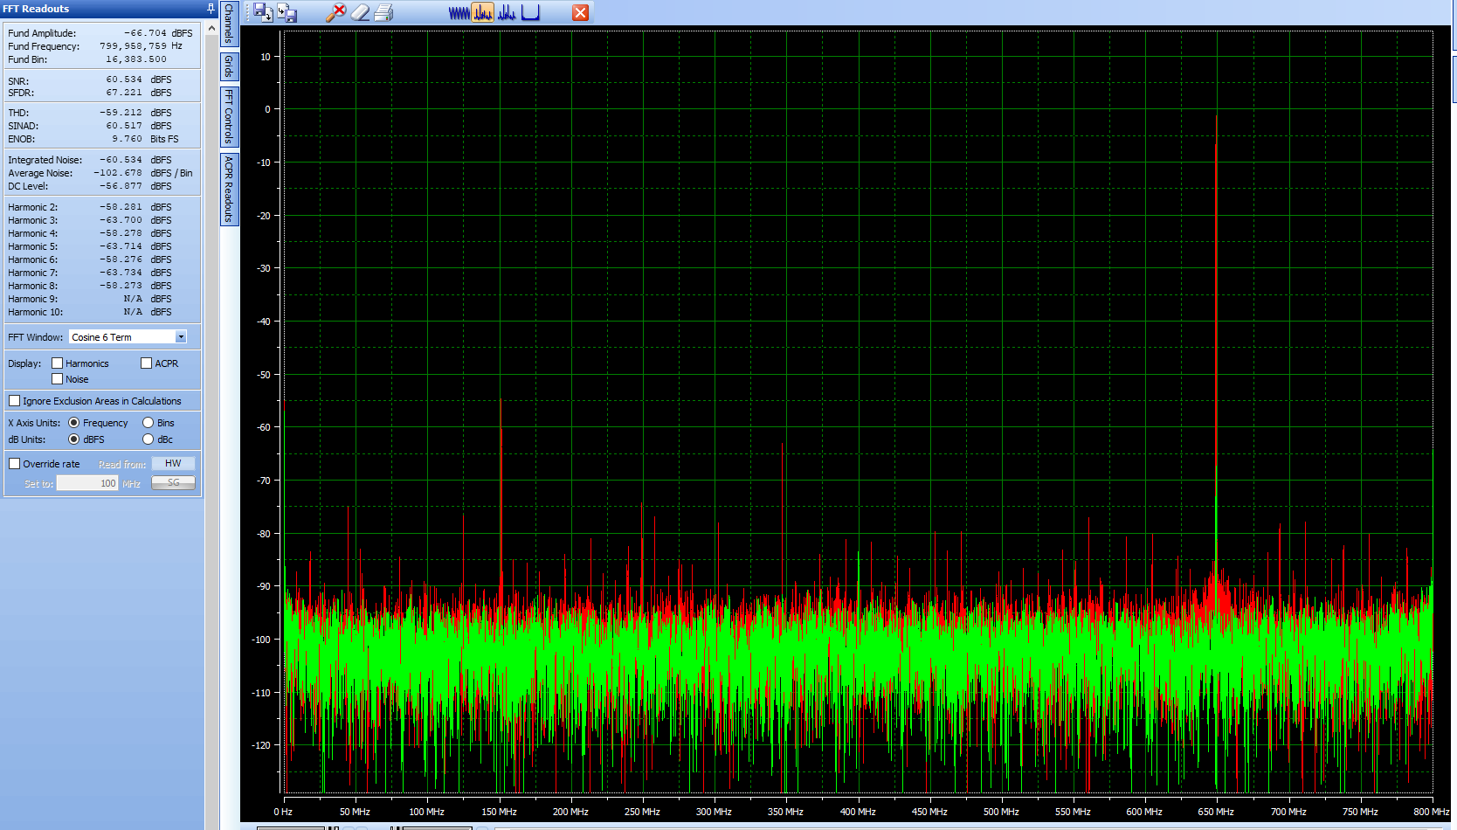

IF = 1001MHz

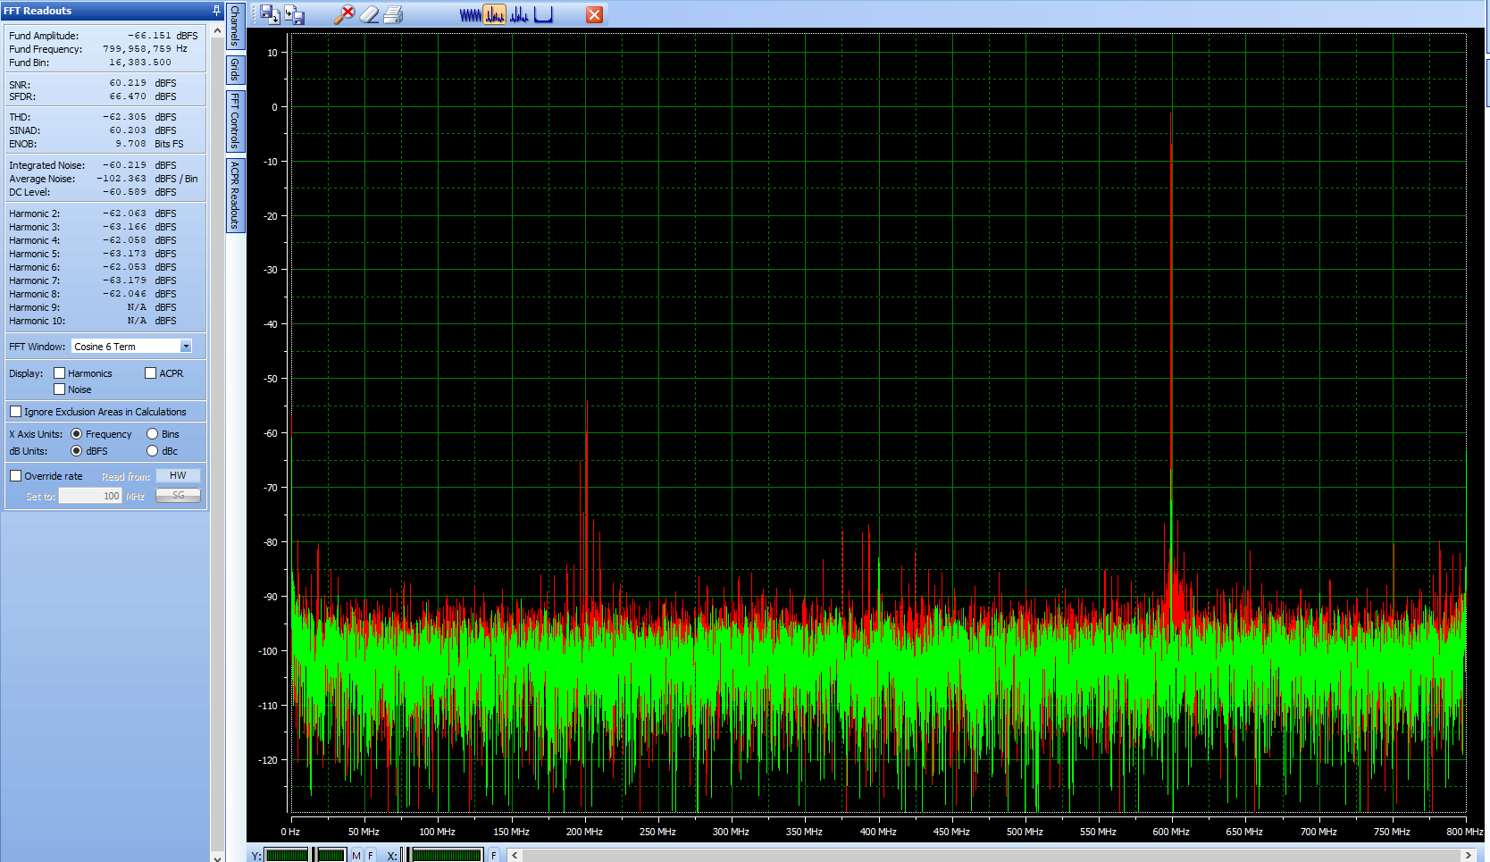

IF = 1051MHz

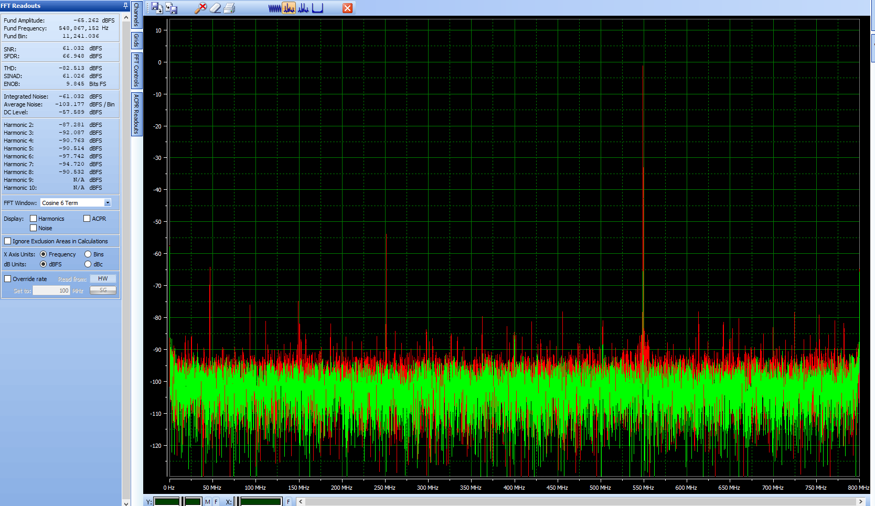

IF = 1101MHz

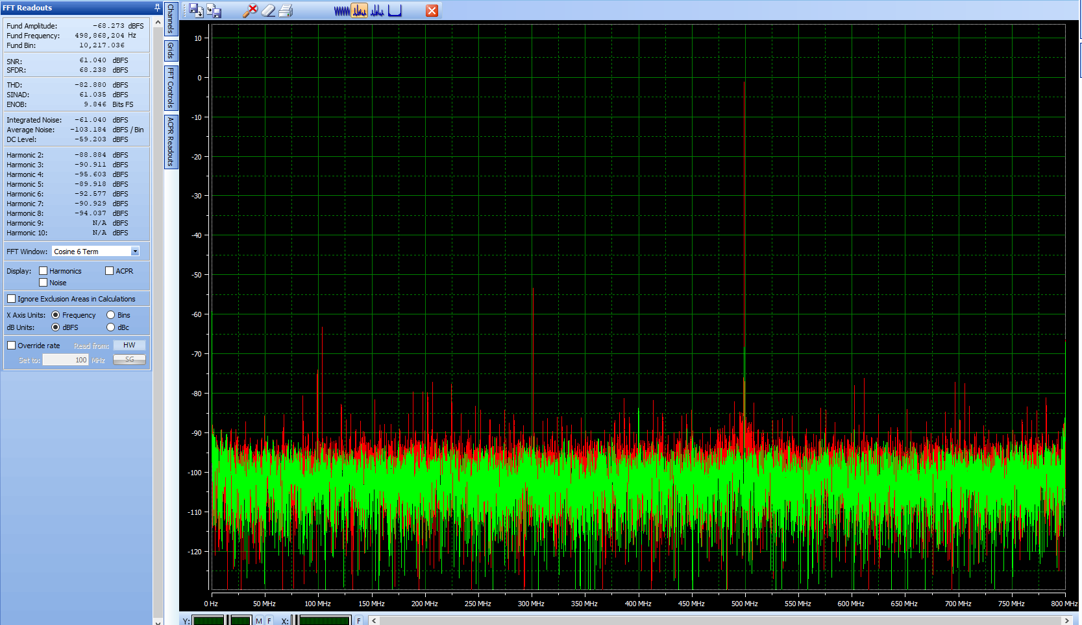

IF = 1151MHz

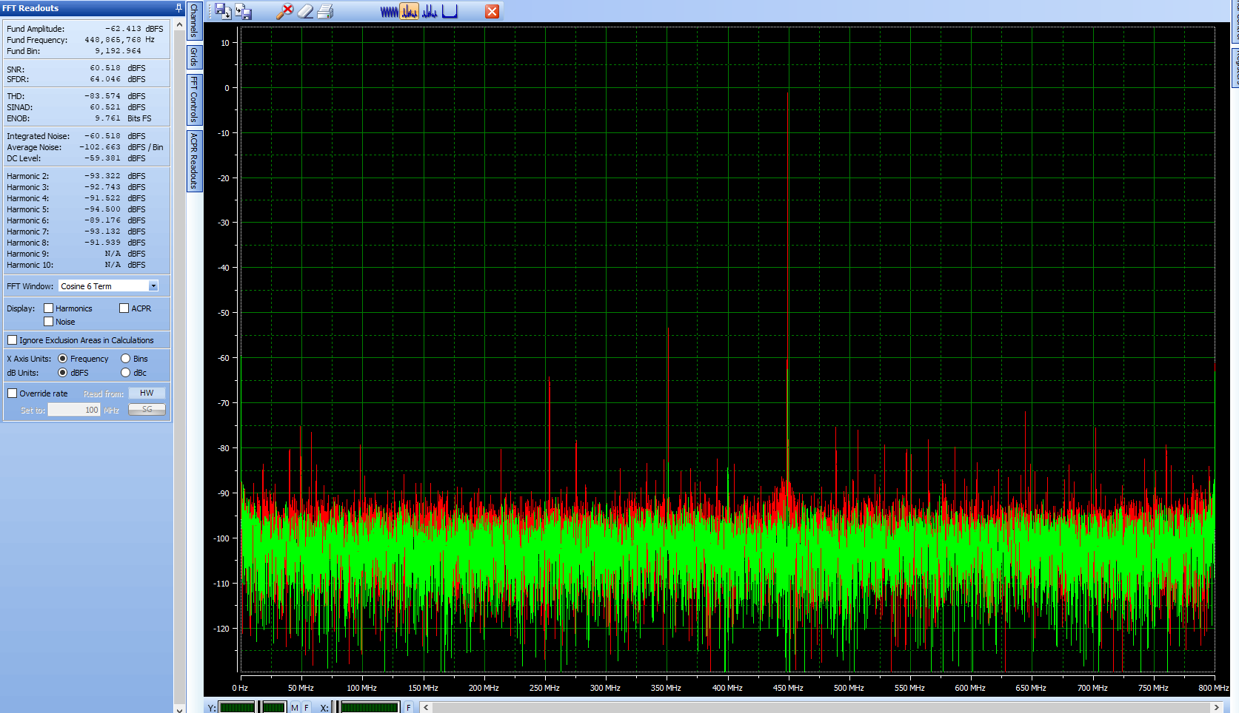

IF = 1201MHz

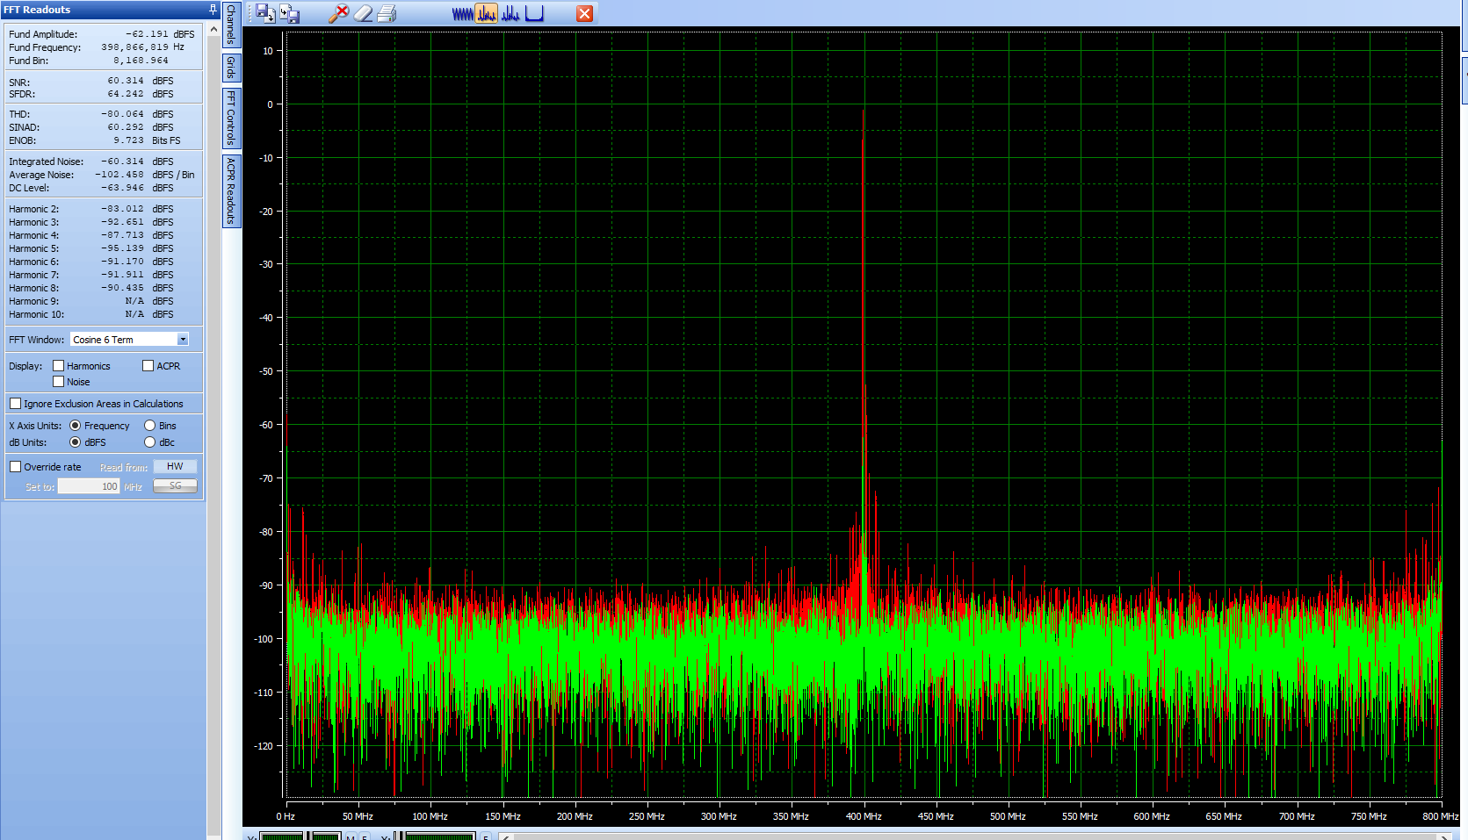

IF = 1251MHz

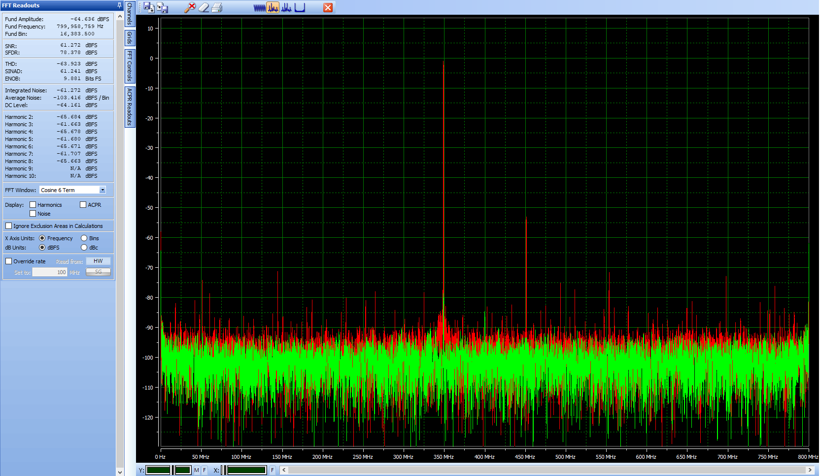

IF = 1301MHz

