ADC3444 2-Wire LVDS Output Verification Results
[System Configuration]
- External ADC Input Clock (CLK_IN): 100 MHz
[ADC3444 Register Settings]
- Address 05h = 0x00: 2-wire mode enabled
- Address 09h = 0x01: Offset binary format selected
- Address 27h = 0xC0: Input clock divide-by-4 enabled
[Resulting Operational Parameters]
- External CLK_IN: 100 MHz
- Internal ADC Sampling Clock: 25 MSPS
- Theoretical DCLK Frequency: 87.5 MHz
- Theoretical FCLK Frequency: 12.5 MHz
[Summary of Observations]
The ADC3444 was configured to 25 MSPS in 2-wire mode, and the "All 1" and "All 0" test patterns were measured on Channel C.
- DC0 Behavior: The DC0 differential output aligned normally with the configured logic polarities.
- DC1 Behavior: While the basic logic polarities for DC1 remained normal, periodic differential voltage fluctuations—which were absent on DC0—were repeatedly observed. However, no polarity inversion was detected during these fluctuations.
To identify the root cause of this behavior, further verification is required regarding the LVDS output swing settings, as well as the differential termination and load conditions.

- ADC3444, DC0(LSB 7-bit, D0~D6)
DCLK(C1, yellow), FCLK(C2, red), DC0P(C3, blue), DC0M(C4, green), DC0P-DC0M (F1, orange)

  - All 1 Test Pattern
Register: 0Bh = 0x20, 06h = 0x02
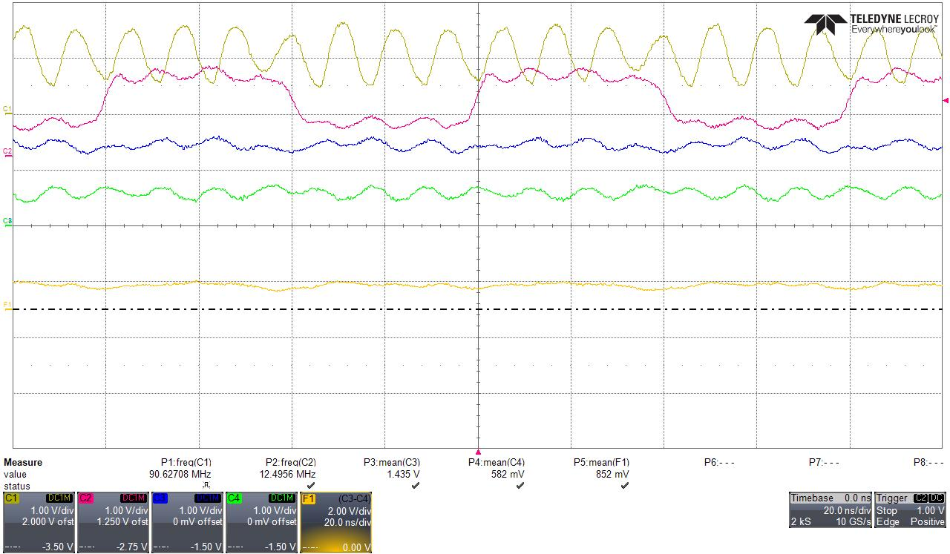
All 1: DC0P − DC0M > 0 V

  - All 0 Test Pattern
register: 0Bh = 0x10, 06h = 0x02
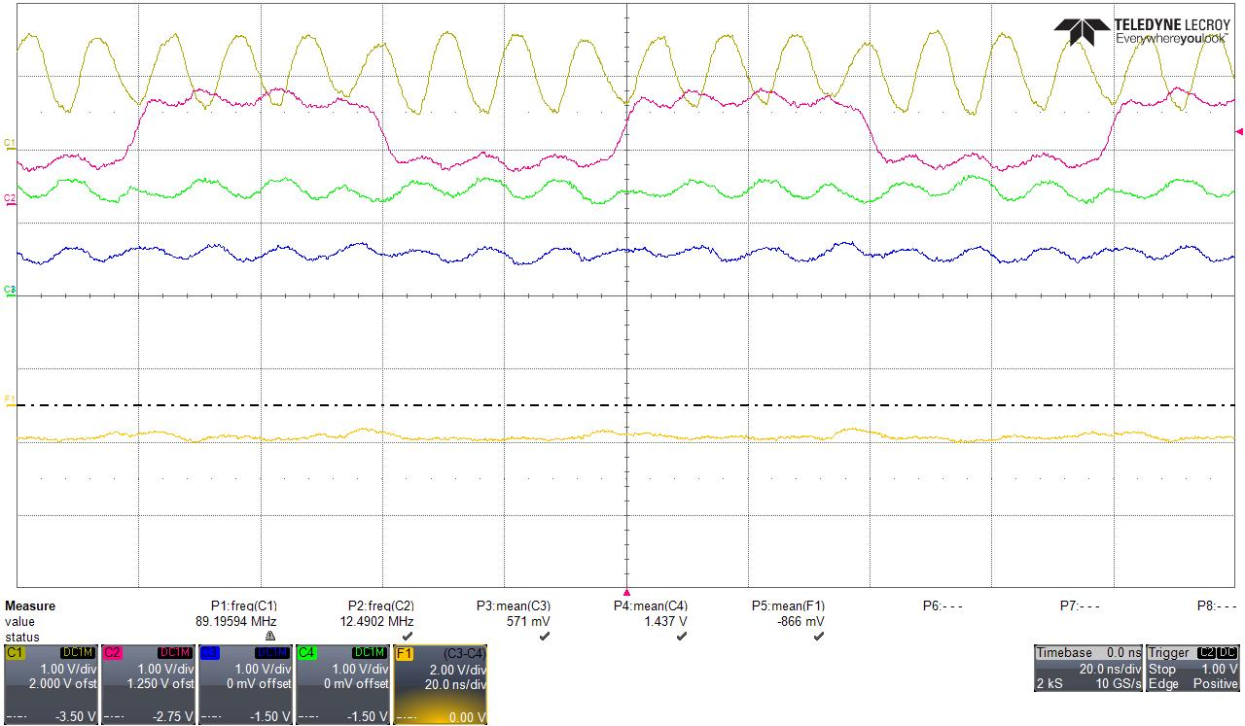
All 0: DC0P − DC0M < 0 V

The DC0P–DC0M differential output maintained a positive polarity for the "All 1" pattern and a negative polarity for the "All 0" pattern, aligning with the configured test patterns.

- ADC3444, DC1(MSB 7-bit, D7~D13)
DCLK(C1, yellow), FCLK(C2, red), DC1P(C3, blue), DC1M(C4, green), DC1P-DC1M(F1, orange)

  - All 1 Test Pattern
register: 0Bh = 0x20, 06h = 0x02
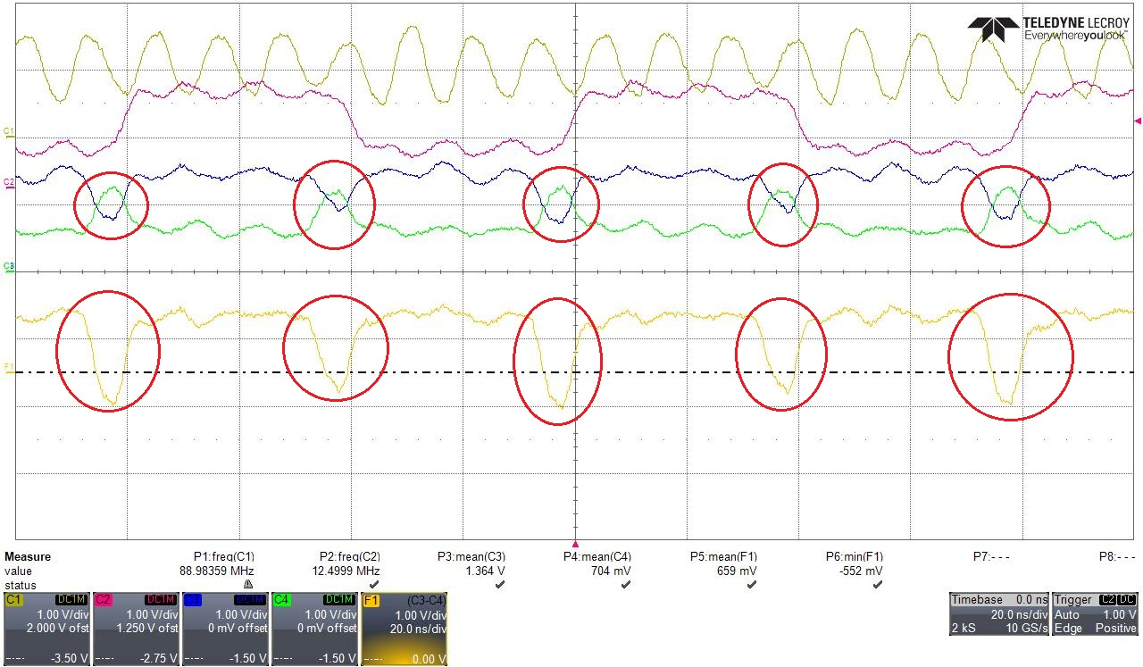
The red circles indicate the intervals of waveform fluctuation that were observed periodically only on DC1, but not on DC0.

  - All 0 Test Pattern
register: 0Bh = 0x10, 06h = 0x02
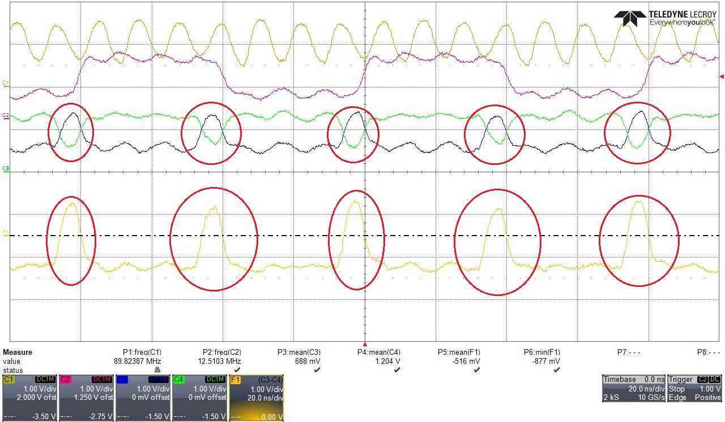
The red circles indicate the intervals of waveform fluctuation that were observed periodically only on DC1, but not on DC0.
  - The DC1P–DC1M differential output maintained the baseline polarities for both "All 1" and "All 0" patterns, but periodic voltage fluctuations—absent on DC0—occurred repeatedly at specific points in time.

Conclusion
The ADC3444 was configured with an internal sampling clock of 25 MSPS in 2-wire mode, and the "All 1" and "All 0" test patterns were measured on Channel C.
The DC0P–DC0M differential output maintained a positive polarity for the "All 1" pattern and a negative polarity for the "All 0" pattern, aligning precisely with the configured test patterns.
Similarly, the DC1P–DC1M differential output matched the configured settings for the baseline logic polarities of both "All 1" and "All 0" patterns. However, periodic differential voltage fluctuations, which were not observed on DC0, were repeatedly identified on DC1. Since the differential voltage polarity was maintained even during these fluctuation intervals, no inversion of the logic state was detected on the oscilloscope measurements.
To determine the root cause of the periodic differential voltage fluctuations observed on DC1, further verification is required regarding the ADC3444 LVDS output settings, as well as the differential termination and load conditions at the output stage.

