REGISTERS CONFIGURED DATA FOR LMK04828 ARE GIVEN BELOW:

LMK04828:
0x00 0x10
0x02 0x00

0x100 0x18
0x101 0x55
0x103 0x00
0x104 0x20 //122.88Mhz dclkout0 JESD_MGT_CLK
0x105 0x00
0x106 0xF0
0x107 0x11

0x108 0x63
0x109 0x55
0x10B 0x00
0x10C 0x20 //983 Mhz dclkout2 ADC_INPUT_CLK
0x10D 0x00
0x10E 0xF0
0x10F 0x66

0x110 0x08
0x111 0x55
0x113 0x00
0x114 0x00 // No Clock
0x115 0x00
0x116 0x79
0x117 0x01

0x118 0x18
0x119 0x55
0x11B 0x00
0x11C 0x00 // 122.88Mhz dclkout4 JESD SYS_CLK
0x11D 0x00
0x11E 0xF0
0x11F 0x01

0x120 0x08
0x121 0x55
0x123 0x00
0x124 0x00 // No Clock
0x125 0x00
0x126 0x79
0x127 0x01

0x128 0x08
0x129 0x55
0x12B 0x00
0x12C 0x00 // No Clock
0x12D 0x00
0x12E 0x79
0x12F 0x01

0x130 0x08
0x131 0x55
0x133 0x00
0x134 0x00 // No Clock
0x135 0x00
0x136 0x79
0x137 0x01

0x138 0x20
0x139 0x03
0x13A 0x03
0x13B 0x00
0x13C 0x00
0x13D 0x08
0x13E 0x03
0x13F 0x00
0x140 0x00
0x141 0x00
0x142 0x00
0x143 0x11
0x144 0xFF
0x145 0x00
0x146 0x10
0x147 0x1A
0x148 0x02
0x149 0x42
0x14A 0x33
0x14B 0x16
0x14C 0x00
0x14D 0x00
0x14E 0x00
0x14F 0x7F
0x150 0x03
0x151 0x02
0x152 0x00
0x153 0x00
0x154 0x78
0x155 0x00
0x156 0x7D
0x157 0x00
0x158 0x96
0x159 0x06
0x15A 0x00
0x15B 0xD4
0x15C 0x20
0x15D 0x00
0x15E 0x00
0x15F 0x0B
0x160 0x00
0x161 0x01
0x162 0x44
0x163 0x00
0x164 0x00
0x165 0x0C
0x166 0x00
0x167 0x00
0x168 0x0C
0x169 0x59
0x16A 0x20
0x16B 0x00
0x16C 0x00
0x16D 0x00
0x16E 0x13
0x17C 0x15
0x17D 0x0F

REGISTERS CONFIGURED FOR ADS54J60 ARE GIVEN BELOW:

ADS54J60: ADC MODE = 4244.
General registers: 0x0000 - 0x81 // software reset
0x0001 - 0x00
0x0002 - 0x00

Analog Bank Master Page: 0x0011 - 0x80 // Page Selection
0x0020 - 0x00
0x0021 - 0x00
0x0023 - 0x00
0x0024 - 0x00
0x0026 - 0x00
0x0053 - 0x00
0x0055 - 0x00
0x0059 - 0x20

Analog Bank ADC Page: 0x0011 - 0x0F // Page Selection
0x005F - 0xE3 // power on reset as it is.

JESD Bank Offset Load Page: 0x4001 - 0x00 // Clearing to 0.
JESD Bank Offset Load Page: 0x4002 - 0x00 // Clearing to 0.
JESD Bank Main Digital Page: 0x4003 - 0x00 // Page Selection.
JESD Bank Main Digital Page: 0x4004 - 0x68 // Page Selection.
0x6000 - 0x00

JESD Bank Digital Page: 0x4003 - 0x00 // Page Selection
JESD Bank Digital Page: 0x4004 - 0x69 // Page Selection
0x6000 - 0x80
0x6001 - 0x02 // ADC MODE = 4244
0x6002 - 0x00
0x6003 - 0x00
0x6005 - 0x80
0x6006 - 0x07
0x6007 - 0x09
0x6016 - 0x80

JESD Bank Analog Page: 0x4003 - 0x00 // Page Selection
JESD Bank Analog Page: 0x4004 - 0x6A // Page Selection
0x6012 - 0x02
0x6016 - 0x02

JESD Bank Offeset Read Page: 0x4003 - 0x00 // Page Selection
JESD Bank Offeset Read Page: 0x4004 - 0x61 // Page Selection
0x6068 - 0x02

JESD Bank Main Digital Page: 0x4003 - 0x00 // Page Selection
JESD Bank Main Digital Page: 0x4004 - 0x68 // Page Selection
0x6000 - 0x01
0x6000 - 0x00 // Pulse reset

JESD Bank Page: 0x4003 - 0x00 // Clearing to 0.
JESD Bank Page: 0x4004 - 0x00 // Clearing to 0.
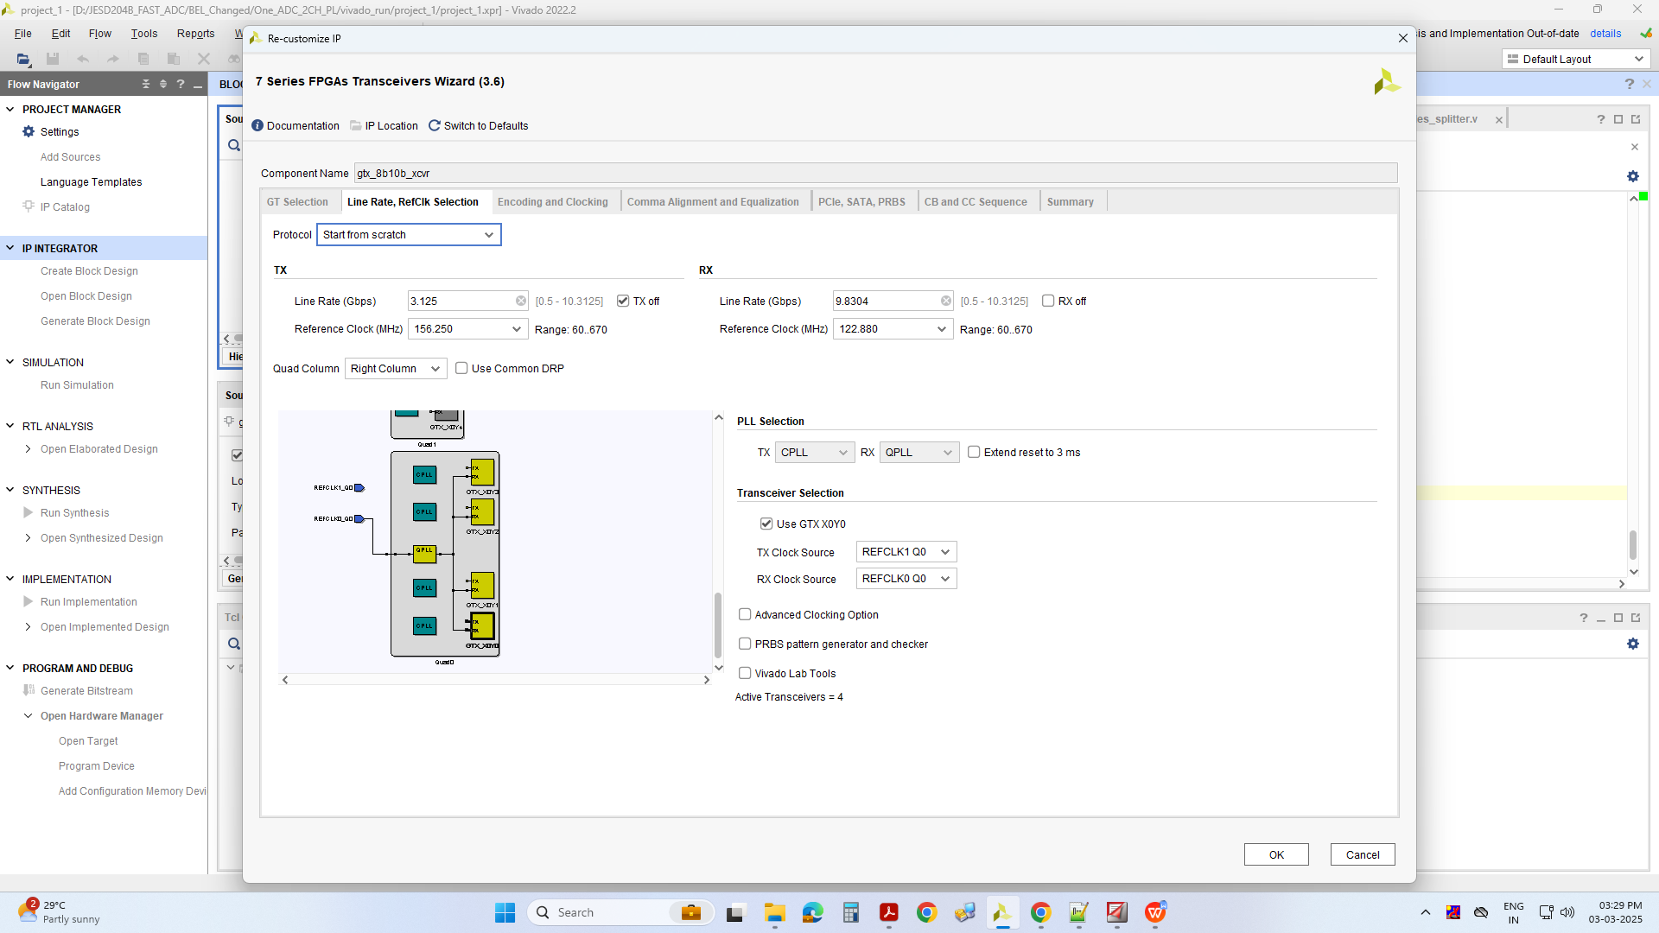
sysref_clk: 3.80 MHz
sys_clk: 122.88 MHz
xcvr_clk: 122.88 MHz

ADC input clock: 983 MHz
ADC sysref_clk: 3.80 MHz

I have configured the following registers in ADS54J60 and LMK04828. I have verified the clocks that I am generating, they fine. But I am not sure for the ADC IC, if any changes in the register mapping please let me know.

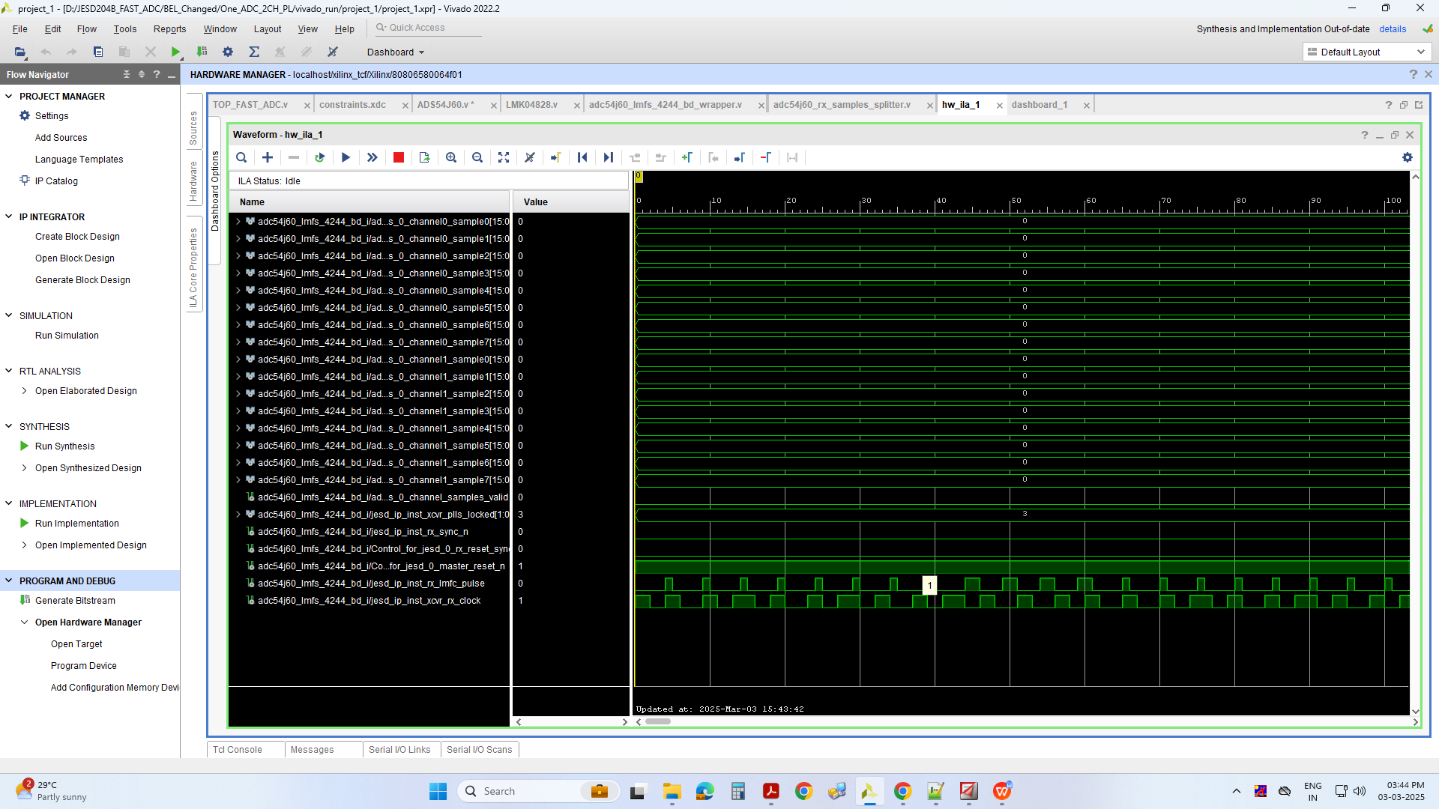
I am getting all 0’s in the both channels, valid signal is low and here is the ILA image of that.

We found that the pull-up voltage on the input line INAP, INAM, INBP and INBM are 2.8V initially and after reset it is 2.6V is there any problem in such case.

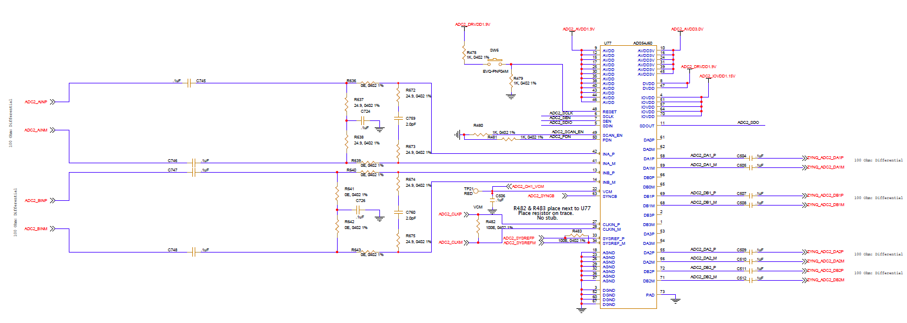
Here is the Schematic of the ADS54J60 IC.

