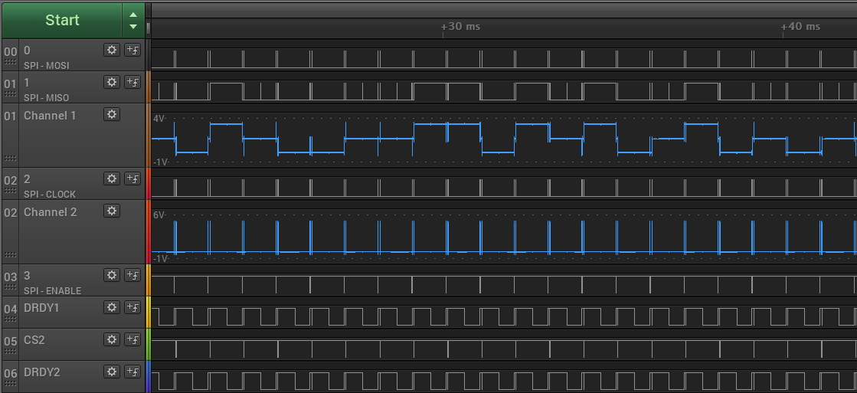
When daisy chaining two ADCs from the new PCBs using the same SPI channel, we get some weird results. The MISO signal (digital data sent by the ADC to the controller; Channel 1 on the image above) seems to be sending data in two voltage levels: 0 to 1.6 V and 1.6 to 3.3 V (should be 0 to 3.3 V).
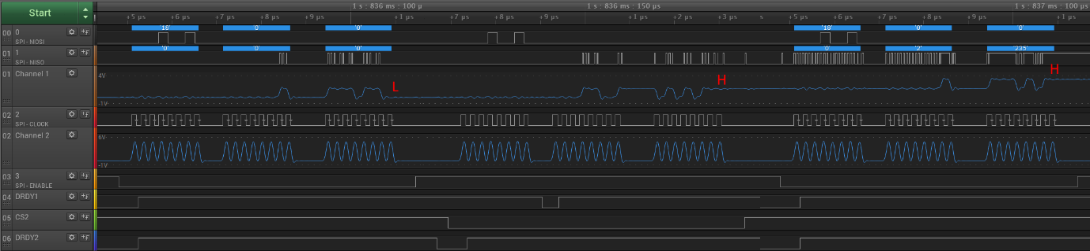

The levels change according to the LSB on the MISO line: if the LSB is low, the level will change to 0 to 1.6 V. If the LSB is high, the level will change to 1.6 to 3.3 V. The image above is a collage of sequential readings.

If you read the MOSI data bit by bit, it is correct. But since the voltage level is not 0 to 3.3 V, the TTL controller cannot differ between the high and low bits. Any idea what could be the cause of this?

