Clarification about test process & date and batch code as per your Query

- Testing process &results:
- We tested randomly selected 16 samples of IC ADS 1218Y from the lot of qty 4000 Nos. against P.O. No: SCL/PS4/2017E006330101 received recently, in our Radiosonde boards after soldering with the following set up.

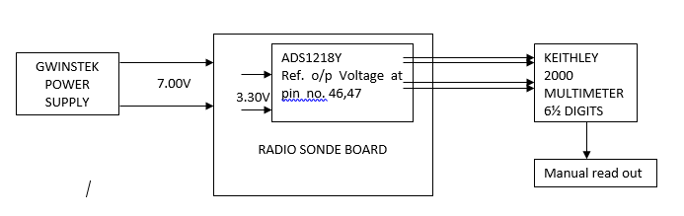

- The test results of qty. received against P.O. No: SCL/PS4/2017E006330101 are attached as Annexure-A. As the readings are taken manually, hence screenshot not to be possible.
- The test results received from previous inventory are attached as Annexure-B.
- The date & Batch code for old inventory was 34A1J7T.
- The date & Batch code of the parts received against P.O. No: SCL/PS4/2017E006330101 is 6CAVR8T.

Annexure-A

Test results of the qty received against P.O. No: SCL/PS4/2017E006330101

s.no | Card no. | Ref o/p voltage(mV) at 22°C (Room temp.) | Ref o/p voltage(mV) at 0°C | Ref o/p voltage(mV) at -30°C | Ref o/p voltage(mV) at 45°C | Remarks(deviation allowed ±2.5mV)
1 | 13613 | 1257.08 | 1257.21 | 1256.96 | 1257.27 | 7.08
2 | 13614 | 1256.09 | 1256.21 | 1256.38 | 1256.08 | 6.09
3 | 13615 | 1257.12 | 1257.05 | 1257.62 | 1257.21 | 7.12
4 | 13616 | 1256.68 | 1256.29 | 1256.51 | 1256.81 | 6.68
5 | 13617 | 1255.92 | 1254.01 | 1240.04 | 1255.91 | 5.92
6 | 13618 | 1256.12 | 1256.01 | 1256.09 | 1256.17 | 6.12
7 | 13649 | 1260.41 | 1259.52 | 1259.52 | 1259.31 | 10.41
8 | 13650 | 1258.62 | 1257.81 | 1257.28 | 1258.89 | 8.62
9 | 13652 | 1262.52 | 1260.48 | 1240.74 | 1261.25 | 12.52
10 | 13653 | 1257.03 | 1256.58 | 1256.16 | 1257.58 | 7.03
11 | 13654 | 1263.81 | 1263.88 | 1262.95 | 1263.91 | 13.81
12 | 13655 | 1258.74 | 1257.94 | 1258.05 | 1258.38 | 8.74
13 | 13656 | 1257.74 | 1257.32 | 1257.33 | 1258.19 | 7.74
14 | 13657 | 1258.37 | 1257.95 | 1256.81 | 1258.24 | 8.37
15 | 13658 | 1256.62 | 1256.36 | 1255.78 | 1257.31 | 6.62
16 | 13659 | 1257.76 | 1257.44 | 1257.13 | 1257.84 | 7.76

Annexure-B

Test results of the qty from old inventory

S.no | Card no. | Ref o/p voltage(mV) at 22°C (Room temp.) | Remarks(deviation allowed ±2.5mV)
1 | 13597 | 1250.35 | 0.35
2 | 13598 | 1249.98 | -0.02
3 | 13599 | 1249.91 | -0.09
4 | 13600 | 1249.78 | -0.22
5 | 13601 | 1250.22 | 0.22
6 | 13602 | 1250.38 | 0.38
7 | 13603 | 1250.35 | 0.35
8 | 13604 | 1249.96 | -0.04
9 | 13605 | 1250.42 | 0.42
10 | 13606 | 1250.12 | 0.12
11 | 13607 | 1250.25 | 0.25
12 | 13608 | 1249.99 | -0.01
13 | 13609 | 1250.15 | 0.15
14 | 13610 | 1250.11 | 0.11
15 | 13611 | 1250.33 | 0.33
16 | 13612 | 1250.07 | 0.07

