**ADS1292 Characterization**

1. **Register set-up and programming verification**

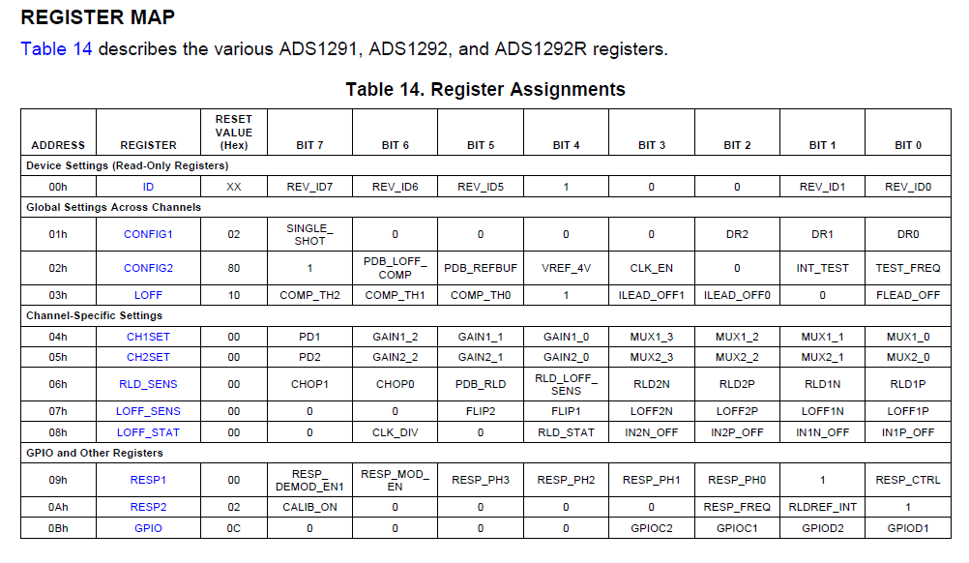

A. Below are the read/write timing diagrams for register access

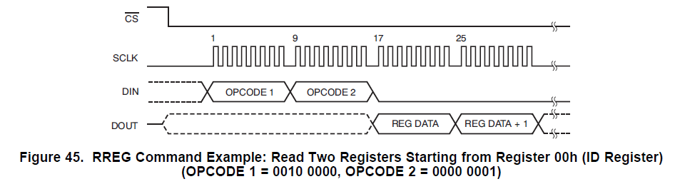

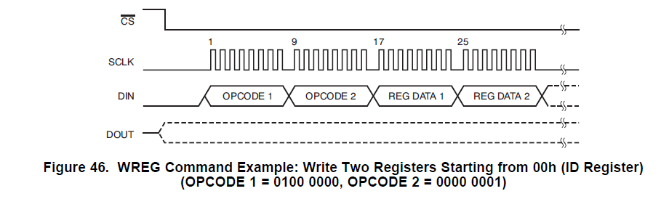

B. Below is capture of CS~(Yellow) and SCLK(Purple) of the timing verification of code implementation.

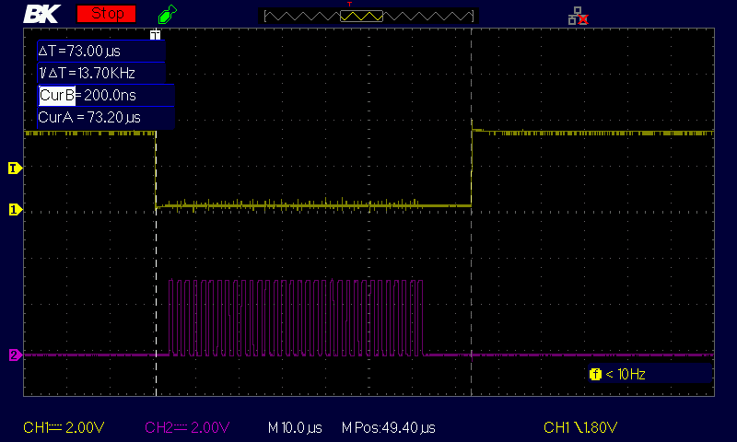

**RESULT**  Below is the beagle capture – Index numbers 34 to 40 show read/write/read verification that code implementation is correct. Configuration Register 2 defaults to 0x80 at power-up. Reprogrammed to 0x88 (internal oscillator is now available on pin 17) and verified it was present on the pin.

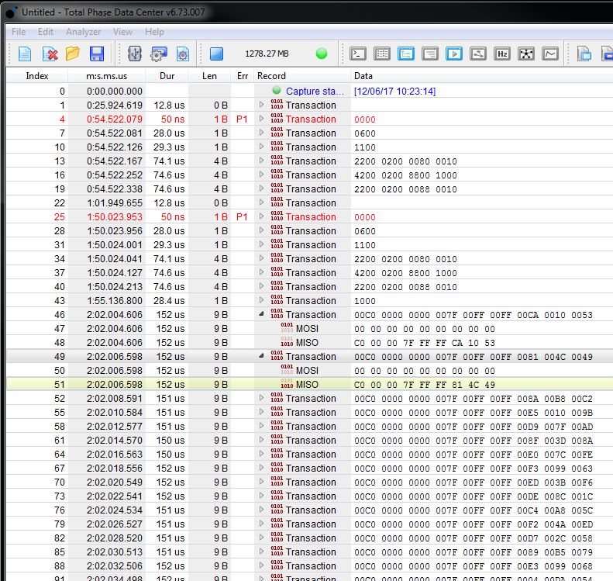

1. **Data Output capture verification**
2. Data output timing diagrams

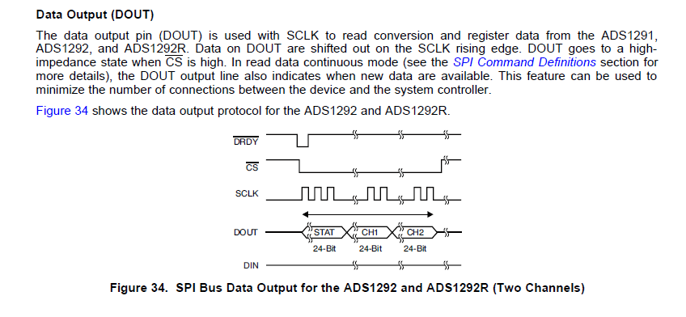

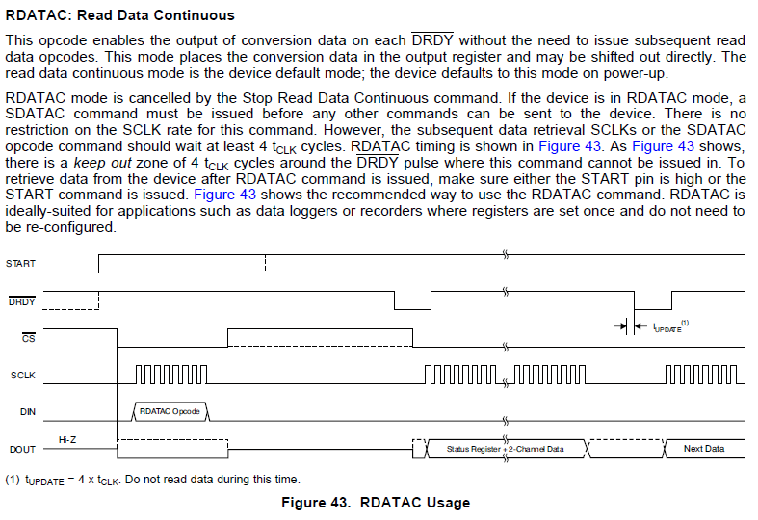

1. Verification Waveform Captures

~DRDY (Purple) - ~CS (Yellow)

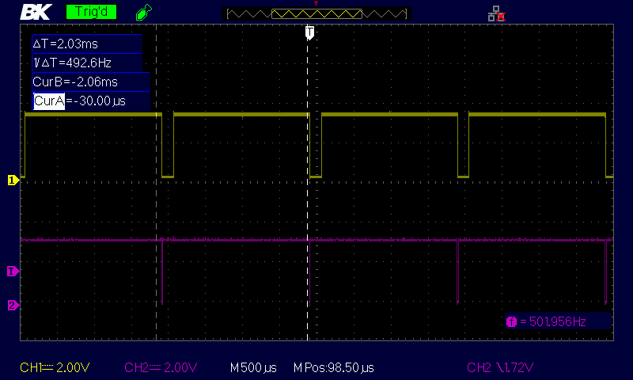

~DRDY (Purple) - ~CS (Yellow)

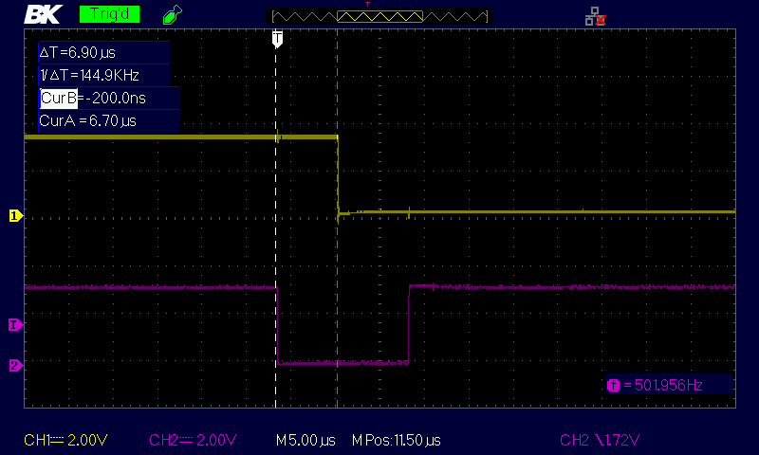

~CS (Yellow) and SCLK(Purple) 3 transfers status, Channel 1 and Channel 2

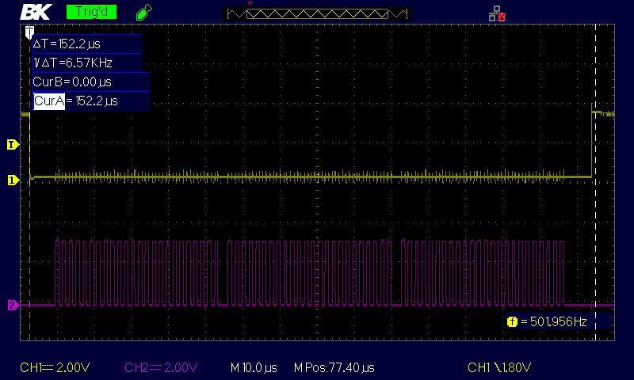

Expanded capture



Ryan,

Index No. 46 starts the Read Data output sequence consisting of 24bit transfers of Status, Channel 1 and Channel 2. Varied data being outputted from the simulator to Pins IN1N,IN1P,IN2N,IN2P. Then rerun the capture with all pins grounded.



Observations

1. Good – Status Byte 0xC0 is first byte response on MISO during data transfer (Index 48). As you said this indicates device is properly converting.
2. Bad – With varying data from the ECG simulator I would expect it to be reflected in the capture but it is not. Starting with INDEX 48 and going on forever (Channel 1) MISO bytes 3-5 are 7F FF FF. When the pins are grounded the results are the same.
3. Good and Bad - When the pins are grounded the results on Channel 2 data MISO bytes 3-5 change from 7F FF FF to 5E 00 00 range. Telling me the inputs are somewhat working.

