We use following block diagram to test the ECG input impedance. We found something wrong and the test methods as following.
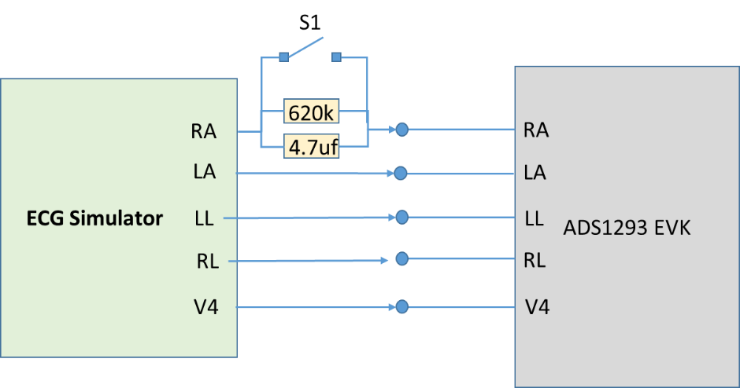
First we send the sinewave 10Hz/5mV and close S1, the RA path direct connect to ADS1293EVK. We can measure the sine waveform on lead I of ADS1293 UI.
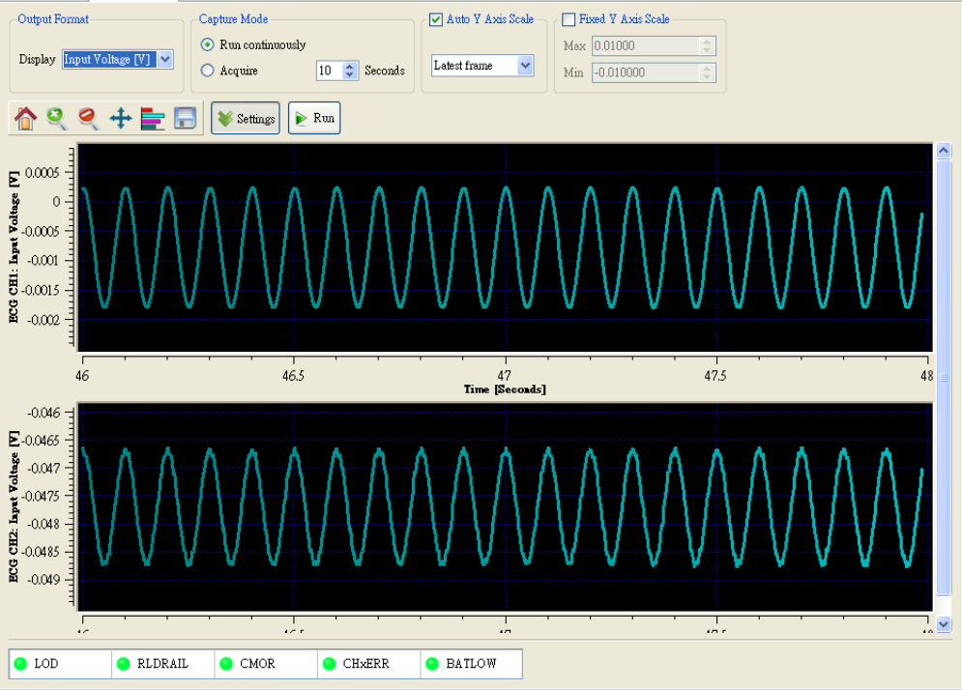

Second we send the sinewave 10Hz/5mV and open S1, the 620k and 4.7uf on the RA path between ECG simulator and ADS1293EVK. We only get the noise on lead I of ADS1293UI.
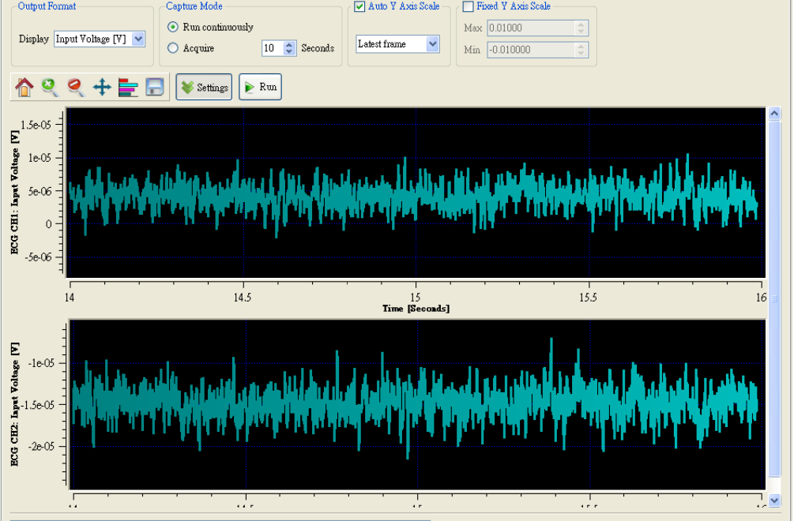
Please help to provide the suggestion to us regarding the input impedance of ADS1293.

