The following is a problematic electrocardiogram:
- The problem of ADS 1298 with high noise,corresponding files E70GC00000211_20190706092125.dat (BLT man)
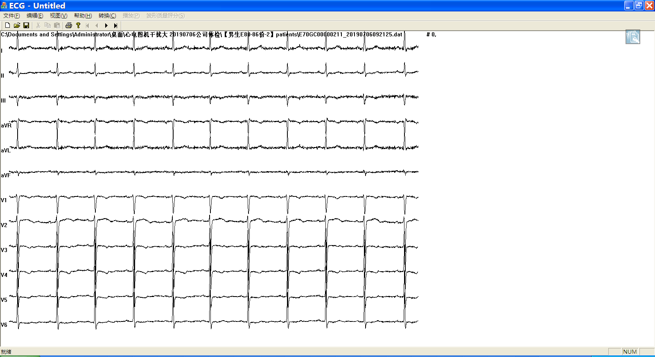

2、The problem of ADS 1298 with high noise,corresponding files E70GC00000214_20190706092440.dat (BLT man)
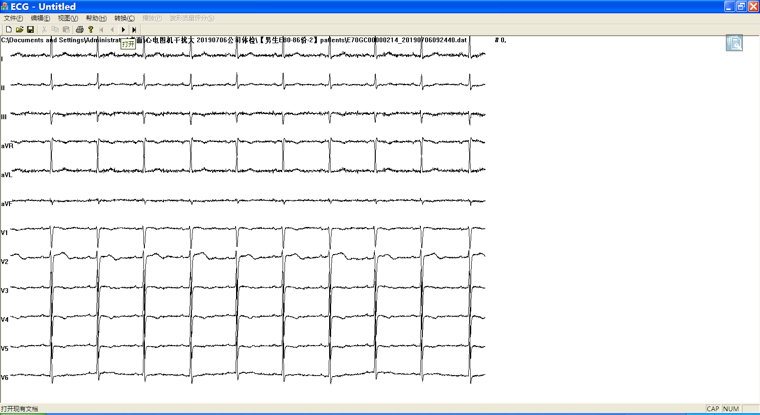

3、 The problem of ADS 1298 with high noise,corresponding files E70GC00000262_20190706100331.dat (BLT man)
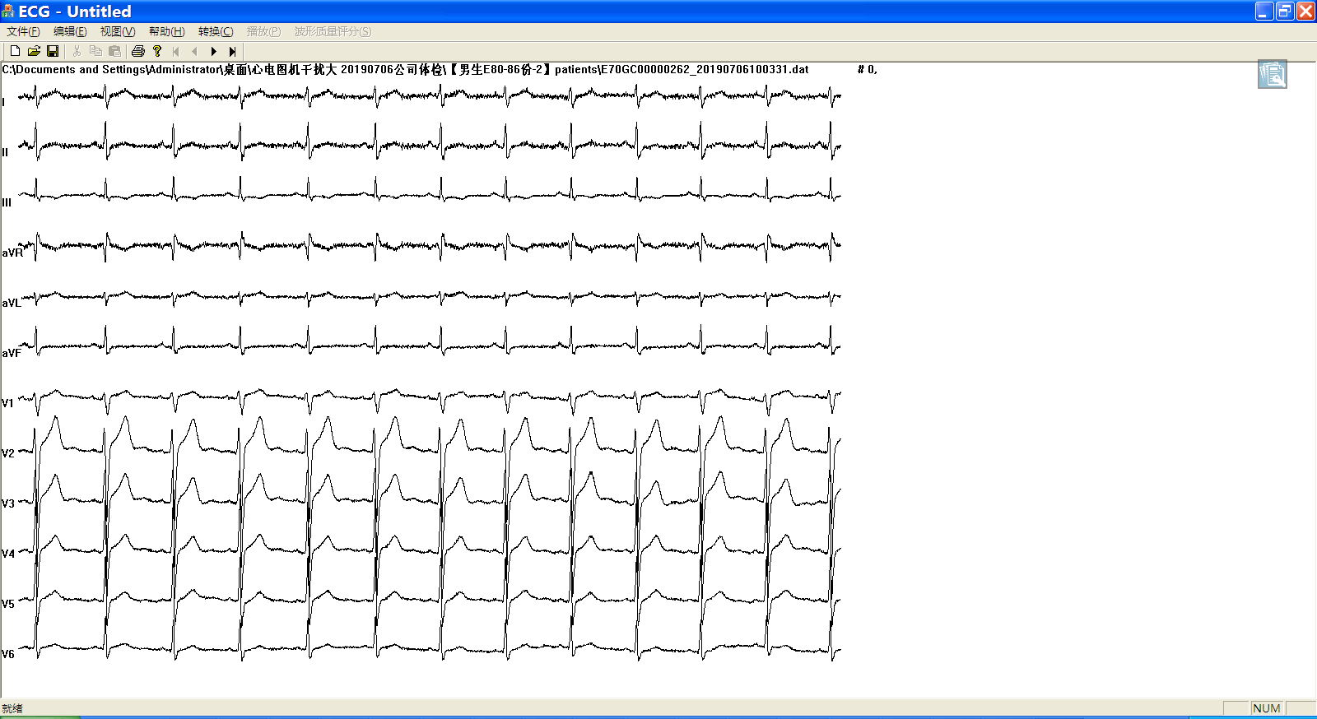

4、 The problem of ADS 1298 with high noise,corresponding files E70KF0000010_20190706095831.dat (BLT woman)
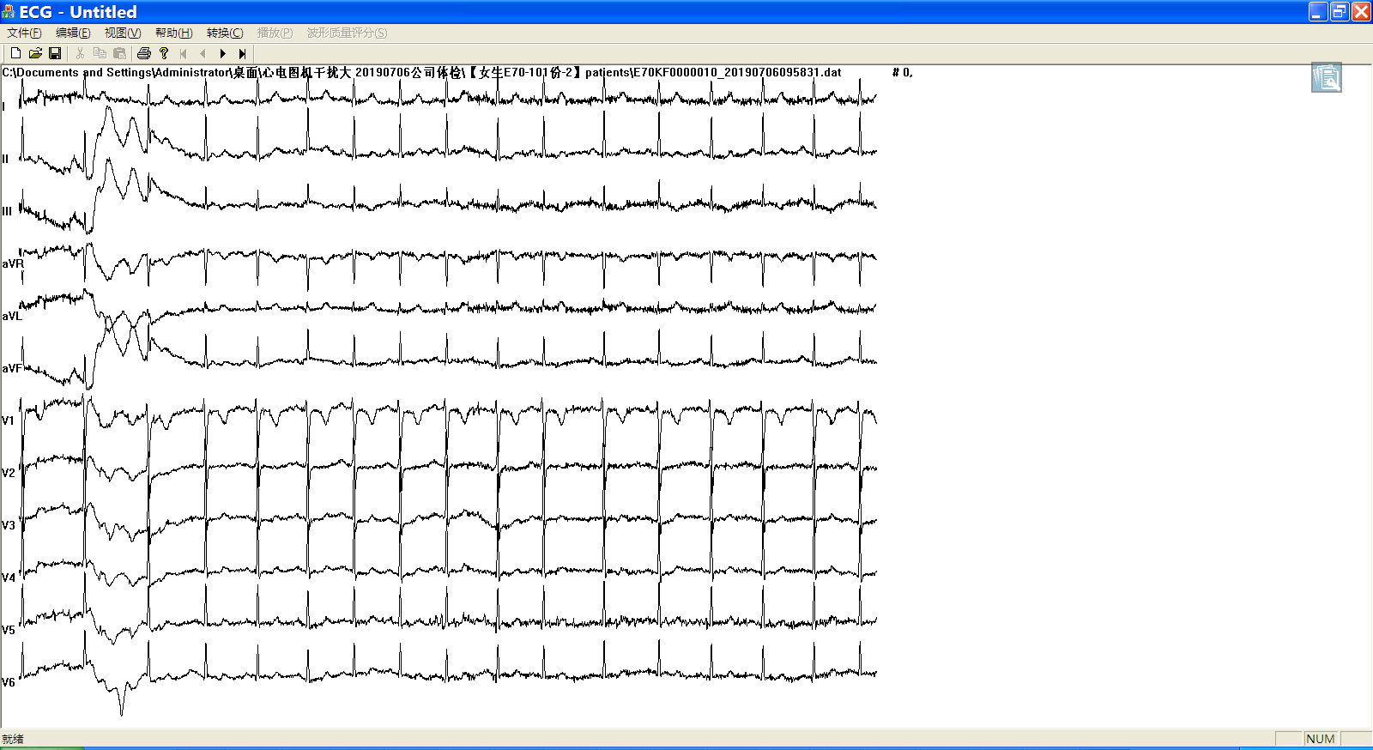

5、 The problem of ADS 1298 with high noise,corresponding files E70KF00000110_20190706102348.dat (BLT woman)
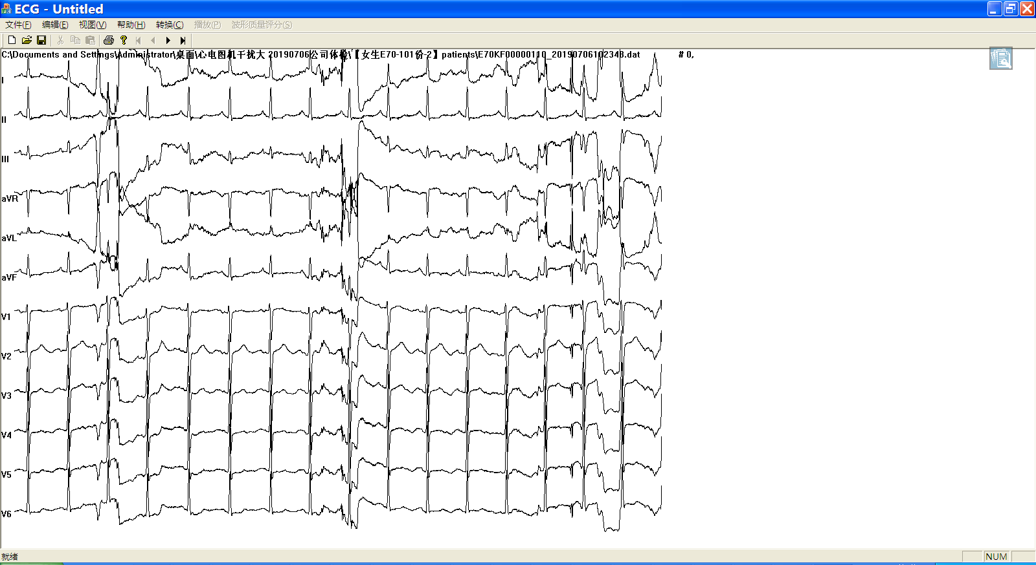

6、 The problem of ADS 1298 with high noise,corresponding files E70GC00000294_20190706105115.dat (BLT woman)
