ADS1298:

ECG waveforms with Normal Electrode input from Simulator.

(Software developed by us.)

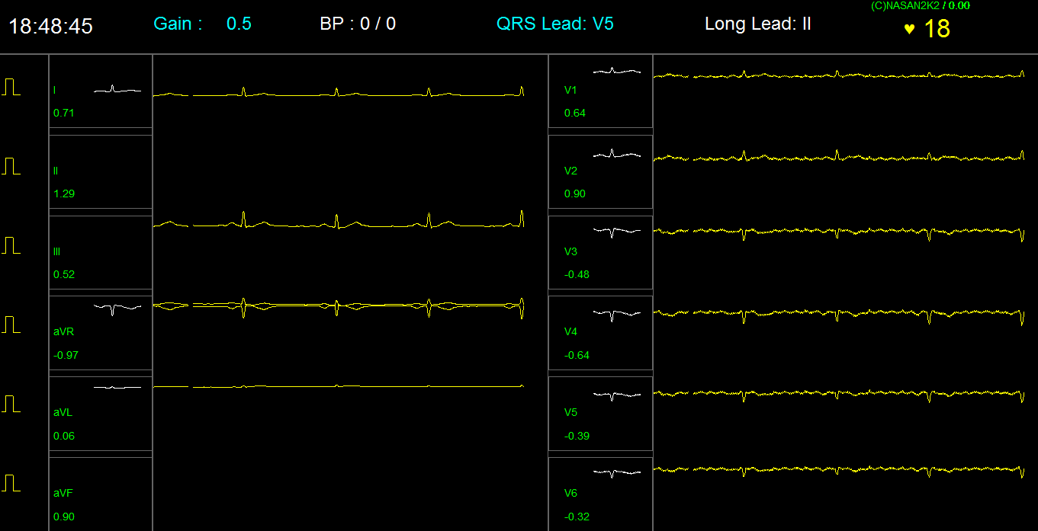

Waveforms with Test Input

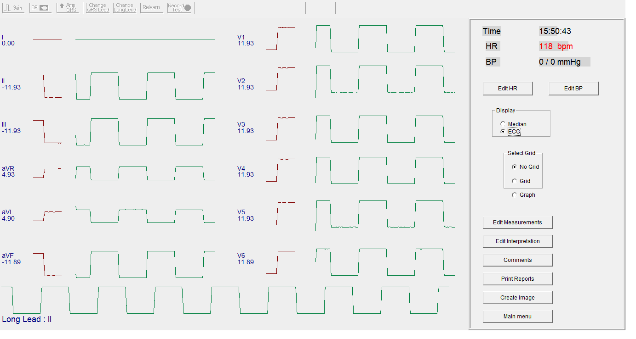

Schematic:

Input filter ckt for each channel is similar to as below:

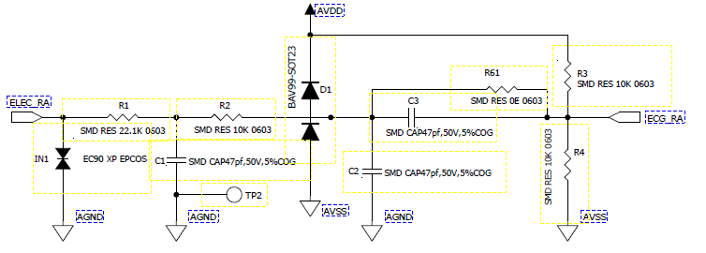

From Connector

