Customer can use equations given in the app-note to find Rcomp and Ccomp for his application.

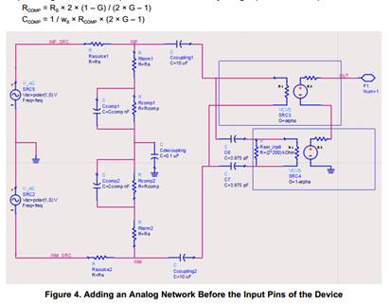

The external compensating Rcomp||Ccomp network is essentially a Low pass filter which flattens out overall response of buffer.

The filter corrects the response for low frequencies (down to DC) but the performance of input buffer is not as good for very low input frequencies (say less than 10kHz).

A note in the app-report says,” Note that at very-low input frequencies, the high-pass structure inside the analog buffer results in a  
degradation of linearity (for example, degraded harmonic or SFDR performance) as well. The compensating network only corrects the low-frequency response of the buffer and cannot correct the  
linearity degradation”