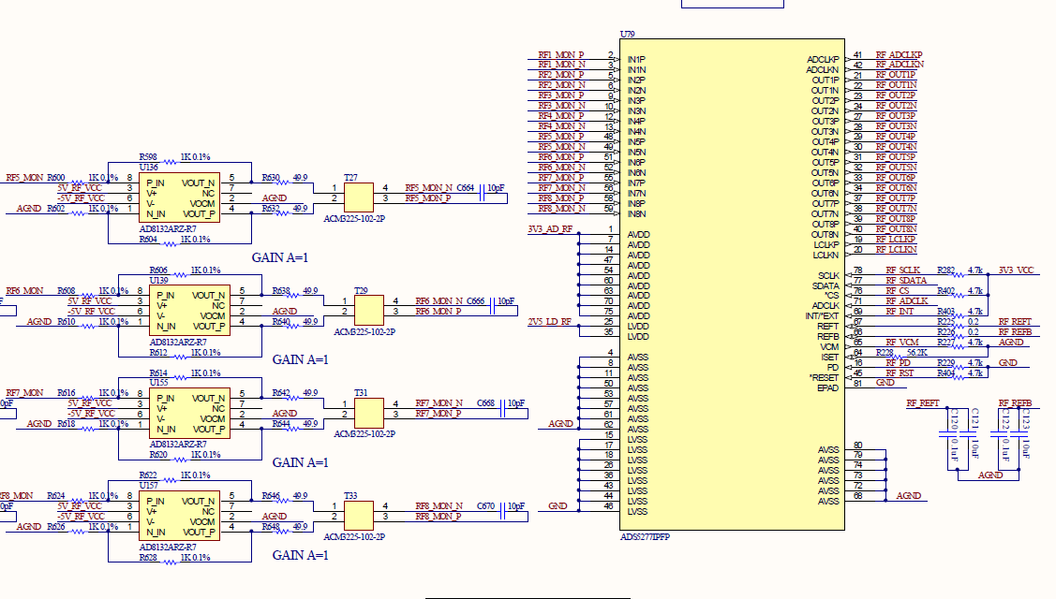

Fixes we made: remove R227 from ADS5277’s VCM pin and connect VCM pin to the VOCM pin of AD8132ARZ-R7 (and lift VOCM pin such that it doesn’t connect to the ground). This is to ensure the difference between VCM and VOCM is within 50mV as required by ADS5277. However the measurement of VOCM is about 0.25V before and after the modification even though the datasheet said that the VCM should be 1.45V.

