# ADS54J66 EVM Quick Startup Guide

## ADS54J66 GUI Installation Instructions

1. Go to the ADS54J66EVM product folder on the TI website and download the ADS54Jxx EVM GUI.
2. Unzip the file and run the file called *setup.exe* and follow the installation prompts.
3. Start the GUI by going to **Start Menu** → **All Programs** → **Texas Instruments ADCs** → **ADS54JXX GUI**.
4. When plugging the board into the computer for the first time through the USB cable, you are prompted to install the USB drivers.
   * Windows® XP: If Windows XP does not automatically install the drivers, follow the prompts on the screen to do so. Do not let Windows XP search Microsoft Update for the drivers, but do let Windows XP install the drivers automatically.
   * Windows 7: After installing the GUI, Windows 7 should automatically be able to install the drivers for the ADS54J66EVM with no input from the user.

## HSDC Pro GUI Installation Instructions

1. Install version v4.0 or newer of HSDC Pro GUI. This can be downloaded from the TI website under the TSW14J56EVM product folder.

## Software Operation

The following sections detail the operation of the ADS54JXX GUI.

### ADS54JXX Tab

The ADS54JXX controls can be found on the ADS54JXX tab. These controls can be used to access the register controls in the ADS54JXX. Figure 2 below shows the ADS54JXX tab.

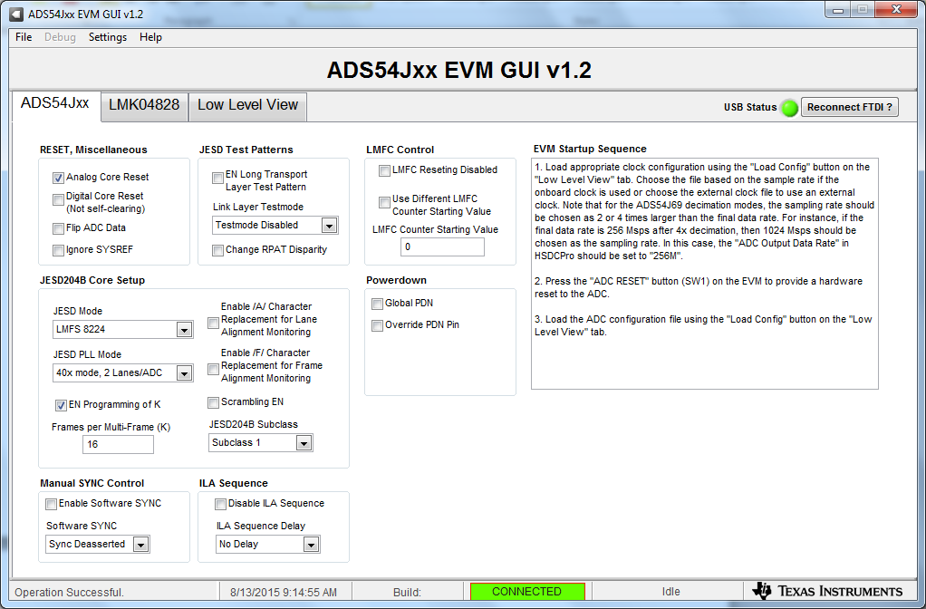

**Figure 2:** ADS54JXX Tab

# Typical Demo Setup

## 

## ADS54J66 Quick-Start Procedure

### TSW14J56 EVM

1. Connect a 5-V power supply to connector J11 (+5V IN)
2. Connect a USB cable to the USB connector (J9)
3. Flip the power switch (SW6) to the “ON” position

### ADS54J66 EVM

1. Connect a 5-V power supply to connector J14
2. Connect a USB cable to the USB connector (J13)
3. Connect a filtered 170-MHz signal source to AIN SMA connector (J1).

**Channel A Setup for Mode 0 Test**

### ADS54JXX GUI

1. Open the ADS54JXX GUI by going to *Start Menu 🡪 All Programs 🡪 Texas Instruments ADCs 🡪 ADS54JXX GUI*
2. Verify that the green *USB Status* indicator is lit. If it is not lit, click the *Reconnect USB* button and check the *USB Status* indicator again. If it is still not lit then verify the EVM is connected to the computer through USB.
3. Click on the “Low Level View” tab then click on “Load Config”. Navigate to C:\Program Files(86)\Texas Instruments\ADS54JXX GUI\Configuration Files and select the file called “*LMK_Config_LMF_4841_491p52_MSPS.cfg”*. This will provide a 491.52MHz sample clock to the ADC. Click on “OK”.

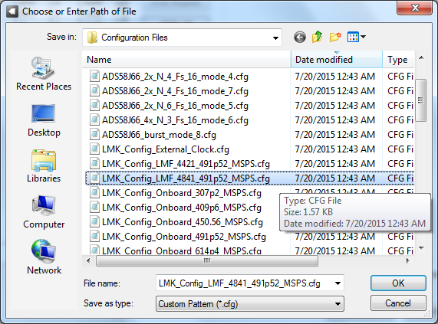

1. Verify that the LMK04828 PLL is locked by checking that the “PLL2 LOCKED” LED (D3) is lit. If the LED is not lit, please check the hardware setup and make sure that JP2 (XO PWR) has a jumper installed. Then try to reload the clock configuration file.
2. If an external 10MHz source is applied to SMA J12 (CLKIN), led D6 will illuminate indicating the 122.88MHz VCO is locked to this source. This input is not required. This is normally used to reference the VCO to the IF signal source by using the external reference output from the signal source if available.
3. The next step is to load the ADC configuration file. In the “Low Level View” tab, click “Load Config”. Load the file called “ADS5xJ6x_2x_Fs_4_mode_0*.cfg”*. The ADS54J66EVM is now configured for a fixed frequency Fs/4 complex digital mixer and decimate by 2 digital filter mode using 4 lanes.

### High Speed Data Converter Pro (HSDCPro)

1. Open High Speed Data Converter Pro v4.0 by going to *Start Menu* 🡪 *All Programs* 🡪 *Texas Instruments* 🡪 *High Speed Data Converter Pro*
2. Click “Ok” to connect to the TSW14J56.
3. Select the *ADC* tab at the top of the GUI.
4. Use the *Select ADC* drop down menu at the top left corner to select *ADS54J66_LMF_4841*.
5. When prompted to update the firmware for the ADC, click “Yes” and wait for the firmware to download to the TSW14J56.
6. Enter “245.76M” into the *ADC Output Data Rate* field at the bottom left corner.
7. Click the *Instrument Options* menu at the top of HSDC Pro and select “*Reset Board”*.
8. Click “Capture” in HSDC Pro to capture data from the ADC.
9. Channel 1 should look as shown below:

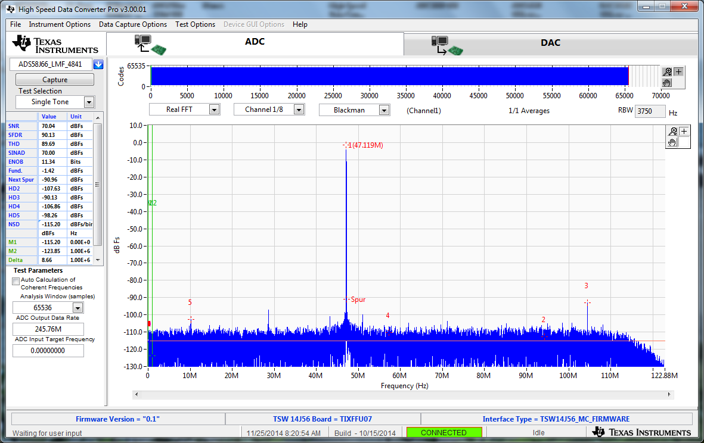

Channel A Data Capture Results, Mode 0, 170MHz IF

Channel A I data will be captured on Channel 1/8. Channel A Q data will be captured on Channel 2/8. Channel B I data will be captured on Channel 3/8 and so on. The user can display the results as complex data by changing the default setting of “Real FFT” to “Complex FFT” as shown below.

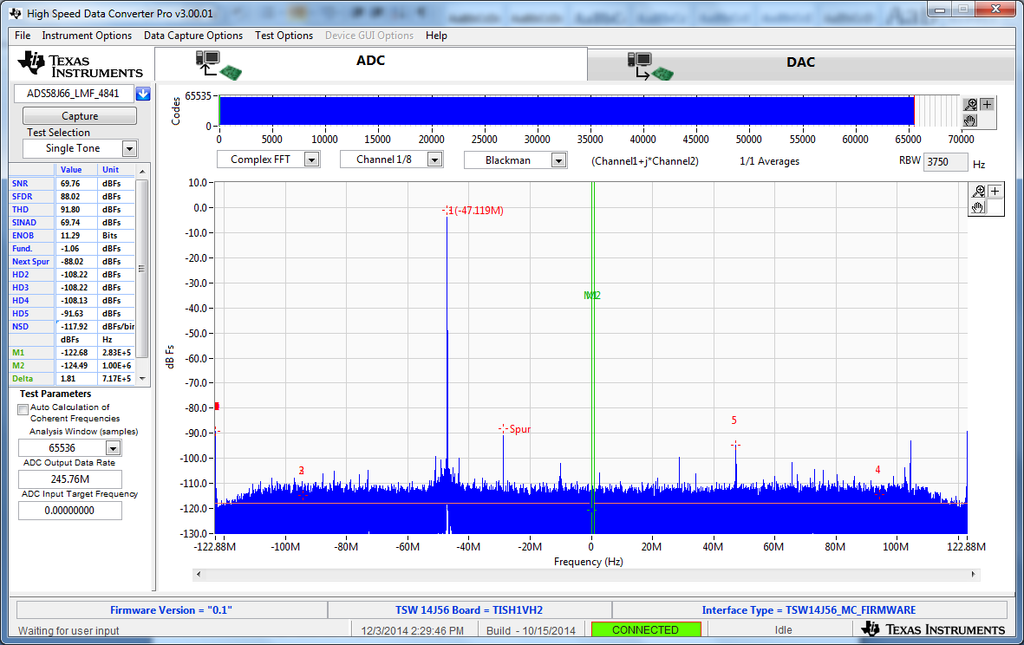

Channel A Data Capture Results, Complex FFT, Mode 0, 170MHz IF

(Fs/4-IF)

**Setup for Mode 2 High Pass Filter (HPF) Test**

1. Program the LMK. On the ADS54JXX GUI, in the “Low Level View” tab, click “Load Config”. Load the file called “LMK_Config_LMF_4421_491p52_MSPS. *Cfg*
2. The next step is to load the ADC configuration file. In the “Low Level View” tab, click “Load Config”. Load the file called “ADS5xJ6x_2x_HPF_mode_2*.cfg”*. The ADS54J66EVM is now configured for real outputs using a high pass decimate by 2 digital filter mode and using only 4 lanes.
3. On the HSDC Pro GUI, s*elect ADC* drop down menu at the top left corner to select *ADS54J66_LMF_4421*.
4. Enter “245.76M” into the *ADC Output Data Rate* field at the bottom left corner.
5. Click the *Instrument Options* menu at the top of HSDC Pro and select “*Reset Board”*.
6. Click on “Capture”. The output should look as shown below:

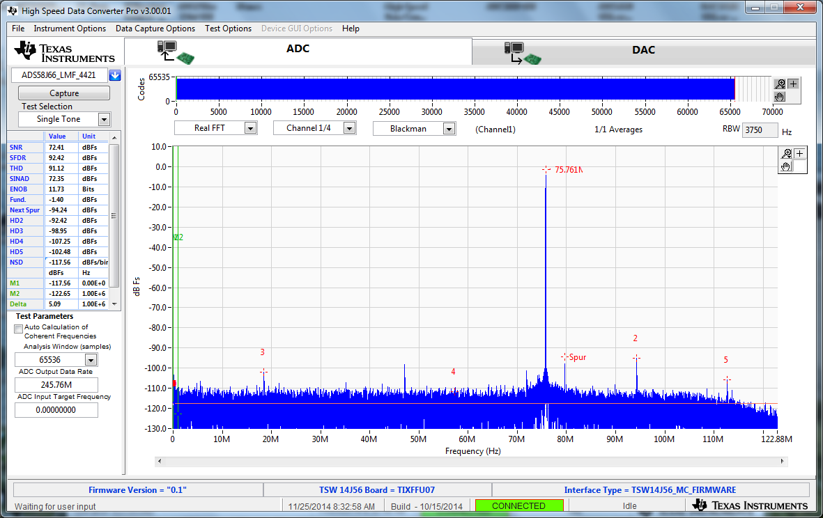

**Mode 2 HPF Channel A Data Capture Results**

**Setup for Mode 2 low Pass Filter (LPF) Test**

1. Program the LMK. On the ADS54JXX GUI, in the “Low Level View” tab, click “Load Config”. Load the file called “LMK_Config_LMF_4421_491p52_MSPS. *Cfg*
2. The next step is to load the ADC configuration file. In the “Low Level View” tab, click “Load Config”. Load the file called “ADS5xJ6x_2x_LPF_mode_2*.cfg”*. The ADS54J66EVM is now configured for real outputs using a low pass decimate by 2 digital filter mode and using only 4 lanes.
3. On the HSDC Pro GUI, s*elect ADC* drop down menu at the top left corner to select *ADS54J66_LMF_4421*.
4. Enter “245.76M” into the *ADC Output Data Rate* field at the bottom left corner.
5. Click the *Instrument Options* menu at the top of HSDC Pro and select “*Reset Board”*.
6. Click on “Capture”. The output should look as shown below:

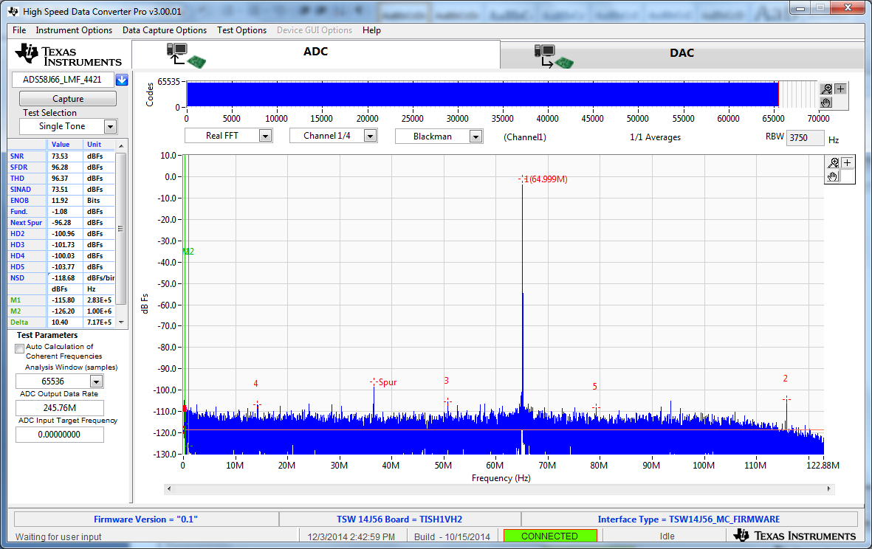

**Mode 2 LPF Channel A Data Capture Results**

**Setup for Mode 4 Test**

1. Program the LMK. On the ADS54JXX GUI, in the “Low Level View” tab, click “Load Config”. Load the file called “LMK_Config_LMF_4421_491p52_MSPS. *Cfg*
2. The next step is to load the ADC configuration file. In the “Low Level View” tab, click “Load Config”. Load the file called “ADS5xJ6x_2x_N_4_Fs_16_mode_4*.cfg”*. The ADS54J66EVM is now configured for real outputs using a 2 low pass decimate by 2 digital filter mode and using only 4 lanes.
3. On the HSDC Pro GUI, s*elect ADC* drop down menu at the top left corner to select *ADS54J66_LMF_4421*.
4. Enter “245.76M” into the *ADC Output Data Rate* field at the bottom left corner.
5. Click the *Instrument Options* menu at the top of HSDC Pro and select “*Reset Board”*.
6. Click on “Capture”. The output should look as shown below:

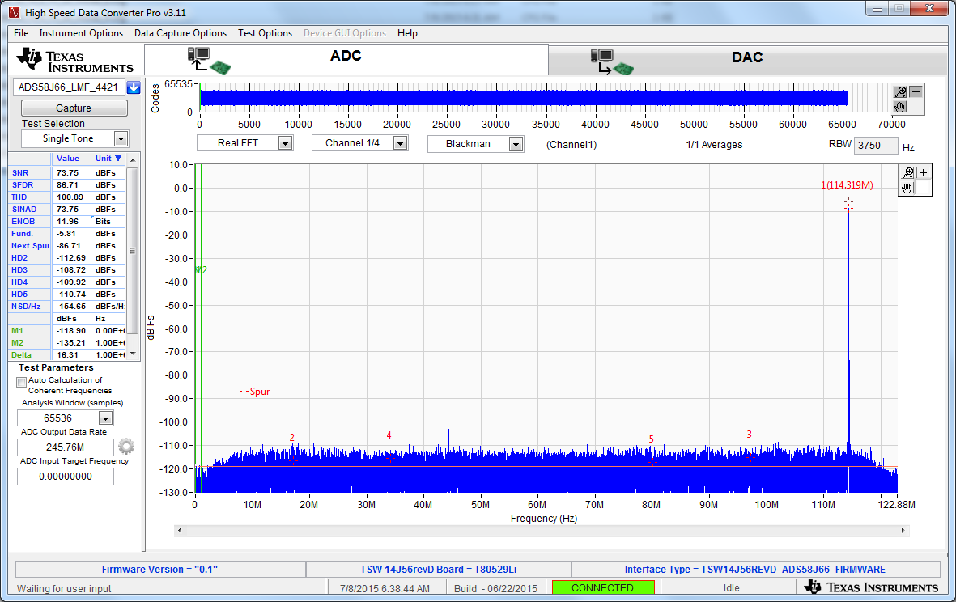

**Mode 4 Capture with 70MHz IF**

**(NFs/16 – IF + Fs/8 = 122.88 – 70 + 61.44 = 114.32 )**

**Setup for Mode 5 Test**

1. Program the LMK. On the ADS54JXX GUI, in the “Low Level View” tab, click “Load Config”. Load the file called“*LMK_Config_LMF_4841_491p52_MSPS.cfg”*.
2. The next step is to load the ADC configuration file. In the “Low Level View” tab, click “Load Config”. Load the file called “ADS5xJ6x_2x_N_6_Fs_16_mode_5*.cfg”*. The ADS54J66EVM is now configured for real outputs using a decimate by 4 digital filter mode and using 4 lanes.
3. On the HSDC Pro GUI, s*elect ADC* drop down menu at the top left corner to select *ADS54J66_LMF_4841*.
4. Enter “245.76M” into the *ADC Output Data Rate* field at the bottom left corner.
5. Click the *Instrument Options* menu at the top of HSDC Pro and select “*Reset Board”*.
6. Click on “Capture”. The output should look as shown below:

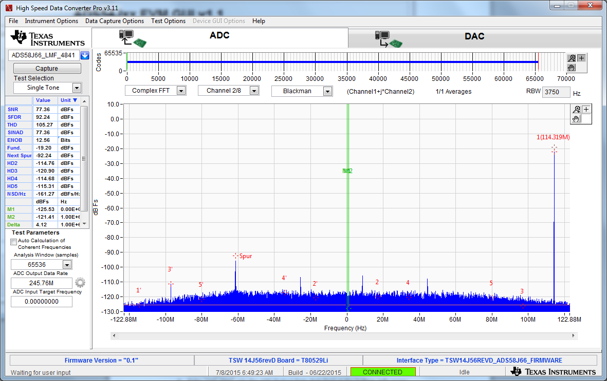

**Mode 5 Complex Capture with 70MHz IF**

**(NFs/16 – IF = 6 * 491.52 – 70 = 114.32 )**

**Setup for Mode 6 Test**

1. Program the LMK. On the ADS54Jxx GUI, in the “Low Level View” tab, click “Load Config”. Load the file called “LMK_Config_LMF_4421_491p52_MSPS. *cfg”.*
2. The next step is to load the ADC configuration file. In the “Low Level View” tab, click “Load Config”. Load the file called “ADS5xJ6x_4x_N_3_Fs_16_mode_6*.cfg”*. The ADS54J66EVM is now configured for real outputs using a decimate by 4 digital filter mode and using 4 lanes.
3. On the HSDC Pro GUI, s*elect ADC* drop down menu at the top left corner to select *ADS54J66_LMF_4841*.
4. Enter “122.88M” into the *ADC Output Data Rate* field at the bottom left corner.
5. Click the *Instrument Options* menu at the top of HSDC Pro and select “*Reset Board”*.
6. Click on “Capture”. The output should look as shown below:

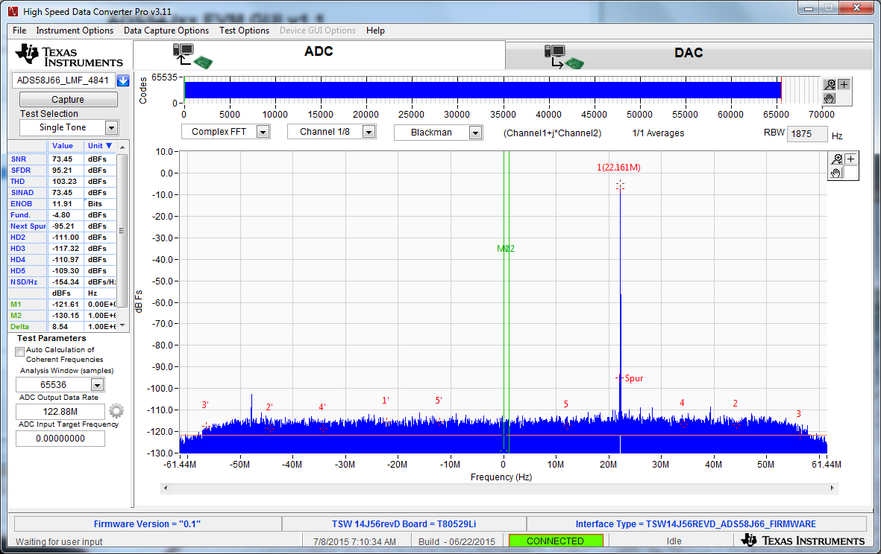

**Mode 6 Complex Capture with 70MHz IF**

**(NFs/16 – IF = 3 * 491.52/16 – 70 = 22.16 )**

**Setup for Mode 7 Test**

1. Program the LMK. On the ADS54JXX GUI, in the “Low Level View” tab, click “Load Config”. Load the file called “LMK_Config_LMF_4841_491p52_MSPS. *Cfg*
2. The next step is to load the ADC configuration file. In the “Low Level View” tab, click “Load Config”. Load the file called “ADS5xJ6x_2x_N_4_Fs_16_mode_7*.cfg”*. The ADS54J66EVM is now configured for real outputs using a decimate by 2 digital filter mode and using 4 lanes.
3. On the HSDC Pro GUI, s*elect ADC* drop down menu at the top left corner to select *ADS54J66_LMF_4421_mode7*.
4. Enter “245.76M” into the *ADC Output Data Rate* field at the bottom left corner.
5. Click the *Instrument Options* menu at the top of HSDC Pro and select “*Reset Board”*.
6. Click on “Capture”. The output should look as shown below. Data is not valid on channels 5-8.

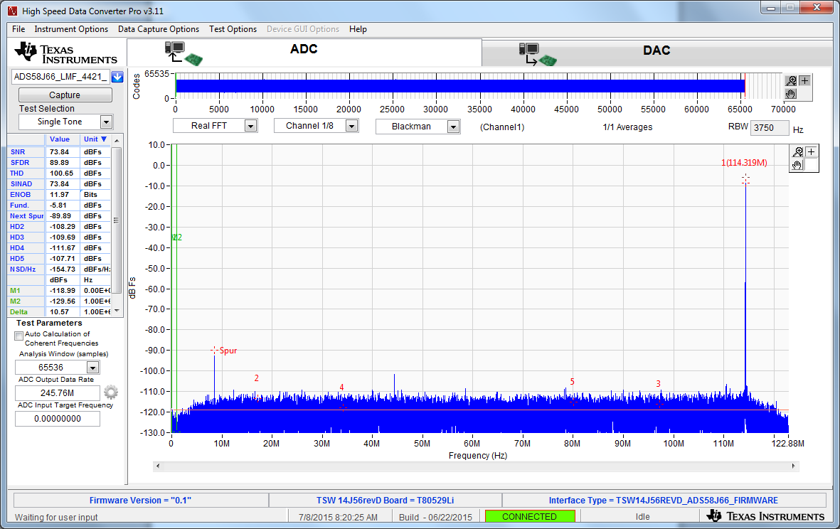

**Mode 7 Real Capture with 70MHz IF**

**(NFs/16 – IF = 4 * 491.52/16 – 70 = 114.319 )**

**Setup for Bypass Test**

1. Program the LMK. On the ADS54JXX GUI, in the “Low Level View” tab, click “Load Config”. Load the file called “LMK_Config_LMF_4841_491p52_MSPS. *Cfg*
2. The next step is to load the ADC configuration file. In the “Low Level View” tab, click “Load Config”. Load the file called “ADS54J66_bypass_4421*.cfg”*. The ADS54J66EVM is now configured for bypass mode and using 4 lanes.
3. On the HSDC Pro GUI, s*elect ADC* drop down menu at the top left corner to select *ADS54J66_LMF_4421*.
4. Enter “491.52M” into the *ADC Output Data Rate* field at the bottom left corner.
5. Click the *Instrument Options* menu at the top of HSDC Pro and select “*Reset Board”*.
6. Click on “Capture”. The output should look as shown below.

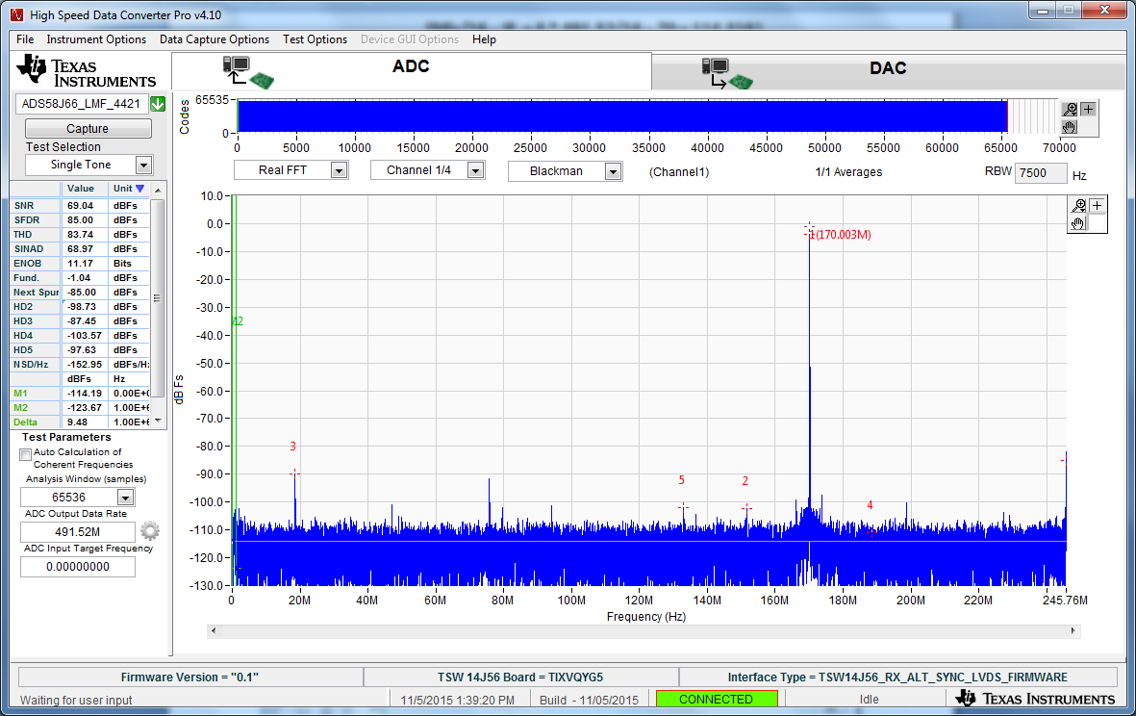

**Bypass Mode Real Capture with 170MHz IF**