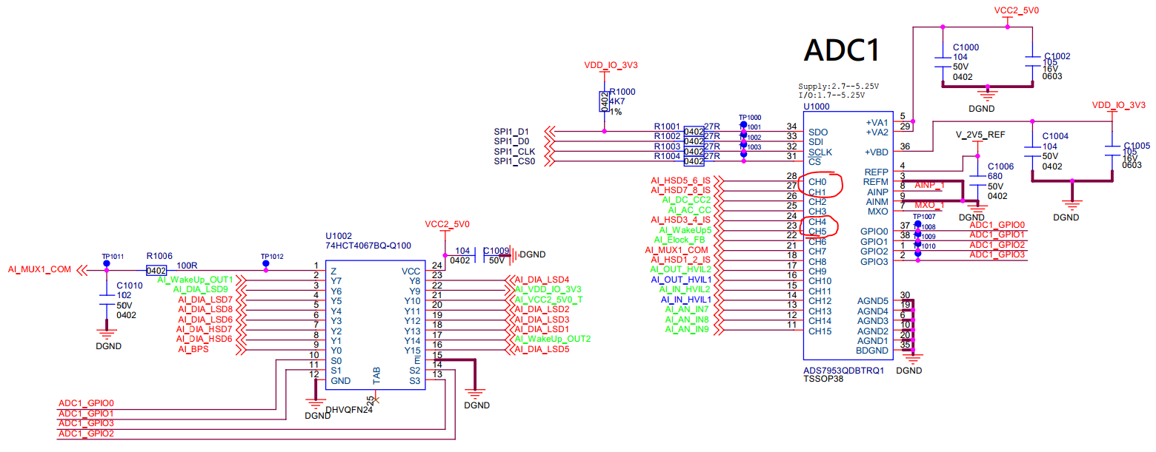
原理图中CH0/CH1/CH4/CH5外部均为0V输入（有下拉电阻）
CH0/1/4/5 all with 0V input(has pull down resistor)

Case1：原程序。CH0/CH1/CH4/CH5波形如下
Original SW, CH0/CH1/CH4/CH5 waveform
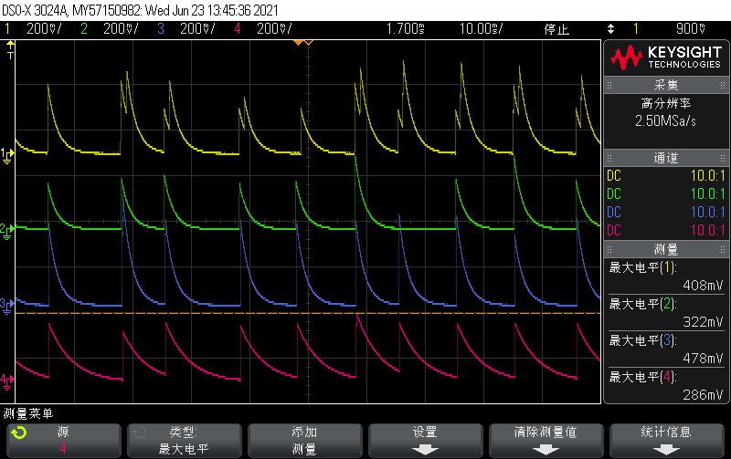
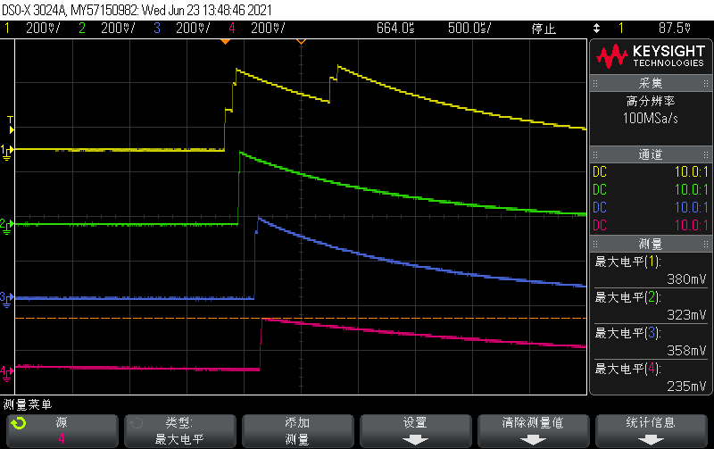

Case2：断开选通器输出端电阻R1006，波形和case1一样，没有变化。
Disconnect the R1006 and the waveform remain the same

Case3：修改程序只采CH0通道。示波器测试CH1/CH4/CH5稳定为0，CH0仍跳变，波形如下。
Change the SW to only sample the CH0 channel, and test CH1/4/5 stable 0. However the CH0 still change as below
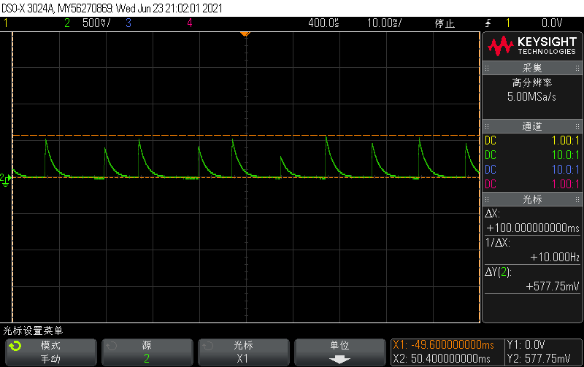

Case4：修改程序只采CH0通道，且屏蔽GPIO控制。CH1/CH4/CH5稳定为0，CH0变成如下波形。
Change the SW to only sample the CH0 channel and don’t control the GPIO, and test CH1/4/5 stable 0. However the CH0 still change waveoform as below
