**AFE4432 test problem**

1. **problem ：**

It’s a test board with the chip AFE432, base on the principle of AFE432EVM. Now there was a problem in the test. After collecting the strong light signal, when the light was turned off and restored, the signal level could not return to the beginning, but was higher than the beginning signal level.

1. Software tool**：**

Software tool: Bio-Sensing_Installer_V6.0.0

2.1

1. Connect the test boars show as below, press the button to Capture data；

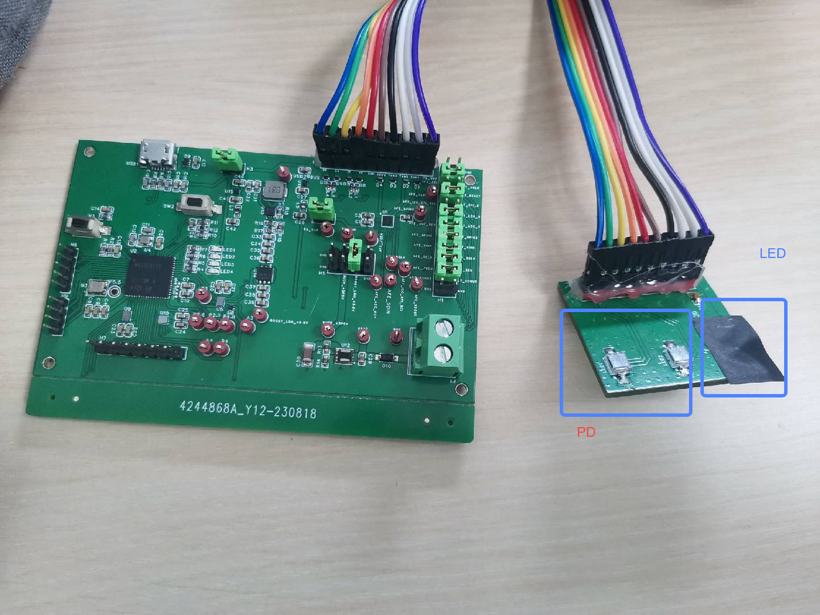

1. Record the baseline position I0 of the ambient light；
2. Turn on the mobile phone flashlight, irradiate 2s, and turn off the mobile phone flashlight;
3. Record the baseline position I2 of the ambient light
4. Different irradiation times of 4s, 8s, and random irradiation, repeated the third and fourth steps, record as I4, I8, Irand

2.2 the Captured data

I0：

Baseline fluctuation

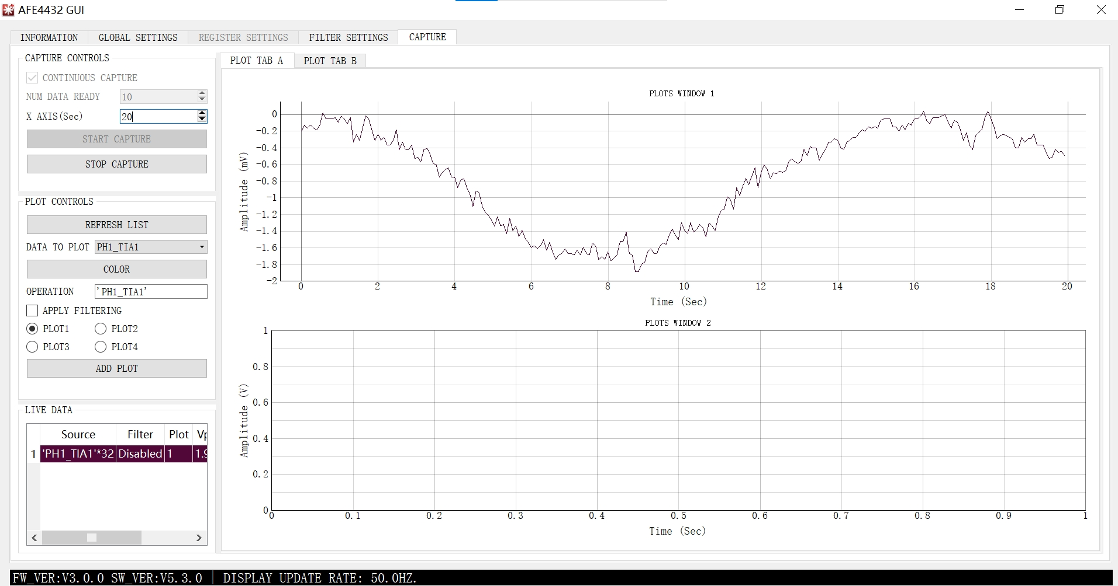

I2：before turn on the light, the baseline is around -4.5v, when turn off the light after 2s irradiation, the baseline is stable around -3.2v

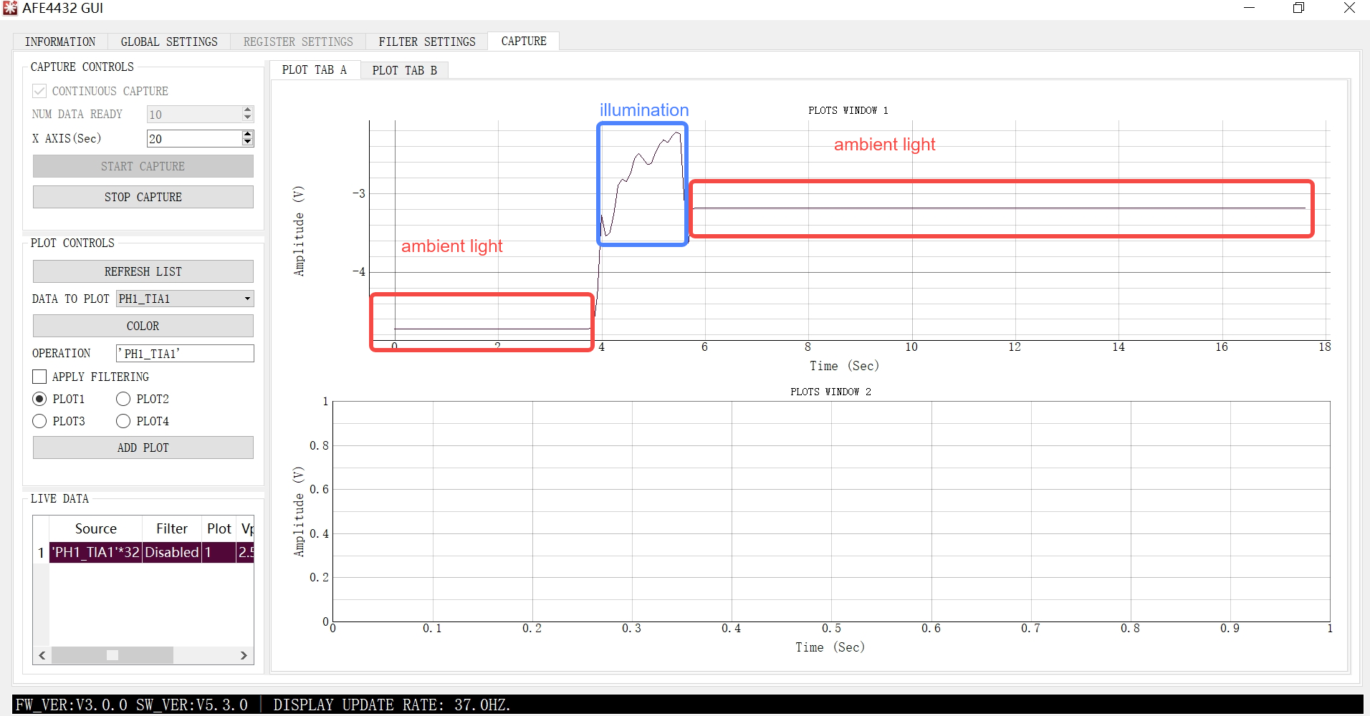

I4：

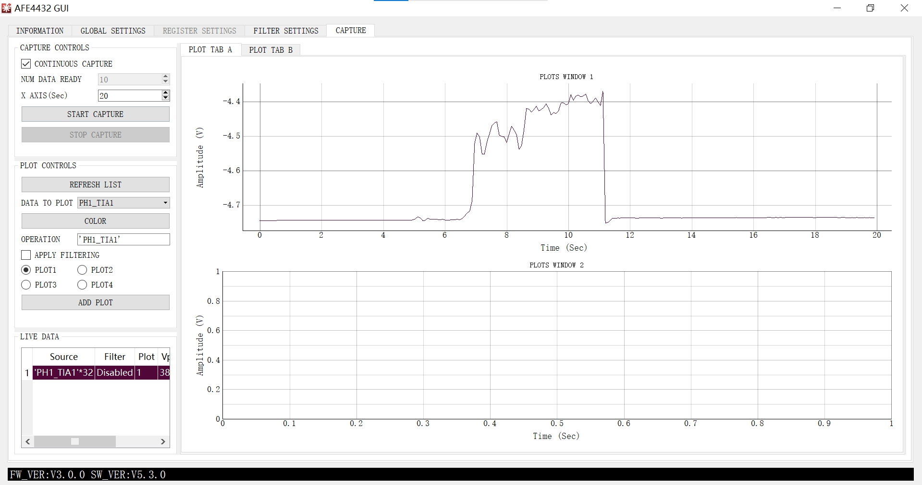

I8：

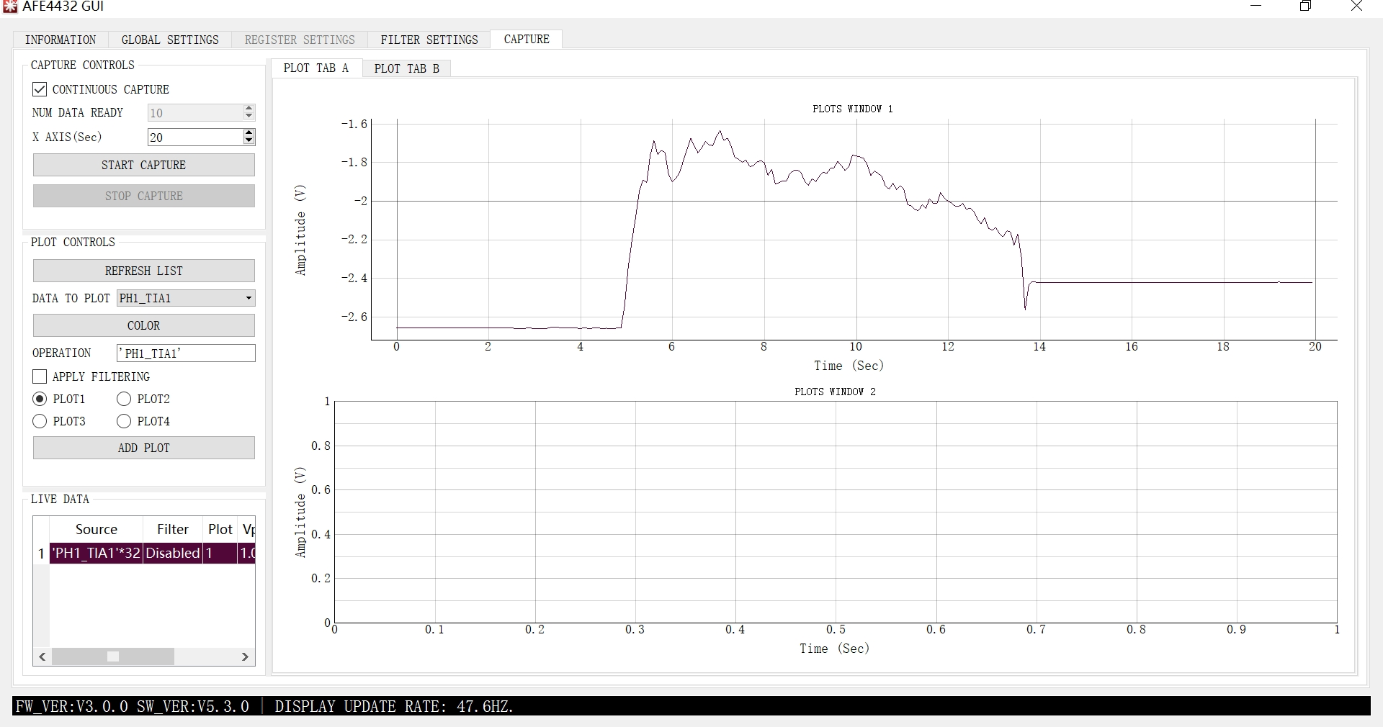

Irand

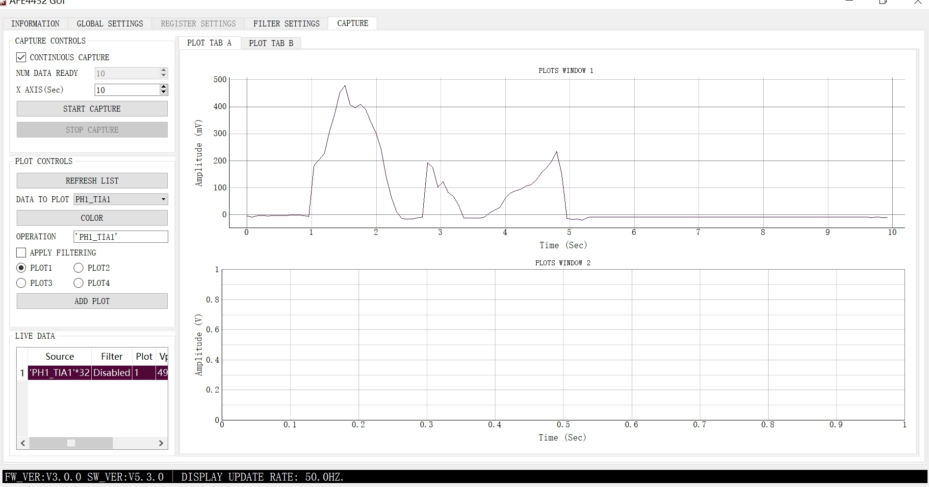

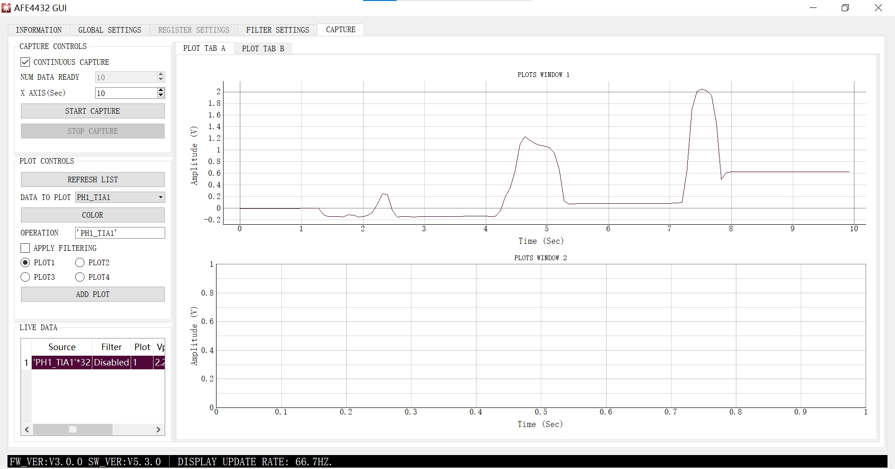

One word, after the light, there will be an increase compared to before the light, sometimes basically flat, sometimes lower, the baseline level is very unstable,why?

3. **Software configuration description：**

All operations are based on AFE4432EVM_UG_sbau404.pdf guidance;

4. **Hardware principle and material:**

PD: EVERLIGHT PD70-01C/TR7

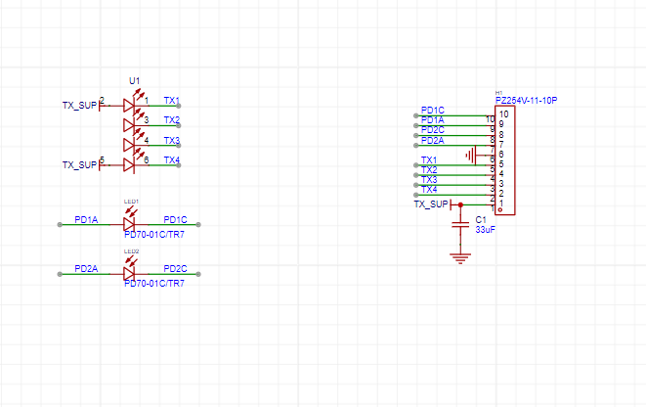

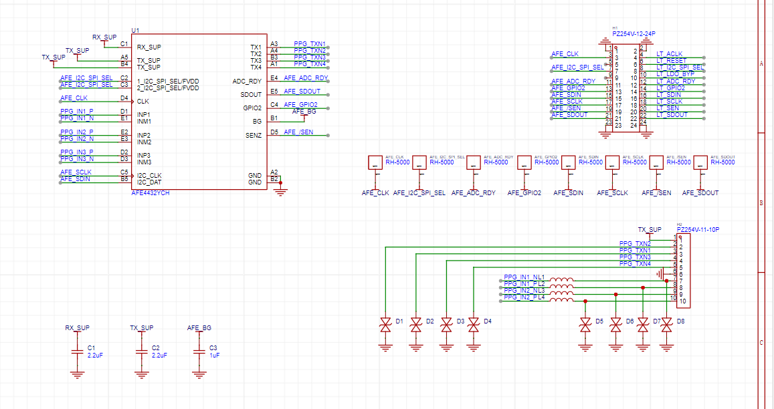

5. **LED is customized material (but the light is weak and has been covered, tested by external mobile phone light)**

6. **others**

