Ppg:
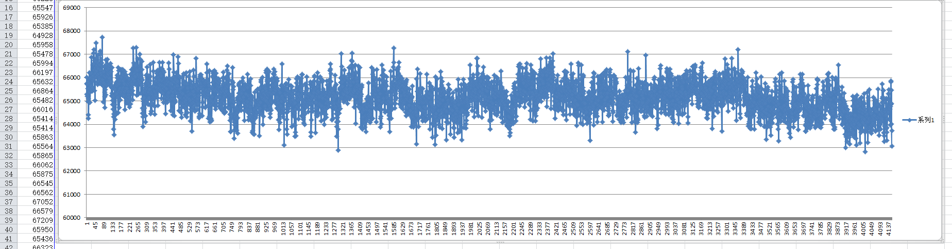
It doesn’t change even when i cover the LED with my fingers;
ECG:It was shown as follows before touching the electrodes:
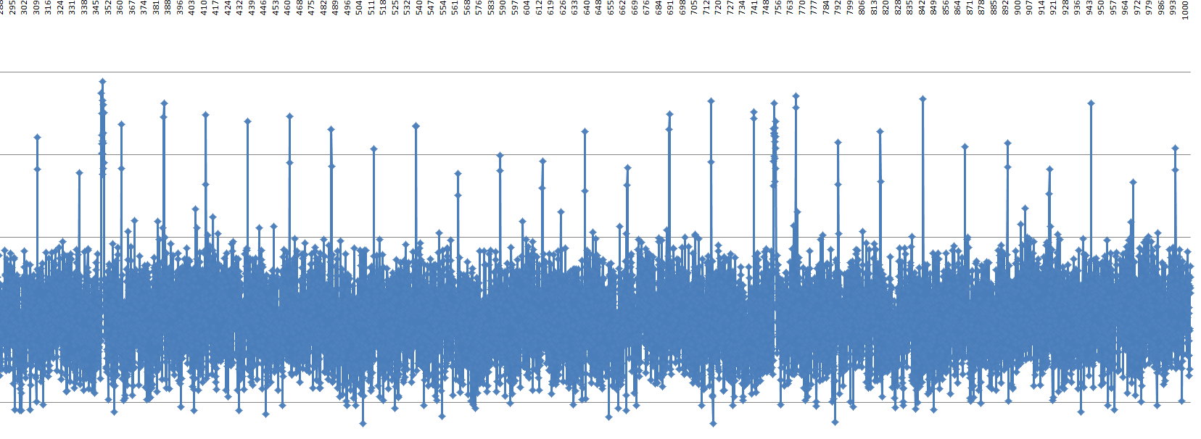
When i touch the electrodes:
