//Register 0X01

//BIT 14 LVDS_RATE_2X 0 = 1X rate 1 = 2X rate

//BIT 5 DIS_LVDS 0 = LVDS interface is enabled 1 = LVDS interface is disabled

//BIT 14 GLOBAL_PDN 0 = The ADC die operates in normal mode 1 = The ADC die enters complete power-down mode

AFE5832_CFG(0x01, 0x0000);

//Register 0X03

//BIT 15-13 SER_DATA_RATE 011 = 10X

//BIT 12 DIG_GAIN_EN 1 = Digital gain enabled

//Bit 4 1,must

//0111 0000 0001 0000

AFE5832_CFG(0x03, 0x7010);

//Register 0X04

//BIT 8 PAT_SELECT_IND 0 = All LVDS output data lines have the same pattern

//BIT 4 MSB_FIRST 1 = The MSB is transmitted first on serialized output data

//Bit 3 DATA_FORMAT 0 = Twos complement format for output data

//Bit 1-0 ADC_RES 11 = 10-bit resolution

//0000 0000 0001 0011

AFE5832_CFG(0x04, 0x0013);

**In DESKEW mode, the register 0x02 = 0x2100, in fpga system, the data 0101010101 captured by ILA capture is right.**

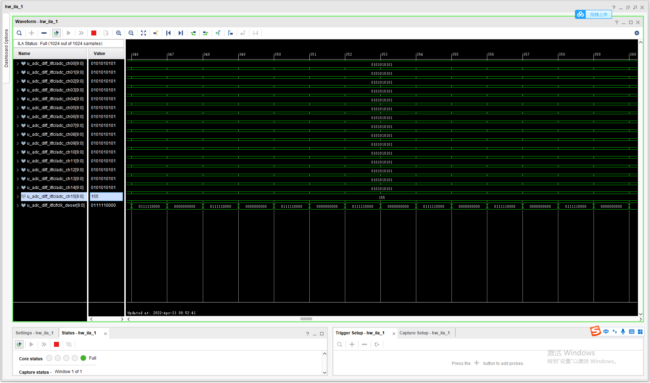

**In sync mode, the register 0x02 = 0x2080, in fpga system, the data 1111100000 captured by ILA capture is right.**

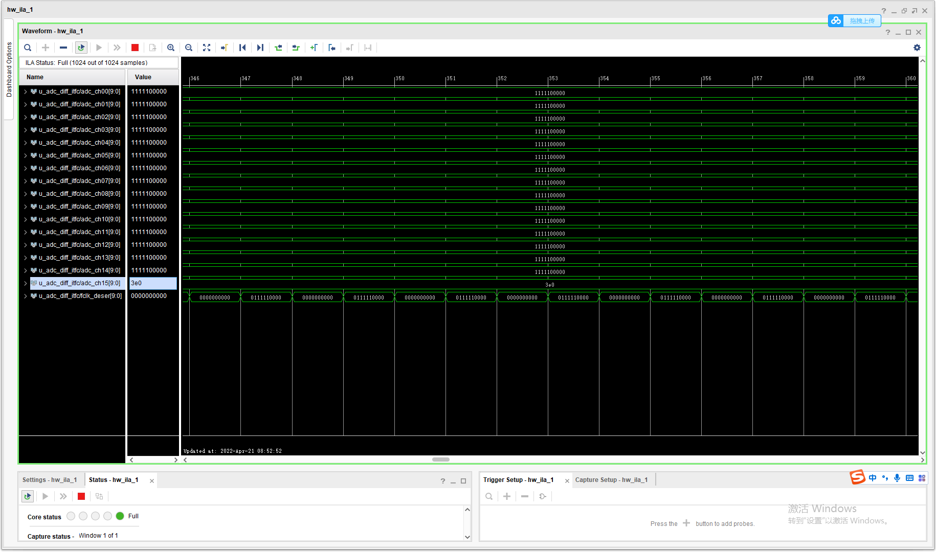

**In All 1s mode, the register 0x02 = 0x2200, in fpga system, the data 1111111111 captured by ILA capture is right.**

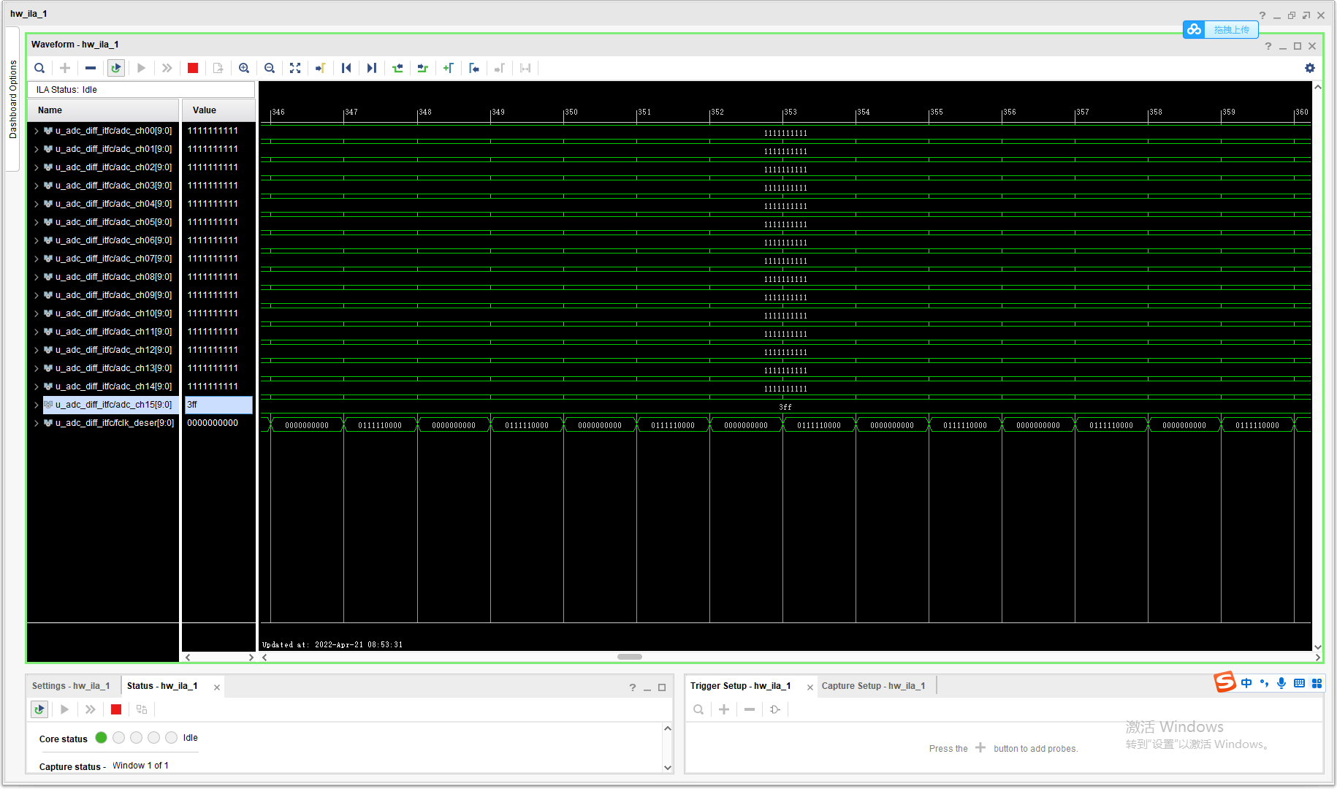

**In RAMP mode, the register 0x02 = 0x2380, in fpga system, the data captured by ILA capture is error.**

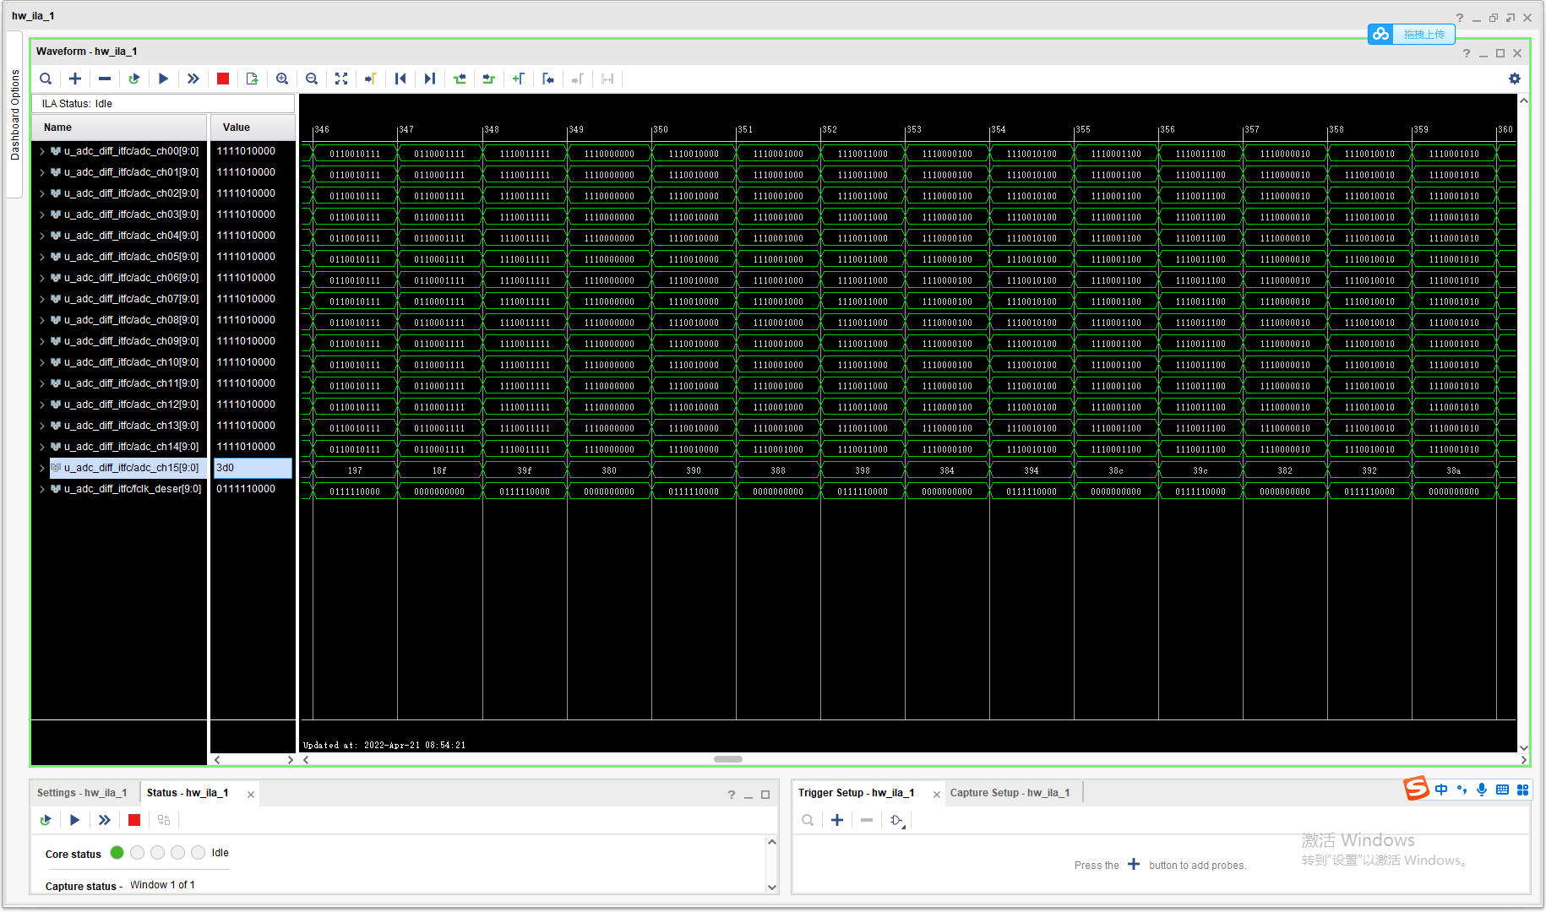

**In RAMP mode, the register 0x02 = 0x23C0, in fpga system, the data captured by ILA capture is error too.**

