System Clock : 32MHz from Tool

Voltage: 5V

Filter Structure: Sync1

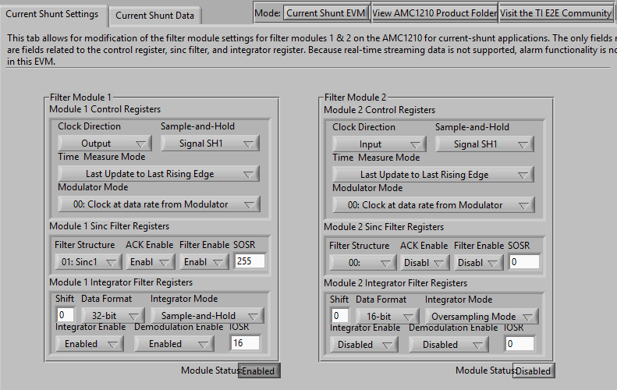 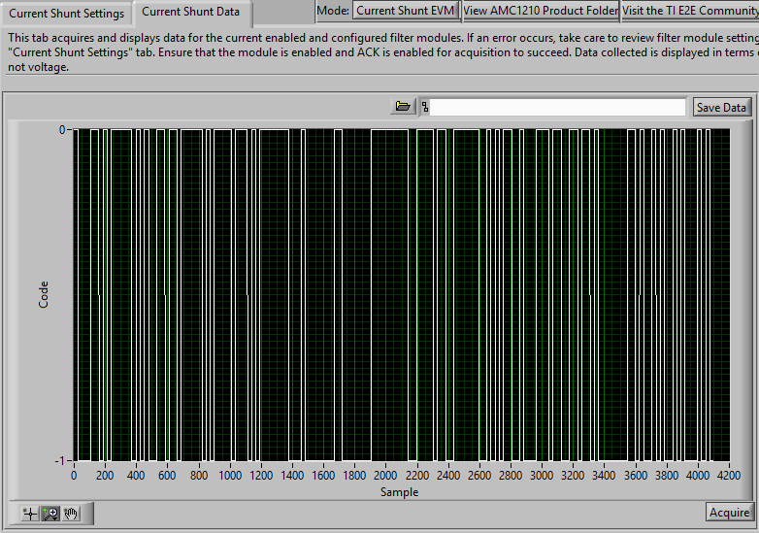

Filter Structure: Sync2

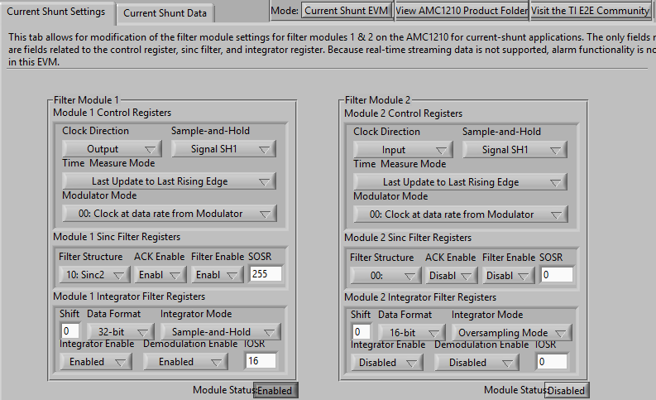 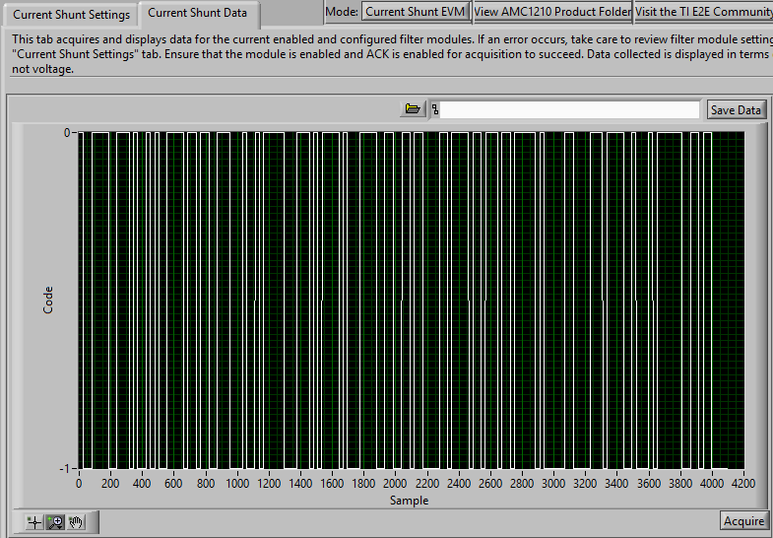

Filter Structure: Sync3

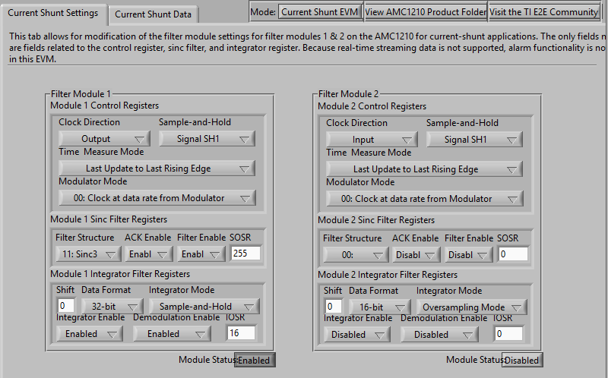 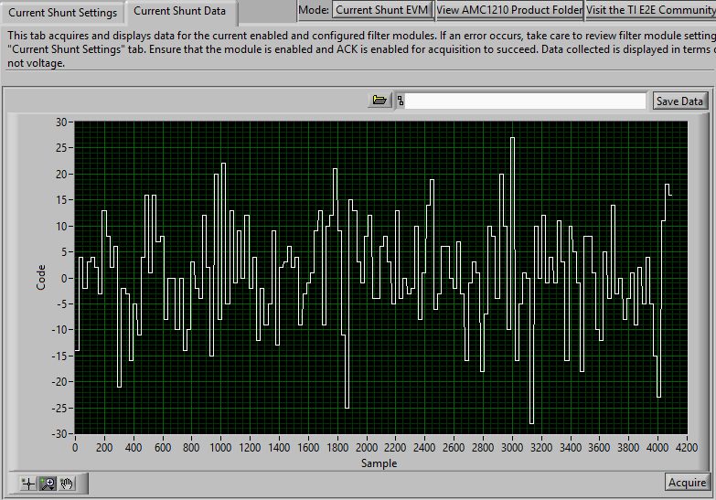

The above are the responses when the input is 0V. So I can expect around 2.5V output at this condition. My application is with DC voltage, the input will go max of 250mV max.

From the above data from Tool, how to identify whether the data is correct or not? Is there any way to find out it? The behavior is completely different with Sync3 filter. And also please let me know the selected setting are correct or not? Hope it will work for all the ranges.

When I select 16bit data format, the behavior completely different and looks like noisy. please see below

16bit data format Settings:

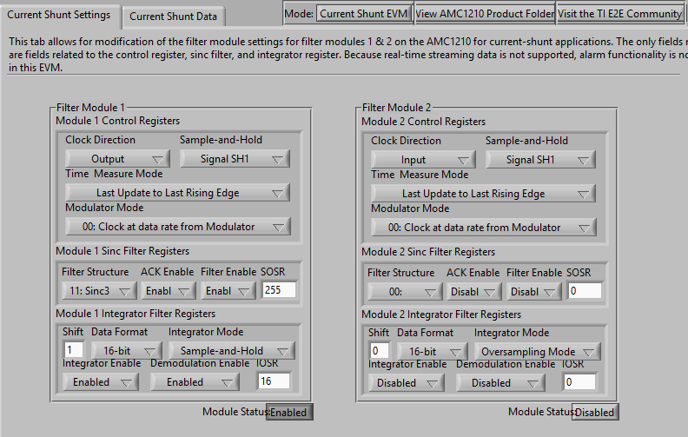 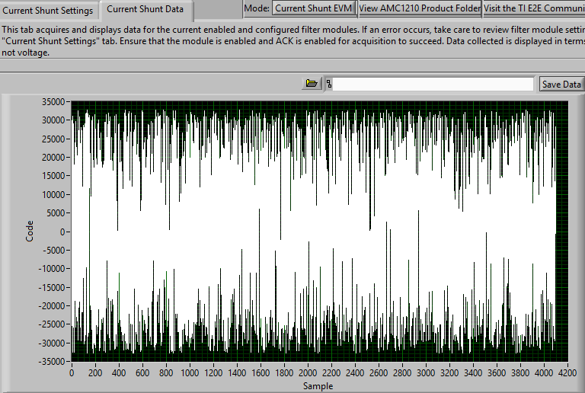

Please let me know how to identify I am getting correct data or not?