Modulator Clock : 10MHz

Clock direction: Input

Voltage: 5V

Filter Structure: Sync3

**Input Applied 250mV (32bit format representation)**

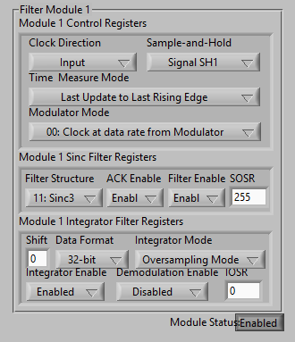

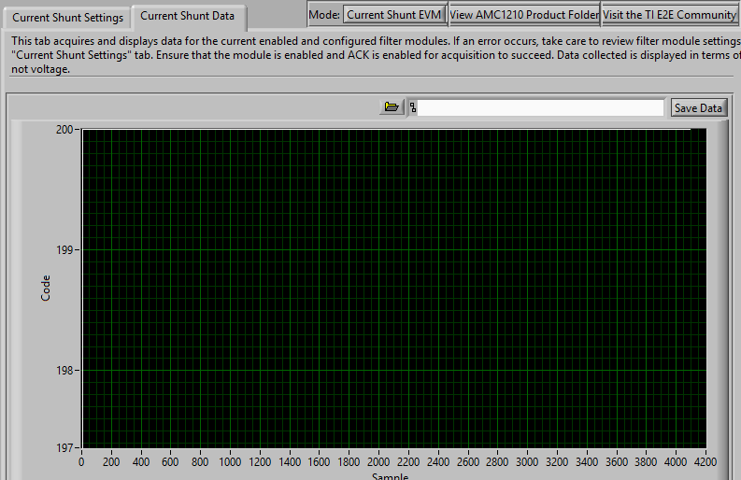

I can see the Code value of 200 when selected 32bit format with Sinc3 Filter config.

**Input Applied 250mV (16bit format representation)**

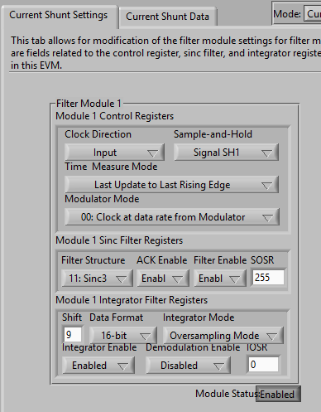

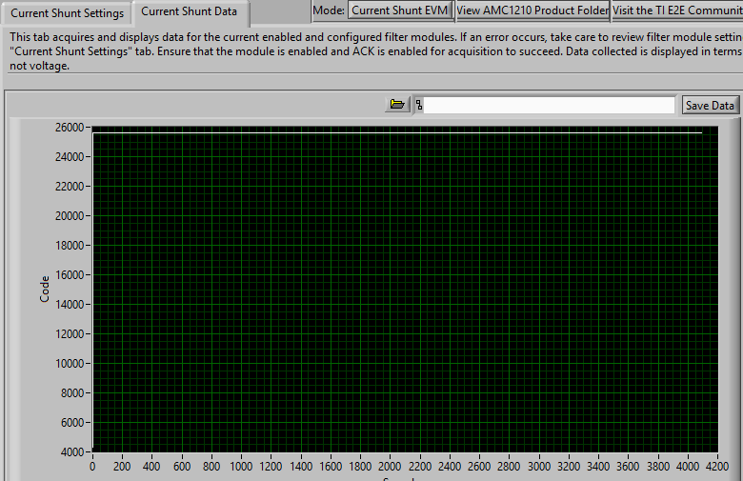

The Code value is approx.. 25500.

**Can you please let me know the difference between these two formats representation?** If we consider 16bit format for 250mV input the code value showing is approx. correct value, because for 0mV the code value is 32768 and for 250mV input the value should be 58368. So if we consider o for 0mV input , the code value at 250mV input is just difference (58368-32768=25600). So 16bit representation is correct.

**But can you please explain me about 32bit representation, and why the code value is low?**

And also, is it possible to calculate back with the given code value 25600. I am assuming that there is some way to calculate the input because its all formulae based to identify by SW.

Formulae: Code value*Vref/(2^bits-1) , is this the way to calculate back the input. How to identify bits from SOSR. Bit width = Log(SOSR^3,2) . if we put 256 value in SOSR, than I am getting 24bit width.

I am little confused about this calculation.