System clock: 32MHz

Used clock divider function in the tool .

Modulator Clock : System clock/2

Clock direction: output

Voltage: 5V

Filter Structure: Sync3

**Input Applied 250mV (32bit format representation)**

With SOSR value 256 and IOSR value 128 and with Integrator function

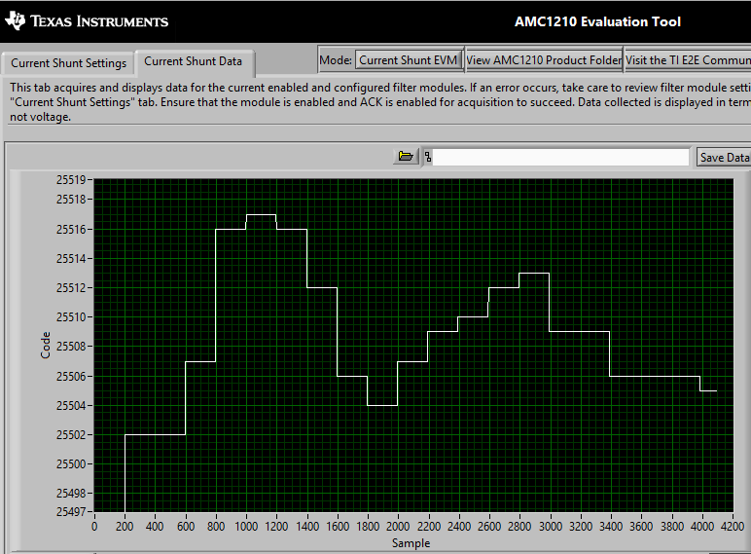

|  |  |  |  |  |  |
| --- | --- | --- | --- | --- | --- |
| **Actual Shunt Input@50mOhm (V)** | **Calculated Code value** | **Measured Code value using AMC1210 Tool** | | **Error%** | |
| 0.24987 | 25587 | 25502 | 25517 | 0.33% | 0.27% |

**Input Applied 250mV (16bit format representation)**

With SOSR value 256 and without Integrator function

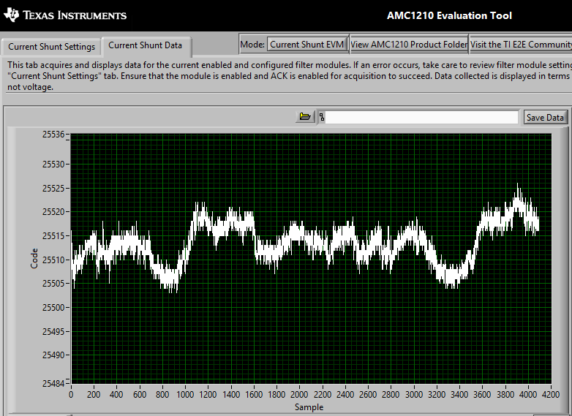

|  |  |  |  |  |  |
| --- | --- | --- | --- | --- | --- |
| **Actual Shunt Input@50mOhm (V)** | **Calculated Code value** | **Measured Code value using AMC1210 Tool** | | **Error%** | |
| 0.2499 | 25590 | 25505 | 25523 | 0.33% | 0.26% |

I am not getting the accuracy at lower voltages. Can you please let me know what will be the max and min accuracy of the device.

At lower inputs means 6mV, 12mV range I am getting accuracy change of 5 to 10% error. Can you please let me know the max error % change?