**Part I**

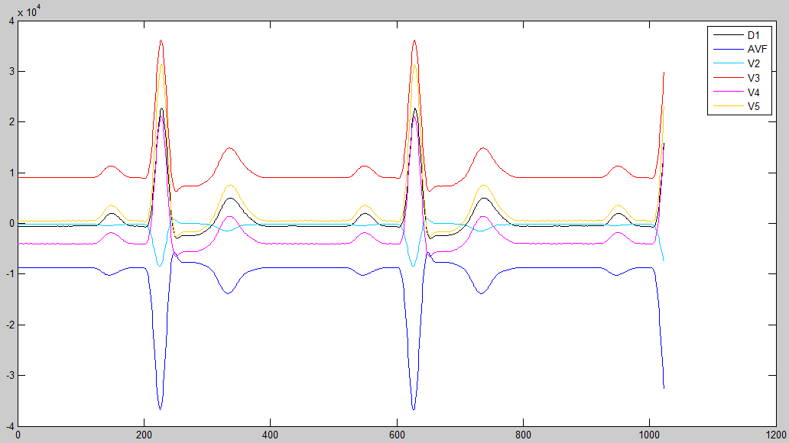

Figure 1. D1, AVF signals and CH4-7 readings (precordials V2-V5)

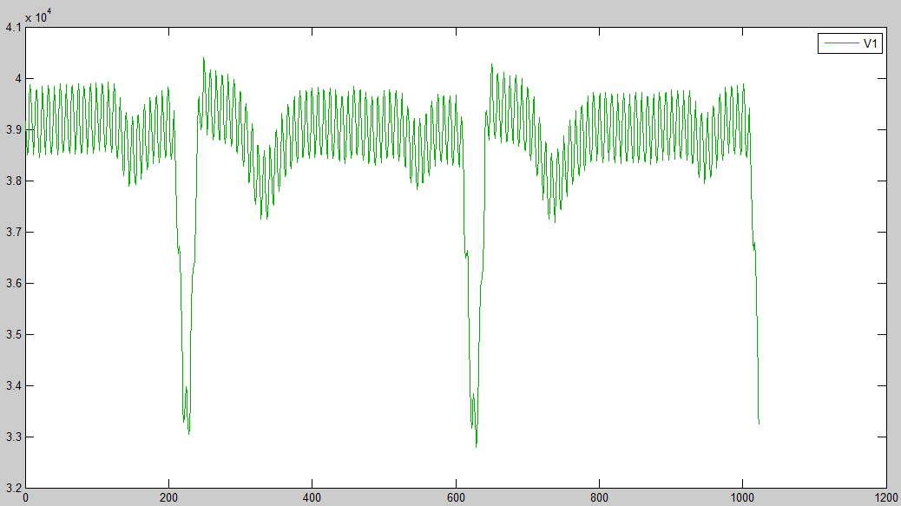

Figure 2. CH8 reading (precordial V1)

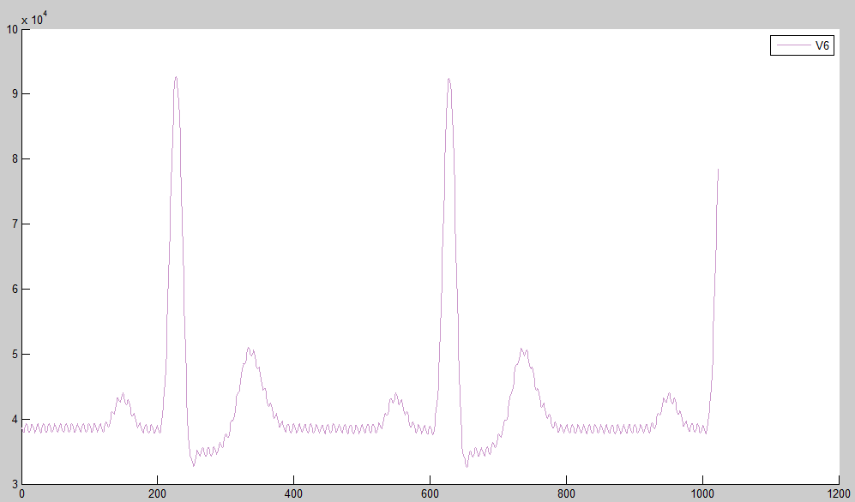

Figure 3. CH1 reading (precordial V6)

**Part II**

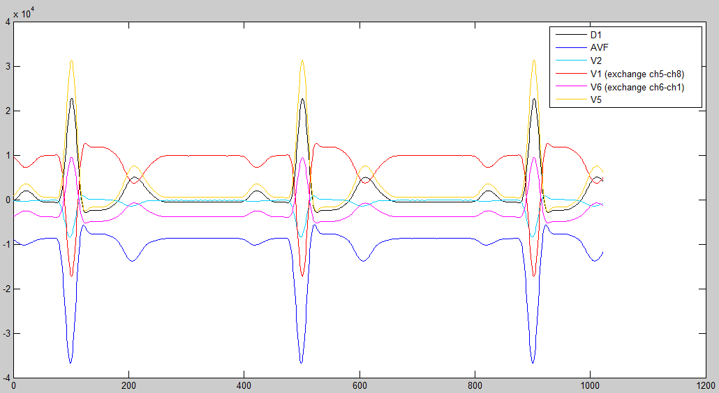

Figure 4. D1, AVF, V2 and V5 signals. Exchange CH5-CH8 (reading CH5 for V1 ) and exchange CH6-CH1 (reading CH6 for V6 ).

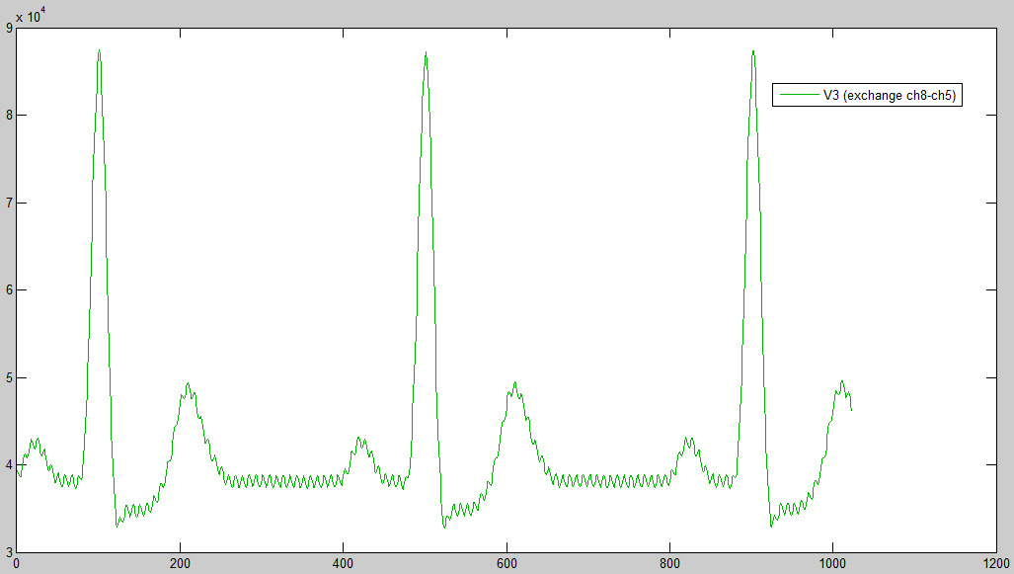

Figure 5. Exchange CH8-CH5 (reading CH8 for V3)

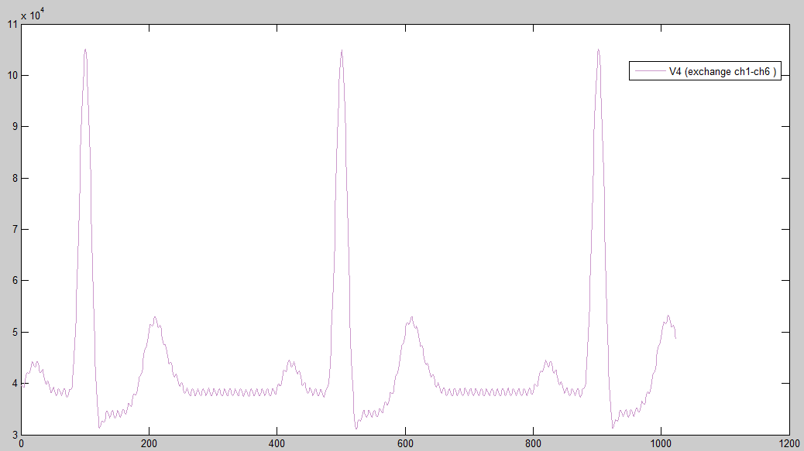

Figure 6. Exchange CH1-CH6 (reading CH1 for V4)