# PC Driver and Software Install

(Note: Install before connecting any BP-DAC81404EVM hardware to the PC)

The BP-DAC81404EVM Software can be installed by launching the ‘exe’ file located in the BP-DAC81404EVM_Software Folder (Fig.1).

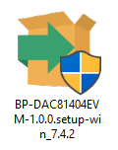

Figure 1. EXE file located in the BP-DAC81404EVM Folder

When the BP-DAC81404EVM software is launched, an installation dialog window opens and prompts the user to select an installation

directory. If left unchanged, the software location defaults to C:\Program Files (x86)\Texas Instruments\BP-DAC81404EVM as shown in Figure 2.

This software needs GUI Composer Runtime. The runtime can be downloaded through the EVM GUI during installation. In case there is no previous installation of the GUI Composer Runtime, the installer will ask for automatic download from the web. Select to install. This might take a while for download and install.



Figure 2. BP-DAC81404EVM GUI Installer

**Analog EVM Controller Firmware Upgrade (Required only for the first time)**

The firmware for the Analog EVM Controller must be upgraded for the first time before using the software. A jumper must be modified, and the USB cable must be connected to the XDS110 port of the Analog EVM Controller to download firmware. The firmware can be programmed to the Analog EVM Controller using the online tool UniFlash. This link is also provided on the Setup page of the GUI. The firmware bin file can be found at <Download Directory>\BP-DAC81404EVM_1.0.0_installer_win\install_image_BP-DAC81404EVM\BP-DAC81404EVM\app\firmware\acctrl.bin after unzipping the file install_image_BP-DAC81404EVM.zip.

Follow the step-by-step procedure below to upgrade the firmware and install the device drivers successfully:

* Remove jumper JP6 on the Analog EVM Controller
* Mount jumper on 5V-OTG. Retain the jumper on 5V-XDS



* Connect the USB cable to the port on the XDS110 side of the board
* Connect the USB cable to PC and open UniFlash. Click on Start Now in the Detect Device section
* If the GUI Composer framework is being installed for the first time on the PC, the browser extension and the TI Cloud Agent must be installed. Follow the 2-step installation flow prompted on the web page, as shown in figure below.
* 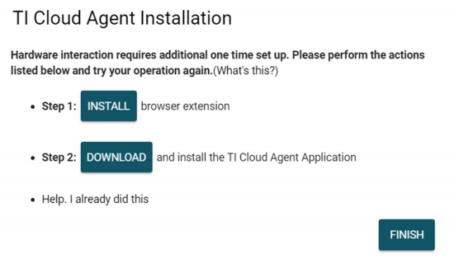
* Press the Refresh or Finish button after the installation is complete. This action should detect the Launchpad
* Press Start and browse for <Download Directory>\BP-DAC81404EVM_1.0.0_installer_win\install_image_BP-DAC81404EVM\BP-DAC81404EVM\app\firmware\acctrl.bin. Press Load Image followed by Verify Image.
* Remove the USB cable and mount the BP-DAC81404EVM on AEVM as shown in Figure 4.
* Replace the OCFSPI.js in file in (C:\Users\<user name>\guicomposer\runtime\gcruntime.v7\BP-DAC81404EVM\components\ti-core-databind\src\internal\reg\OCFInterfaces) by the file with the same name in the directory - \BP-DAC81404EVM_1.0.0_installer_win\install_image_BP-DAC81404EVM\BP-DAC81404EVM\app/patch/
* Connect the USB cable to the port U7 as shown in step 4 of Figure 3. U7 is available near the RJ-45 connector on the board



Figure 3. AEVM Firmware Upgrade Steps

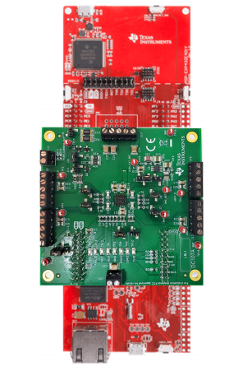

Figure 4: Stack-up of Launchpad and BP-DAC81404EVM

# EVM Hardware Setup

Set all jumpers on BP-DAC81404EVM to the default configurations shown in the figure below.

**BP-DAC81404EVM Jumper configuration Table**

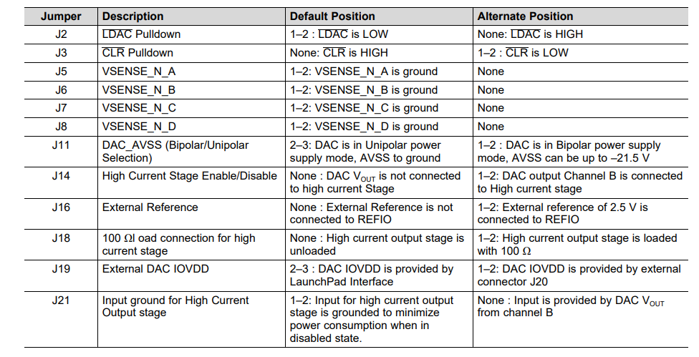

**Launchpad interface pinout**



The software program is now installed onto the PC, and can be invoked by selecting it from the following folder:

**Start>All Programs>Texas Instruments>BP-DAC81404EVM 1.0.0**

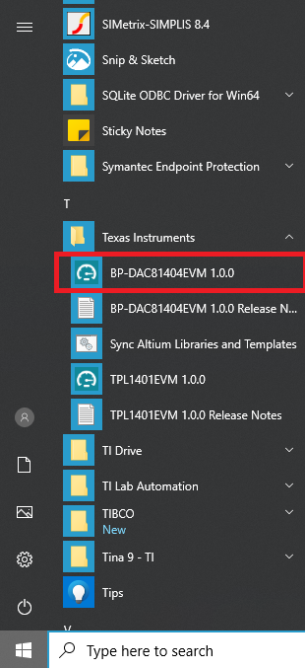

If the Analog EVM Connector is correctly connected, the status bar at the bottom of the screen displays *Hardware Connected*. If the Analog EVM Controller is not properly connected or not connected at all, the status bar displays *Hardware not connected*. In case the *Hardware not connected* status persists even after the hardware is connected, go to *Options-->Serial Port* and select the next available port.