Thanks for your very helpful earlier comments on my board layout. I’ve read your paper “Fundamental of Precision Noise Analysis” many times, and I’d like to ask your advice before I lock in my design.
We are designing a general-purpose ultra-low-noise datalogger, the ClearBox, for analytical chromatography, a technique that separates a mixture of chemicals into separate components.
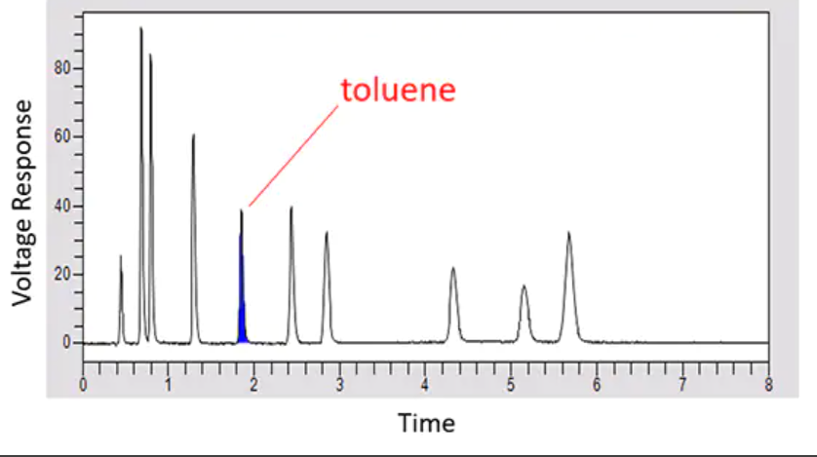
Chromatography is used in almost every chemical and biological laboratory and has many variants, which I won’t bore you with. I’ll use UV detection in liquid chromatography as an example, since that is probably most common, although our interface will work with any chromatographic detector that produces a voltage.
In UV detection for liquid chromatography, the mixture is dissolved in a solvent – call that the sample. The sample is pumped through a column that retards components differentially and then into a transparent flow-cell, through which UV light at a particular wavelength is passed. Simultaneously, the same UV signal is passed through an identical flow-cell that contains only the solvent, the reference. Two signals are monitored simultaneously – the total energy of each flow-stream -- by measuring the current of a UV photodiode and converting it to voltage using a TIA. Call those two signals S and R. When no component is passing through the flow-cell, S = R. When a component that absorbs UV passes through the flow-cell, S will drop. The transmittance signal is defined as
T = S / R.
Which varies between 1 and 0, plus system noise. Noise amplitude is invariant with the amplitude of T.
The signal of most in interest in chromatography is not transmittance but absorbance,
A = - log₁₀(T)
because the area under an absorbance peak is proportional to component concentration (Beers’ law). Noise amplitude increases exponentially with absorbance amplitude. The sample diagram above is an absorbance plot.
For noise improvement, we can’t deal directly with absorbance, although this is the signal most commercial detectors output. We will need to work with sample and reference separately. This will mean that we cannot vary the gain easily, since the reference signal is fixed.
Chromatographic data rates are slow -- 1-100 SPS – and a typical run is less than an hour. No components appear in the first few seconds of a chromatographic run, and we can arbitrarily extend a run past the last component. In analytical chromatography, no decisions need to be made real-time, so we have the advantage of not having to worry about settling rates, computation time of FIR filters, etc and to be able to filter symmetrically, knowing both past and future signal as far out as we like. While commercial chromatographic detectors include real-time analog and digital filters, the manufacturers treat these designs as proprietary information. My belief is that these filters distort the data in unexplained ways and should be suppressed.
Why might we need 32-bit precision? For small-amplitude absorbance peaks with no overlapping peaks, we don’t. But for small peaks sitting under large overlapping peaks, we do, as this is a case where we need to differentiate between large and small signals. In many cases, sensor noise may limit discrimination, however. The industry standard for ADCs is currently 24-bit.
As far as our interface is concerned, I’d appreciate any comments on my nose-reduction plans:
ADC: Use two ADS1262s as the only devices on separate SPI channels.
Signal conditioning: Don’t try to eliminate RF noise using analog filters – we can fix this at the end with a digital filter. (I’ve left an input RC filter on my test board, and I plan to test this assumption.)
Clock: Don’t worry about clock jitter at these low sampling rates – use the ADCs’ internal clocks separately.
Power: Reduce EMI and RF noise by proper layout and, if necessary, shielding. Don’t use switched supplies on-board, and take the ADCs’ AVDD and DVDD supplies from ultra-low-noise LDO regulators (your TPS7A2050 and TPS7A2033) that are driven by a low-noise external voltage.
Reference voltage: Use a shared external reference voltage (your REF5025) for both channels. Internal references will drift differently and be a significant noise source.
1/f noise: Chop the signals to push 1/f noise to out-of-bandwidth frequencies.
Sampling rate: Oversample at 100Hz or greater, and after the fact, decimate to an appropriate sample rate depending on the peak widths in the sample – 40 points is a generous rule of thumb for the minimum peak width, which is about 5 seconds in the e xample above, or 8SPS. You can always move from oversampled to undersampled, but not the other way.
Filters: Don’t use any analog filters. We don’t need to worry about time, so convolution calculations using FFTs are OK, and we can lose the first few seconds and the last few seconds without a problem. We can experiment with a variety of “optimal” FIR low-pass filters after the fact—Kaiser windows, Parks-McClelland, Wiener, matched filters, etc.
l

