Common mode current is the average value of DC switching current which flows into each analog input pin.

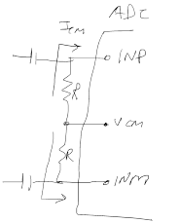

So at 250MSPS, 0.4mA will flow through biasing register R causing a drop of common mode from VCM pin to INP by 0.4m\*R Volts.

According to datasheet, this drop should be limited to within 0.025V – this means max recommended termination resistor is 25/0.4=62.5ohms.