Here is the comparison between ADC324x and ADC34J4x. We added extra quantization noise to 12-b data (ADC322x) to get 14-b data (ADC324x).

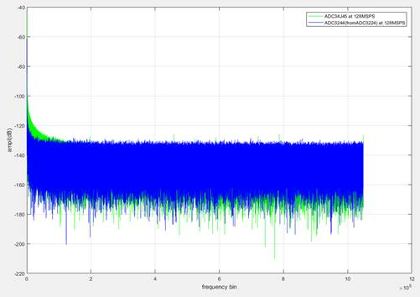

Looks like JESD version’s 1/f noise is poorer compared to LVDS version. However, there is a chopper functionality available only in LVDS version.