Consultation on CIS micro brightness issue in printer standby mode

Problem points：When the printer is in standby mode, the CIS of the scanner will emit blue-green or white light, with low brightness that is difficult for the naked eye to distinguish。

Analysis: In standby mode, both the scanned AFE chip and CIS are powered normally. After checking the manual of the AFE chip VSP5640, it was found that the three registers in the figure below are related to the LED switch and current of CIS. Please confirm with the firmware that EN_LED, LEDx_EN, and LEDx_TGL_EN have all been disabled, and the problem of slight illumination has not been resolved. The voltage of the R G B pin of VSP5640 fluctuates with 5V ripple waves as shown in the figure below.
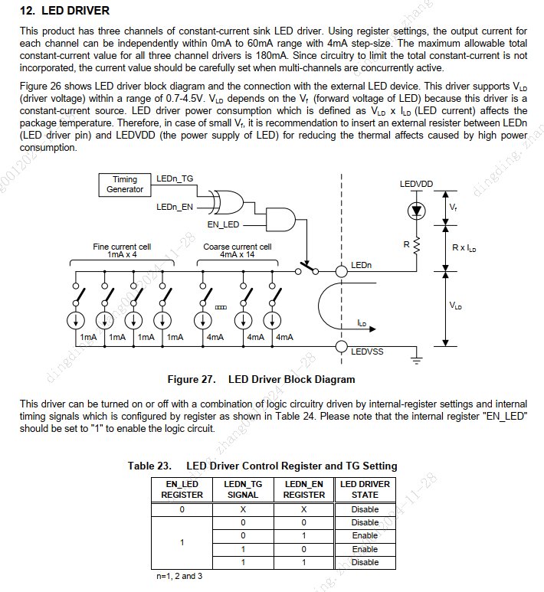
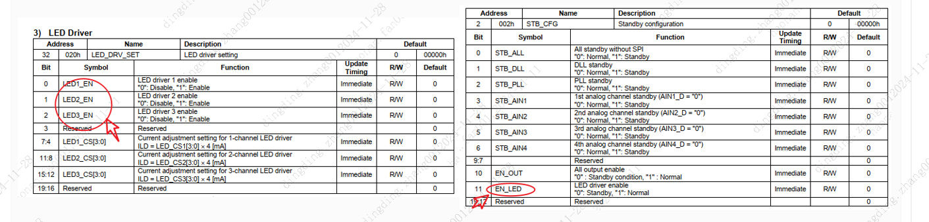
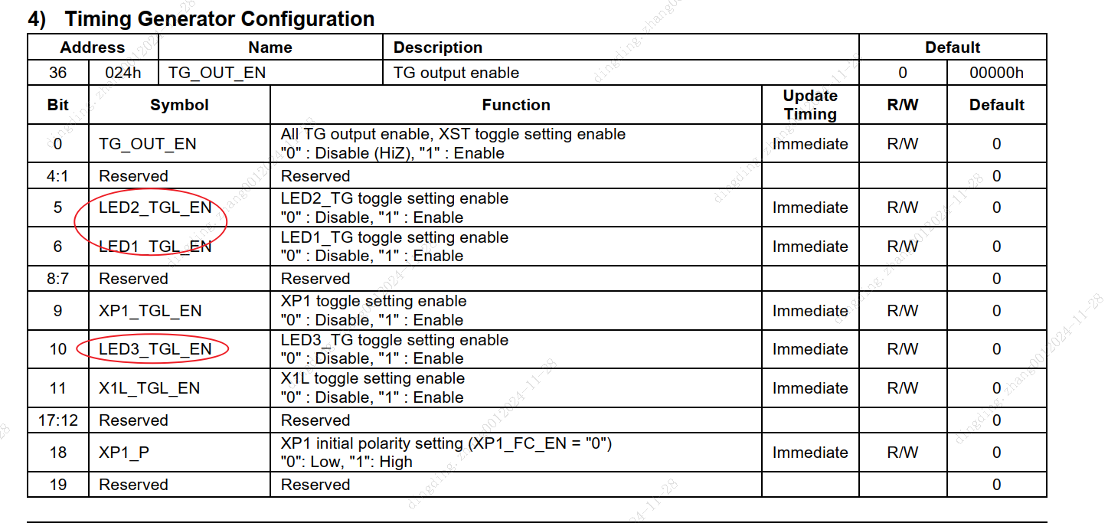
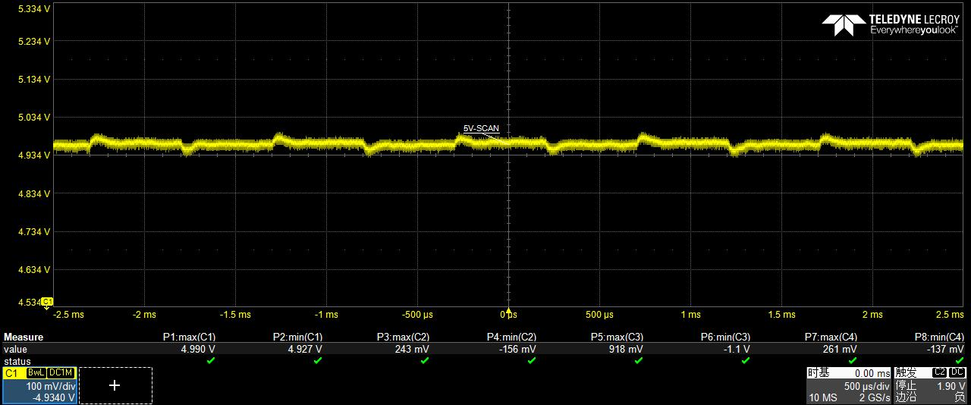
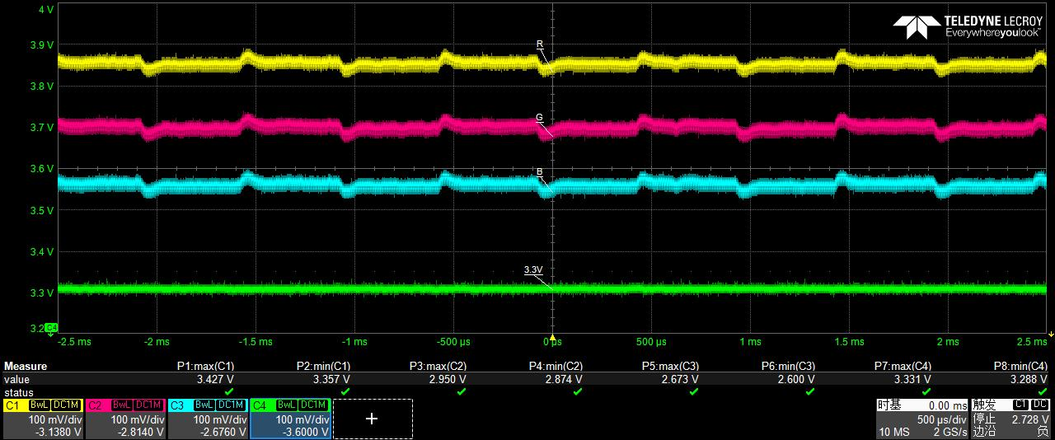

请帮忙分析目前这个问题是不是因为VSP5640的Off-state leak current造成的，还是说有其他问题？
Could you please help analyze if the current issue is caused by the Off state leak current of VSP5640, or if there are other problems?
