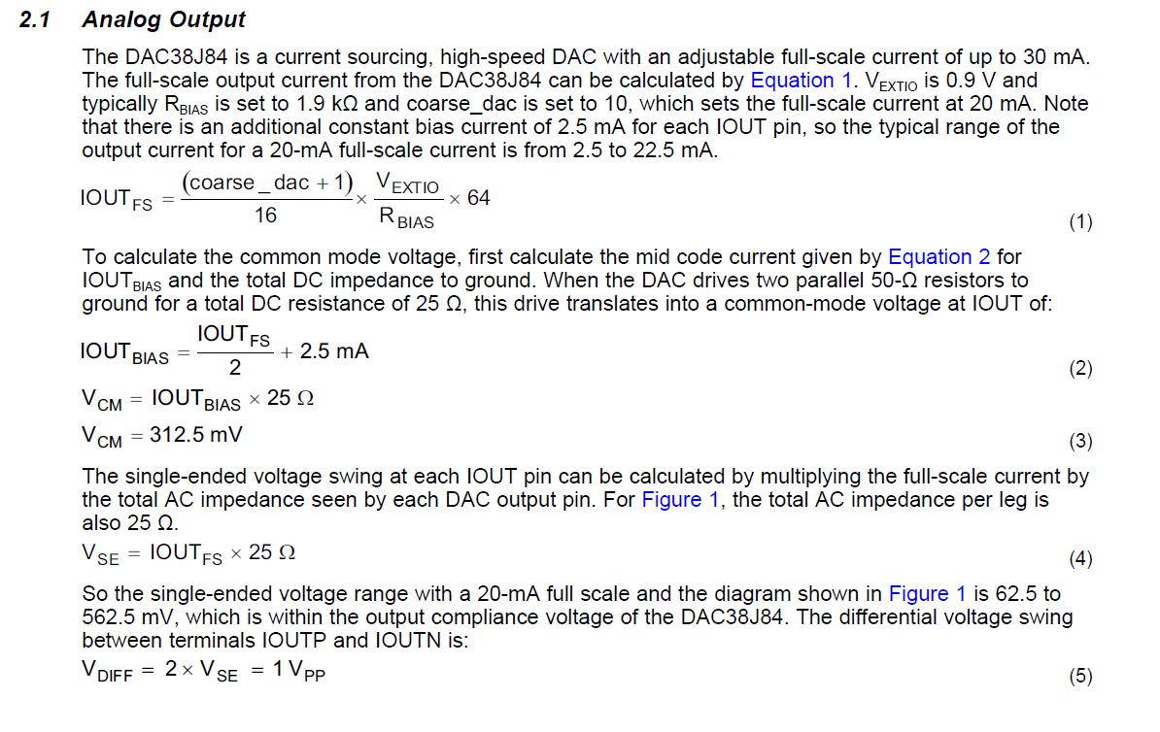
On TI DAC EVM, with 50 Ohms to GND on each pin, with full scale input provided, mixer and NCO off, and coarse DAC gain = 10 (20mA), the swing on both legs was 1.1V. This is to be expected since the load is 2X of equation above.

