Install software BP-DAC11001EVM
1. Install bp-dac11001evm software
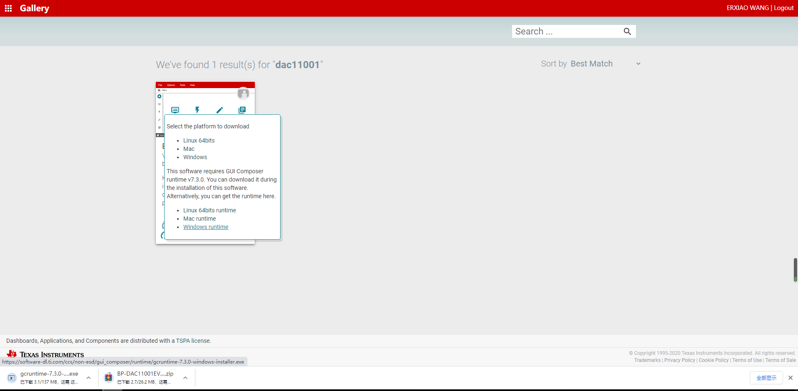
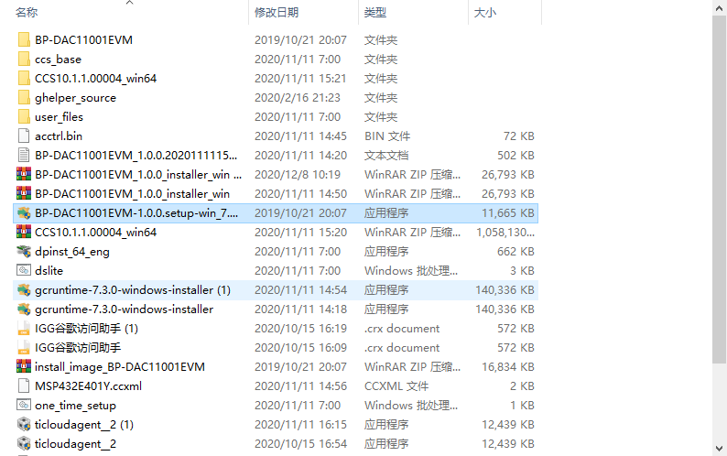
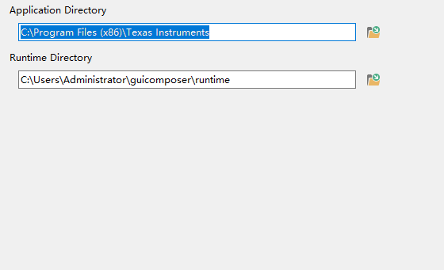
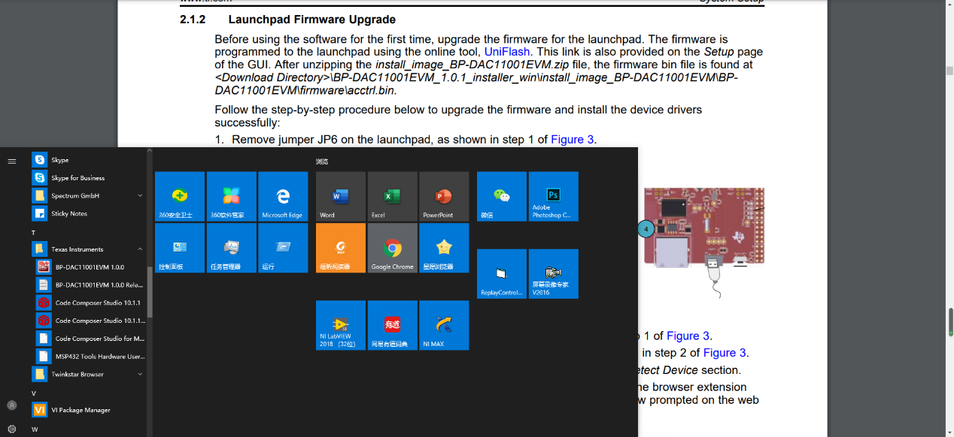

- Launchpad Firmware Upgrade
jumper6 JP6 Remove jumper6 JP6 from the board
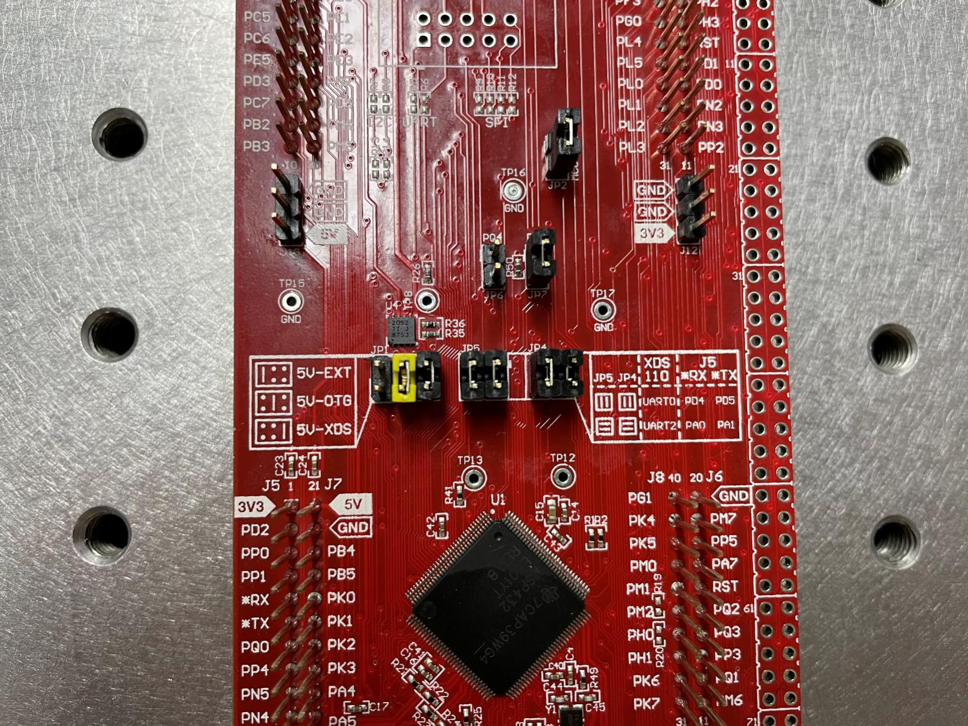

Connecting USB to PC
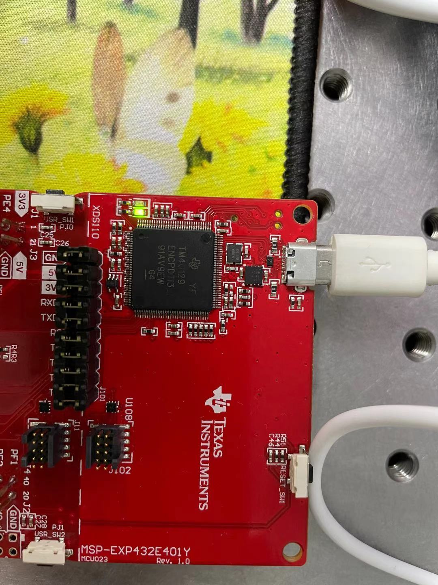

The device is detected in uniflash, and the loading and confirming image operations are performed.
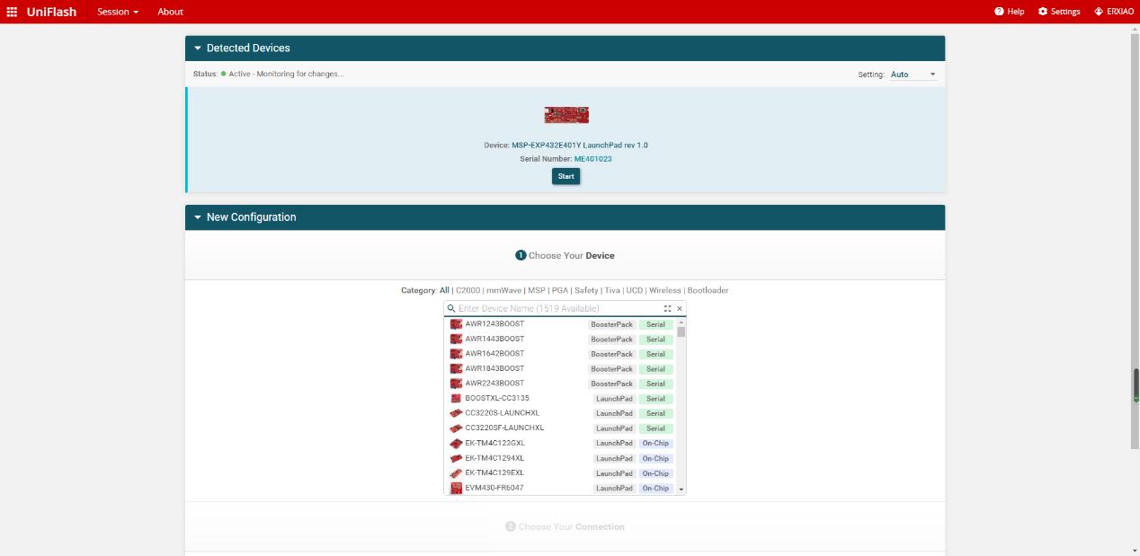
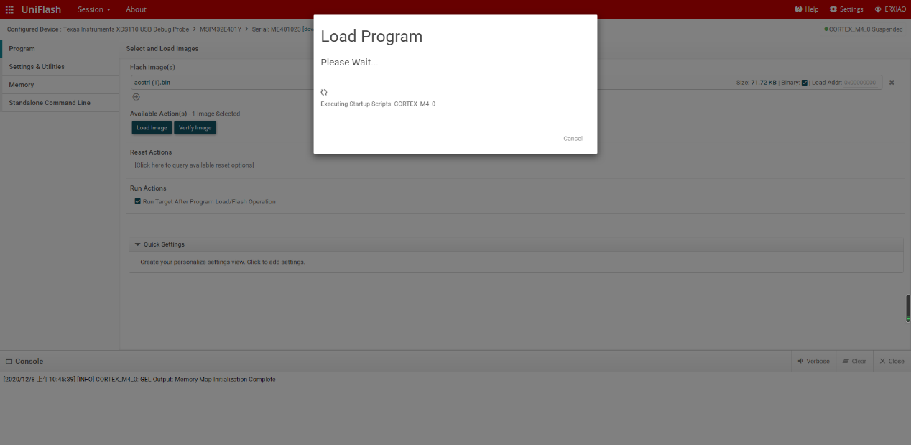
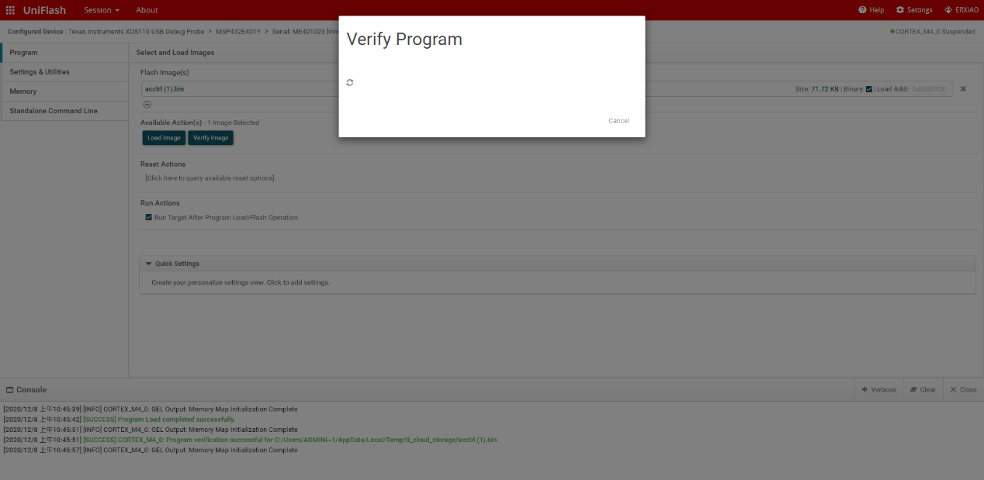

- Hardware Setup
Connect msp-exp432e401y with bp-dac11001evm, as shown in the figure:
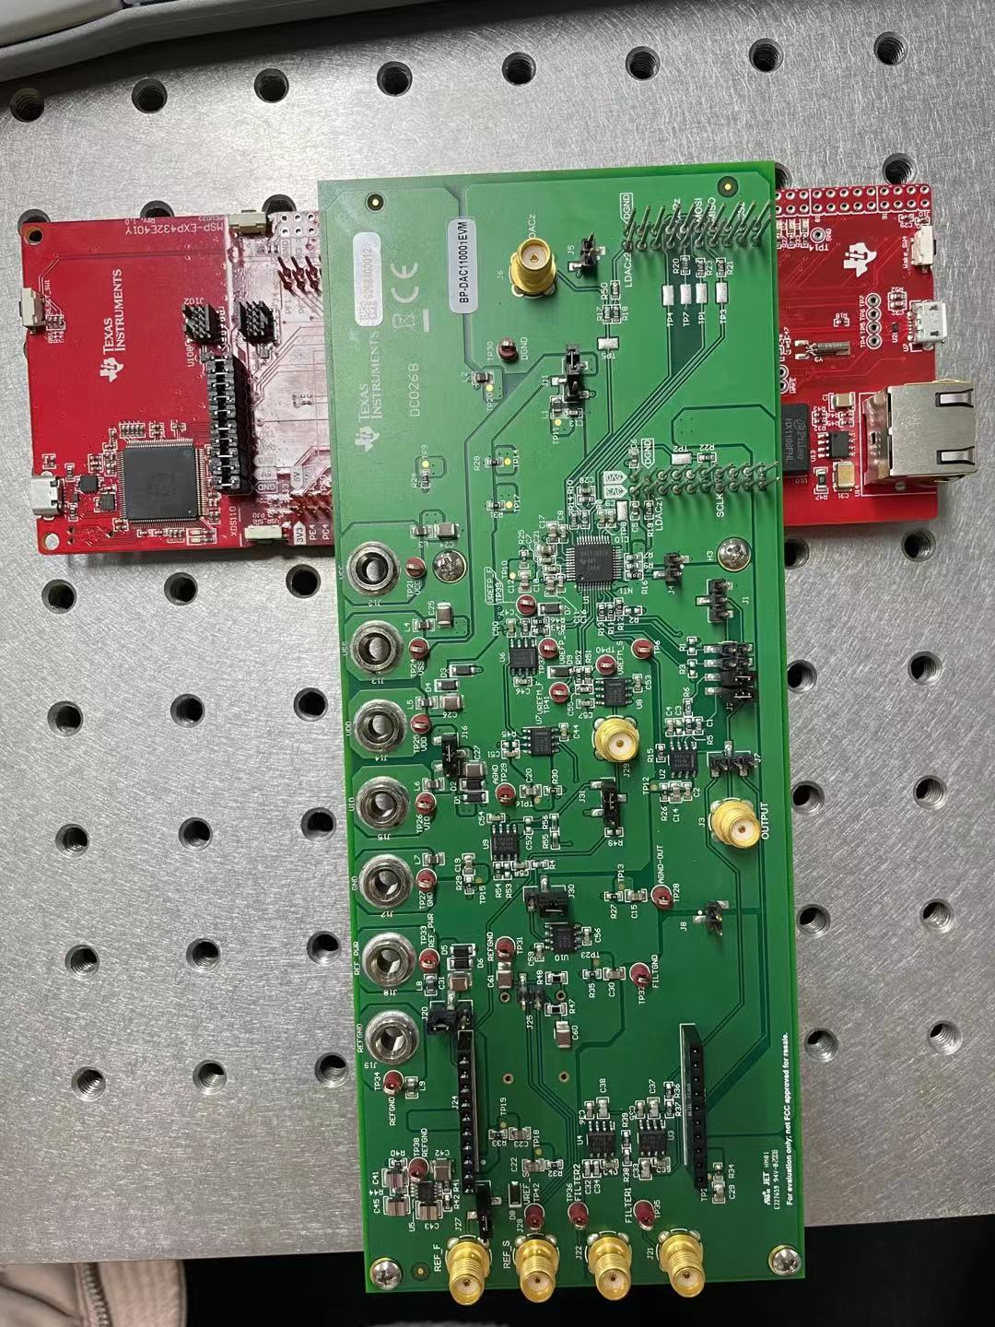

According to the requirements of the manual, set j12 to + 12V, j13 to - 12V, J14 to 5.5V, j15 to 3.3V, J17 to 0V, J18 to 5.4v, and J19 to 0V.
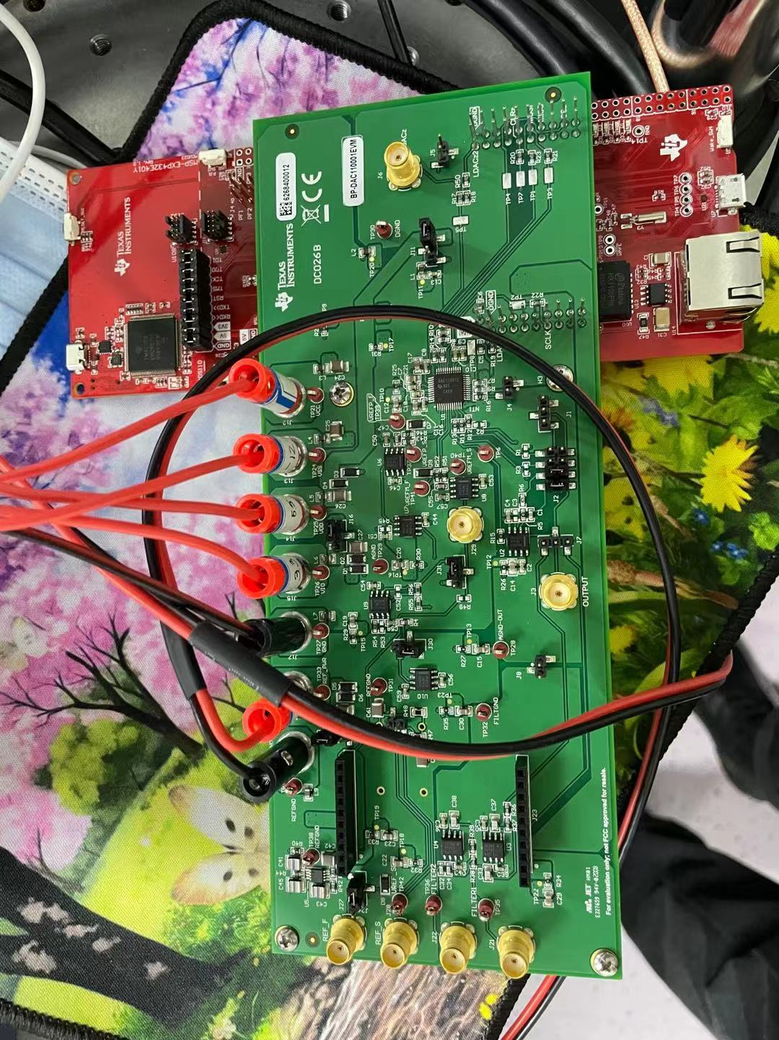
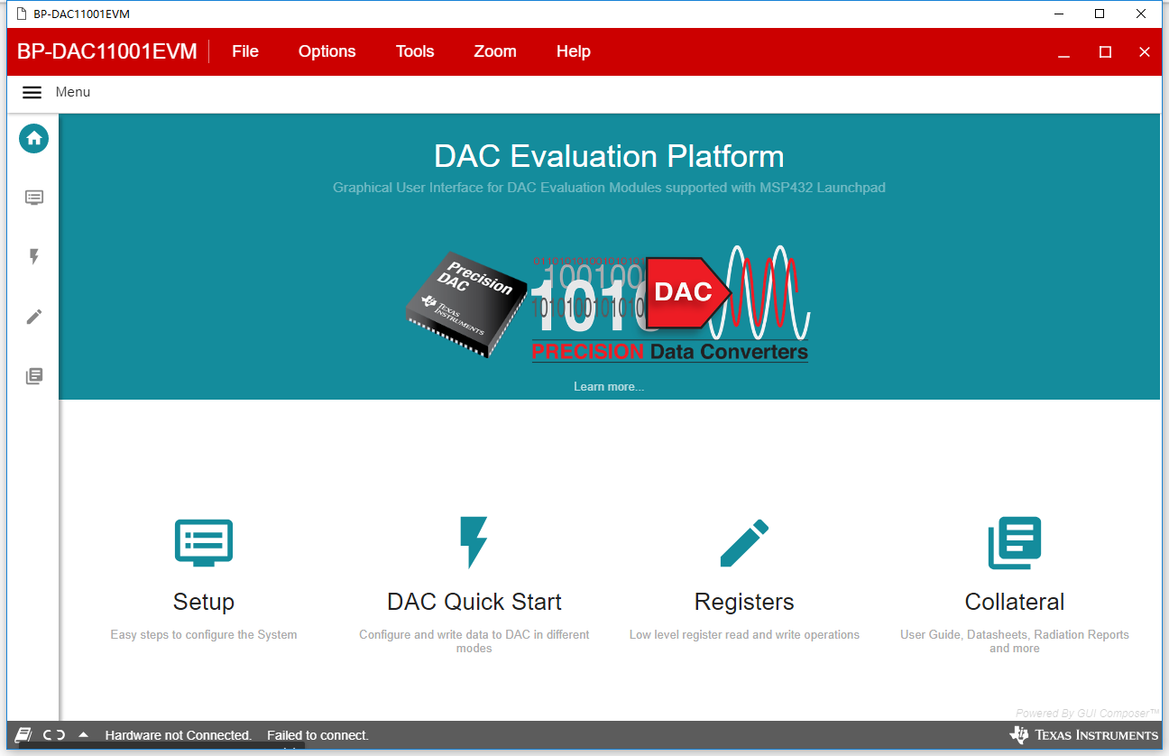

After connecting USB, the display hardware cannot be connected

If the data line is connected with the xds110 end, as shown in the figure:
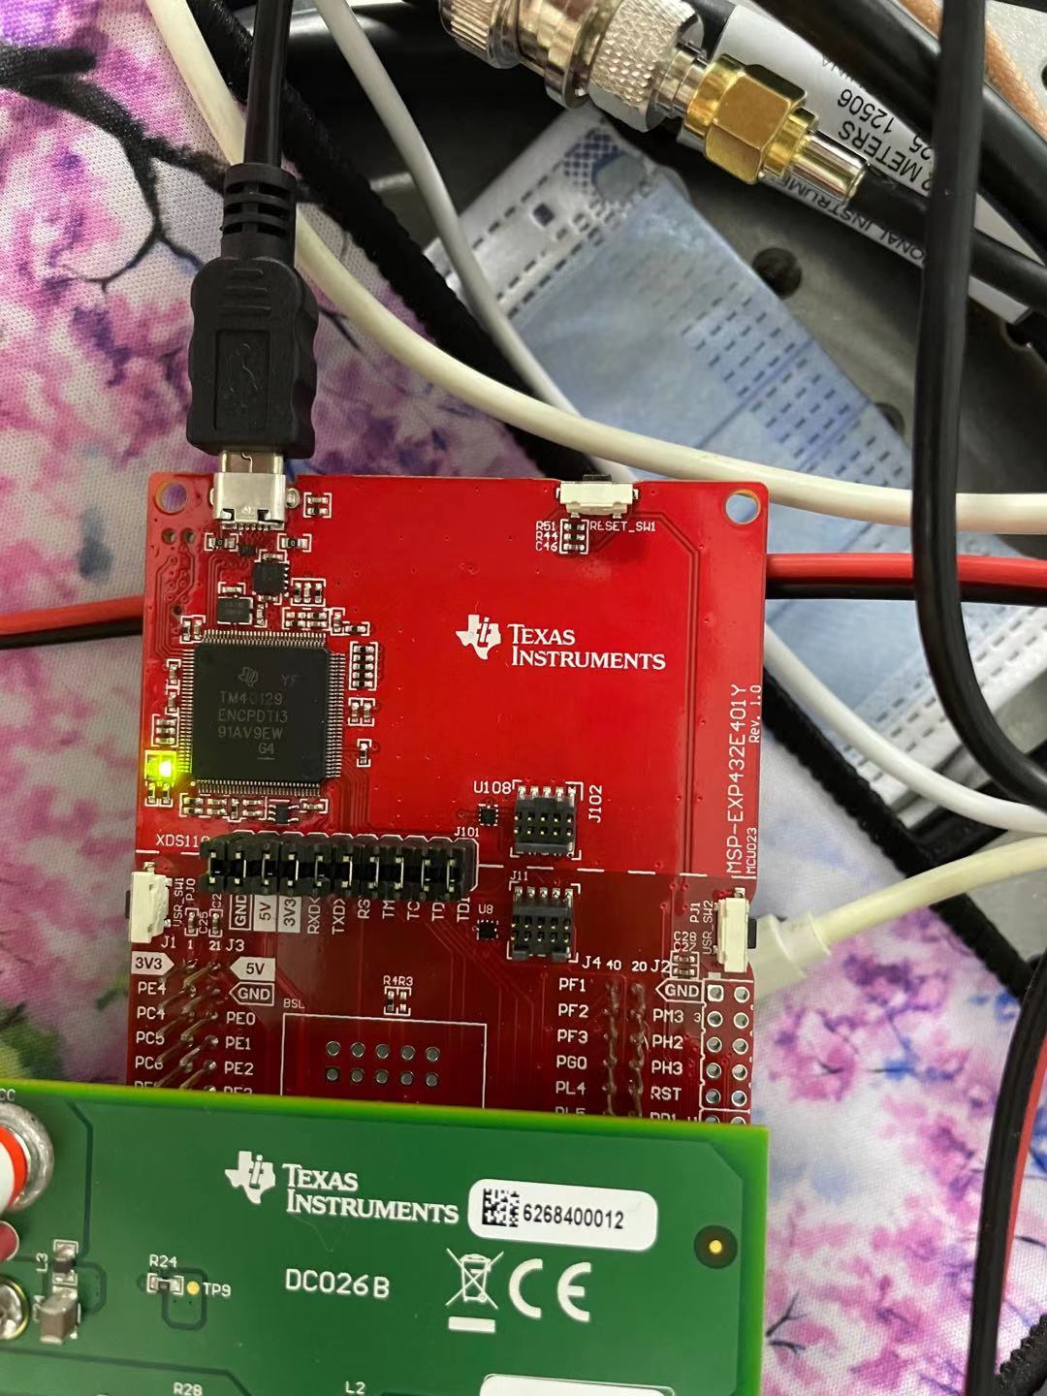

In the device manager, you can see that two devices are connected to the PC
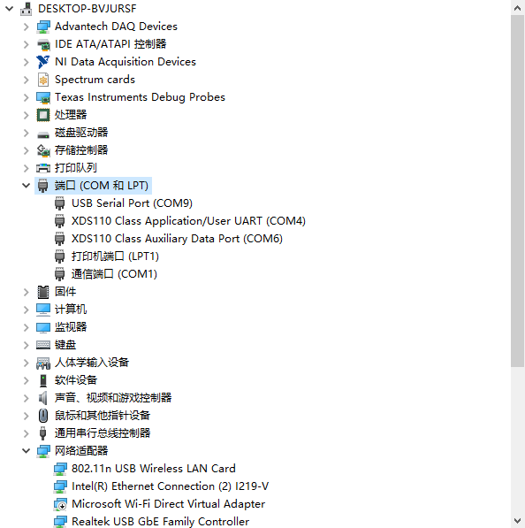

If the data cable is connected with the USB interface at the other end, as shown in the figure:
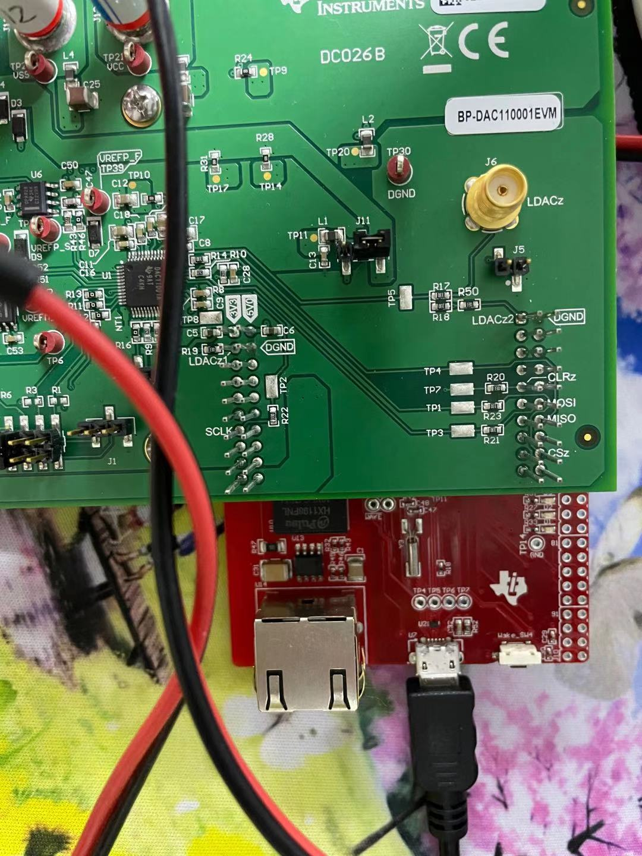

You cannot see any external devices in the device manager
