Hi,

I am using DAC37J84 custom board with NCO enabled bin file which gives me the output (at the 50Ohm termination) as per the below mentioned figure.

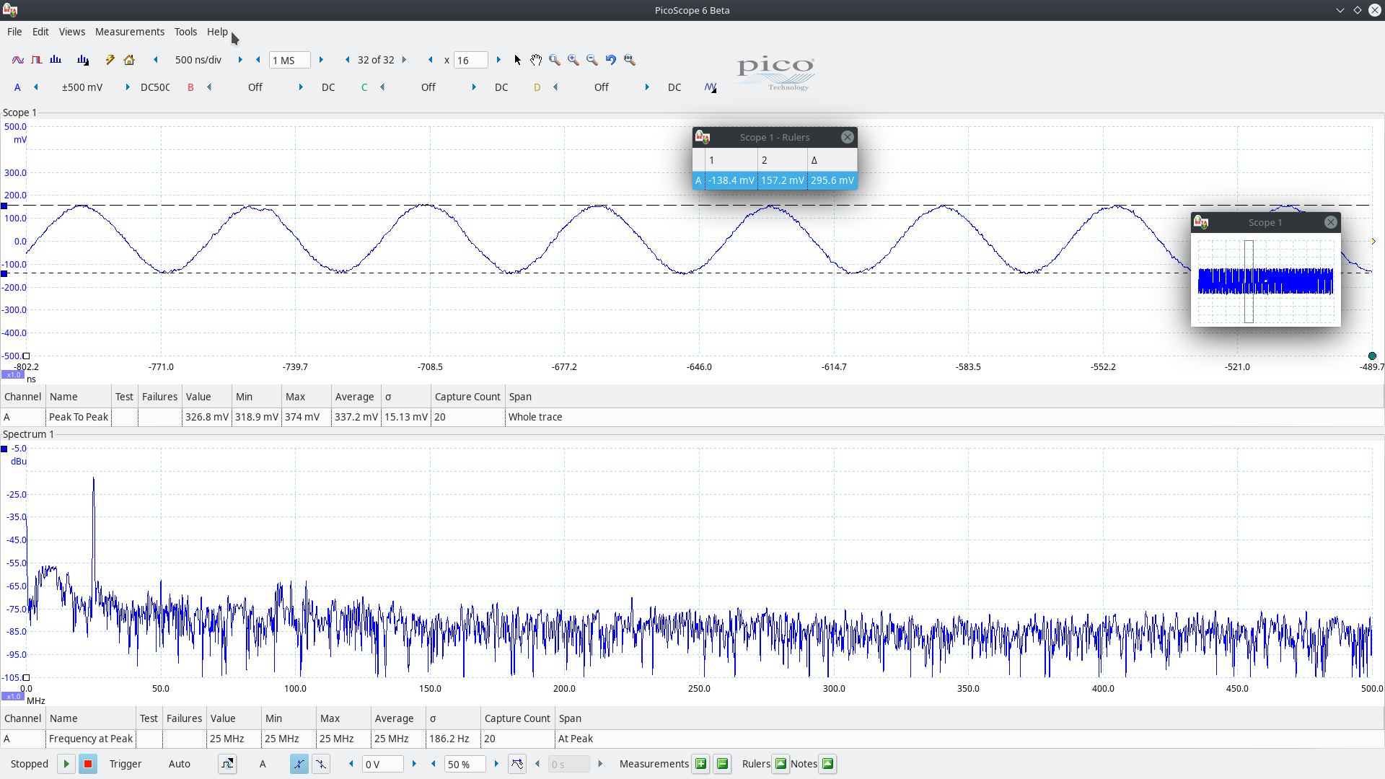

As per the waveform the output voltage is around 296mV peak to peak (single ended) or around 600mV peak to peak (Differential) with the coarse DAC gain set to maximum value (0x3=0xf301).

With the FPGA communication with the DAC37J84 bin file i am getting an output voltage as per the below mentioned figure.

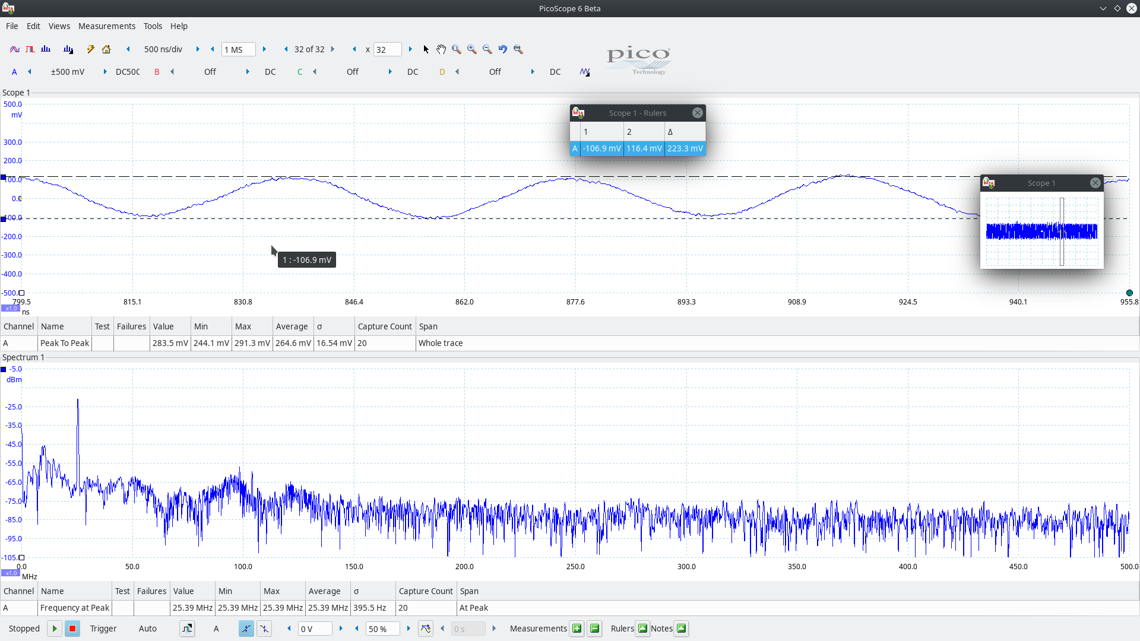
As per the waveform the output voltage is around 223mV peak to peak (single ended) or around 446mV peak to peak (Differential) with the coarse DAC gain set to maximum value (0x3=0xf301).

But as per the calculations with the Rbias resistor value with 1.91K for a current rating of 30mA with the output load of 50 Ohm termination the peak to peak will be 30mAx50Ohm=1.5Volts differential or 750mV peak to peak.

So i am getting a lesser voltage of around 900mV peak to peak (Differential) or 450mV peak to peak (single ended) with the NCO enabled bin file and 1050mV peak to peak (Differential) or 525mV peak to peak (single ended) with the FPGA communication enabled bin file .

So let me know what should i do to acheive the Peak to peak of 1.5Volts (Differential).

Regards,
Sandeep

