I’m trying to get correct transmission from a custom board with a DAC38RF82 on-board. However with a DAC clock of 9000MHz, the only thing I can get the DAC to do is either a constant frequency of 2250MHz or (with different settings) a constant frequency of 562.5MHz. I think I’m missing something on the setup of the chip or setup of the JESD communication, but the DEC indicates everything is working correctly – I just can’t get the start of a signal related to the JESD communication out of the device as a starting point to work from. Any help would be appreciated.
The setup is as follows:
The chip is connected to a Xilinx Kintex-7 FPGA, which generates the JESD204 signal with a rate of 7.5Gbps on 8 lines to the DAC chip. I’ve tested the JESD204 signal using a spectrum analyser and it appears to be trying to send a signal. The input clock to the DAC chip is 375MHz to both the DACCLK pins and to the SYSREF pins. I’m using the onboard PLL to generate the 9000MHz reference DAC frequency (M=6, N=1). The DAC mode is Single (DAC A), 1 IQ Pair with 6x interpolation.
While we are not using the evaluation board, the equivalent settings would be:
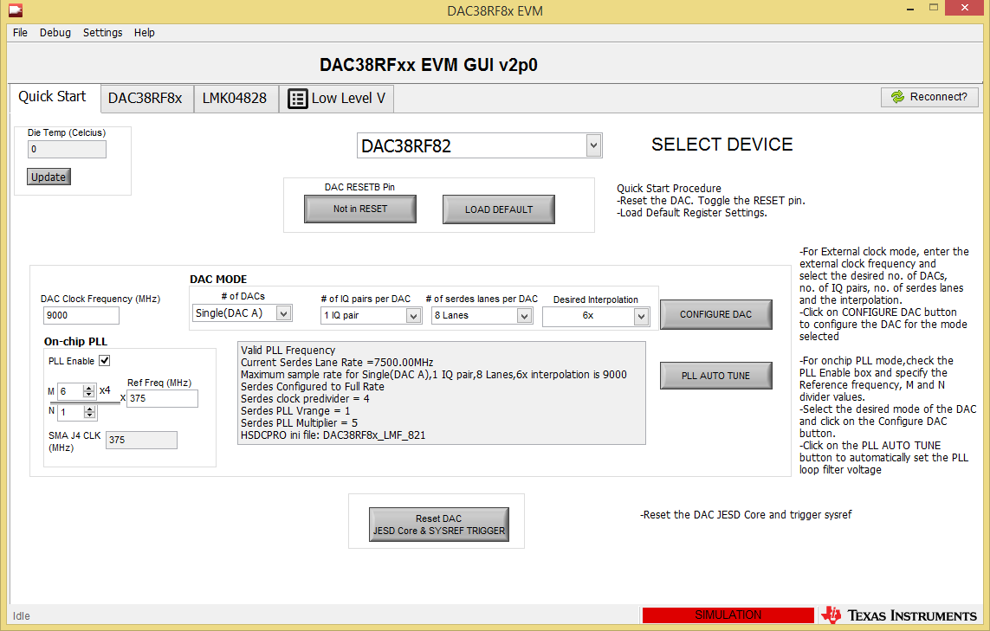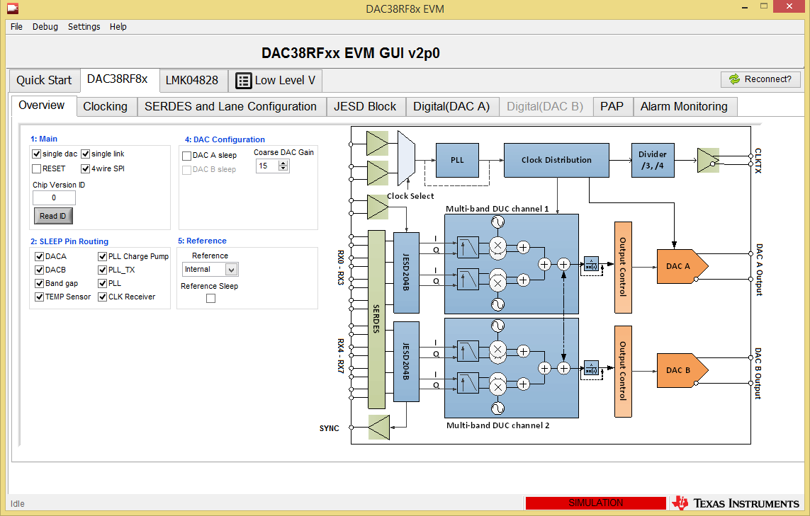
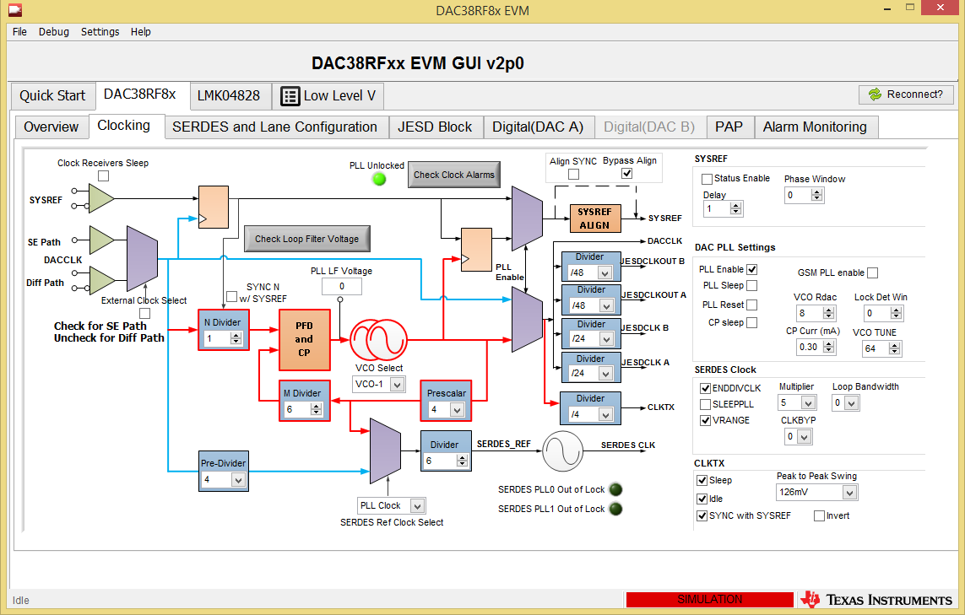
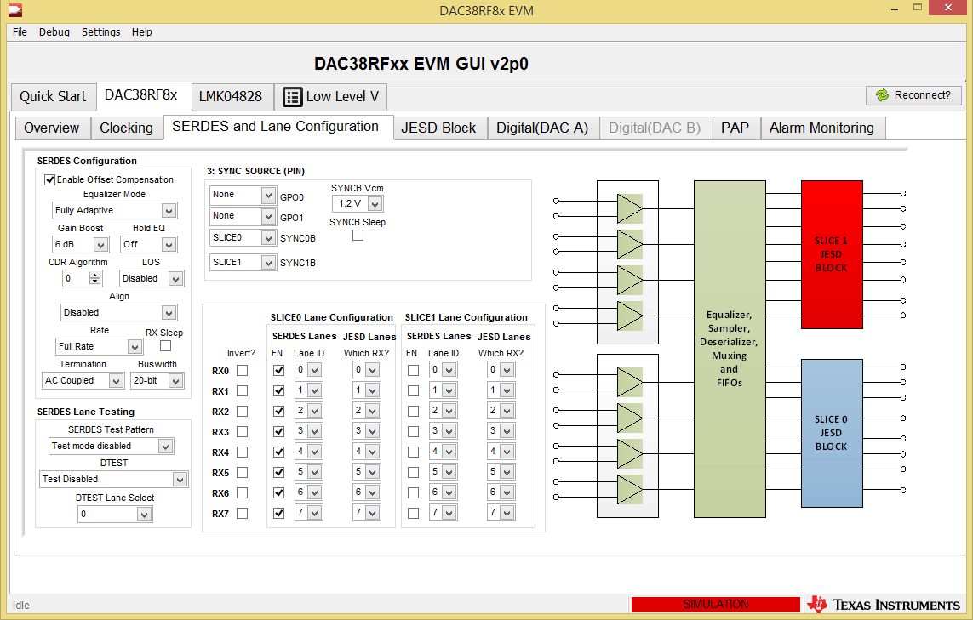
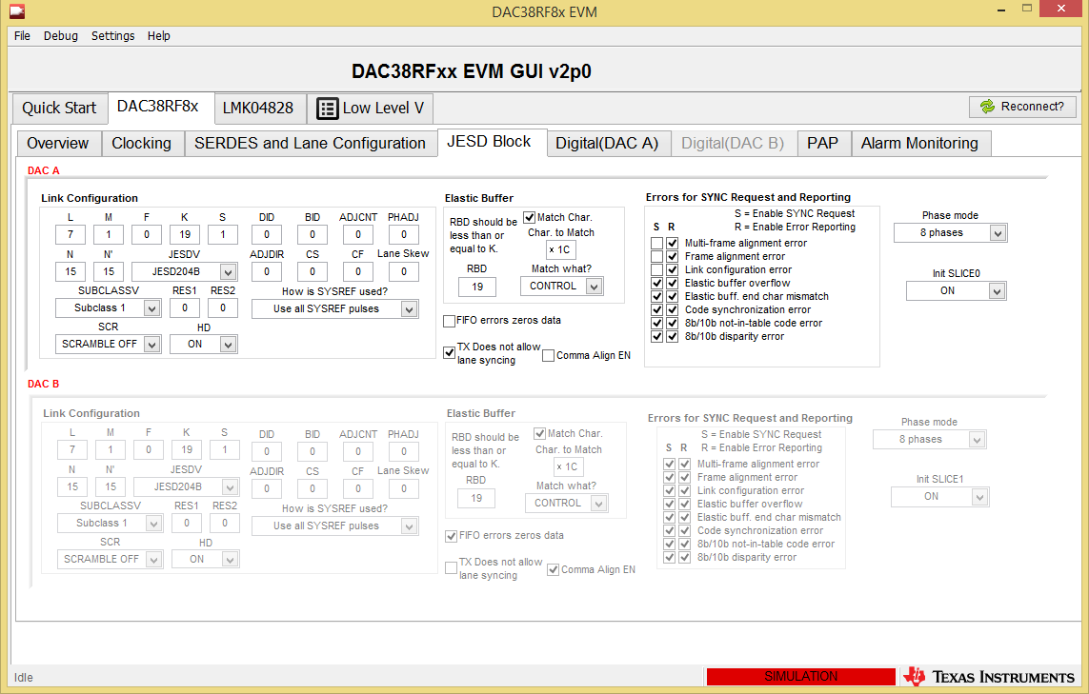
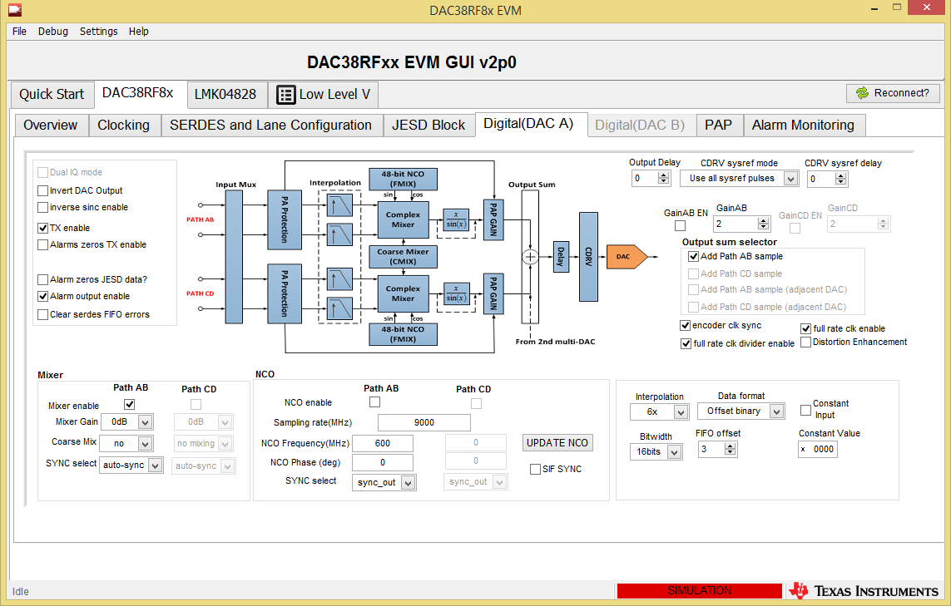
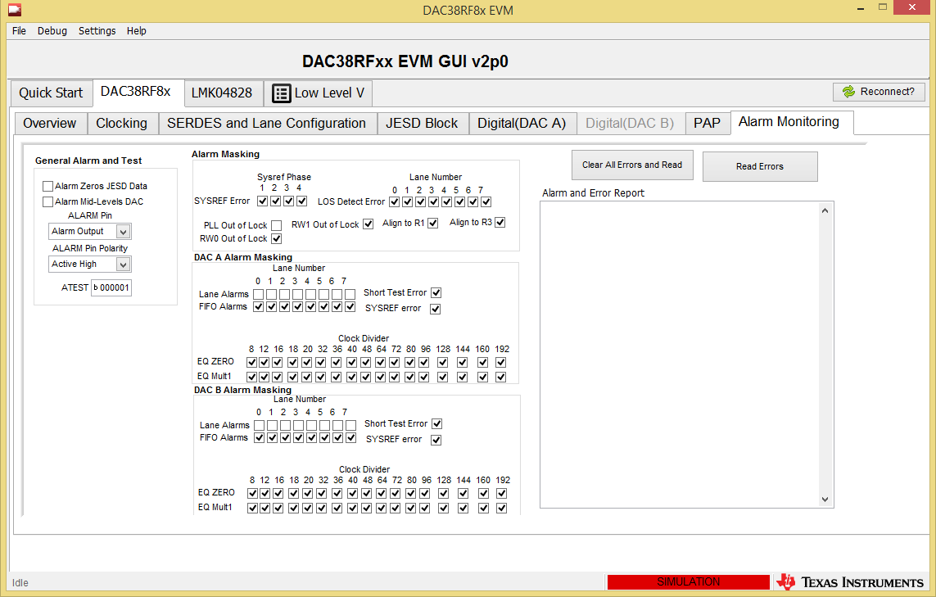
The actual messages I send are as follows (Hex, ADDRESS (2 characters), DATA (4 characters))

x"090000",
x"007860",
x"011880",
x"0200FF",
x"0300FF",
x"090004",
x"0B0000",
x"1B0100",
x"0CA002",
x"241001",
x"310400",
x"320508",
x"33C318",
x"3BA802",
x"3C8229",
x"3E0109",
x"090001",
x"0A0310",
x"0C2600",
x"0D0301",
x"0F1F83",
x"190001",
x"1E1111",
x"1F1111",
x"201111",
x"256300",
x"2D1FFF",
x"2E1FFF",
x"320800",
x"330800",
x"4AFF03",
x"4C1307",
x"4D0101",
x"4F1CE0",
x"51001F",
x"090002",
x"0A03B0",
x"0C2402",
x"256300",
x"4C1307",
x"4D0101",
x"090000"

Testing is as follows:
Power rails have been tested and are working. I can output the downsampled by 80 PLL output clock, and the frequency looks good. The alarms indicate that the main DAC PLL is locked and the SERDES PLL is locked. All the alarms for the JESD look good (no lane or fifo errors), also with a detection of signal on all lanes. However the only way I get the DAC is to output anything is to enable the mixer on the AB path. When this is done, I get a continuous tone of 562.5MHz (along with harmonics). Also if I untenable the QRCLOCK_DACA_ENA setting, it will produce a 2250MHz signal. Nothing seems to be using the signal output from the JESD. I just can’t see what’s going wrong and have run out of options to test. Any help would be appreciated.

