Dear Jim
With your recommendation, I tried to set the GUI for the DAC as follows:
LMK04828, PLL1 bypassed and PLL2 receives the OSCin with the following set as in the picture. The signal delivered to the PLL is 134.4 MHz coming from J17 (after implement the configuration option of Clock Generator using External Reference that is R177, C206, and C121 should be uninstalled and R185, R186, and C92 should be installed).

The VCO frequency designed to 134.4 * 24 = 3225.6 MHz that is using VCO1 (2945 to 3255 MHz) using PLL2 Prescaler =2 and PLL2 N Divider =12. I believe that the Charge pump Tri-State should be left unmarked and I tried to lower the Charge Pump Gain to 100uA but unfortunately the VCO frequency was not stable and with a lot of noise.

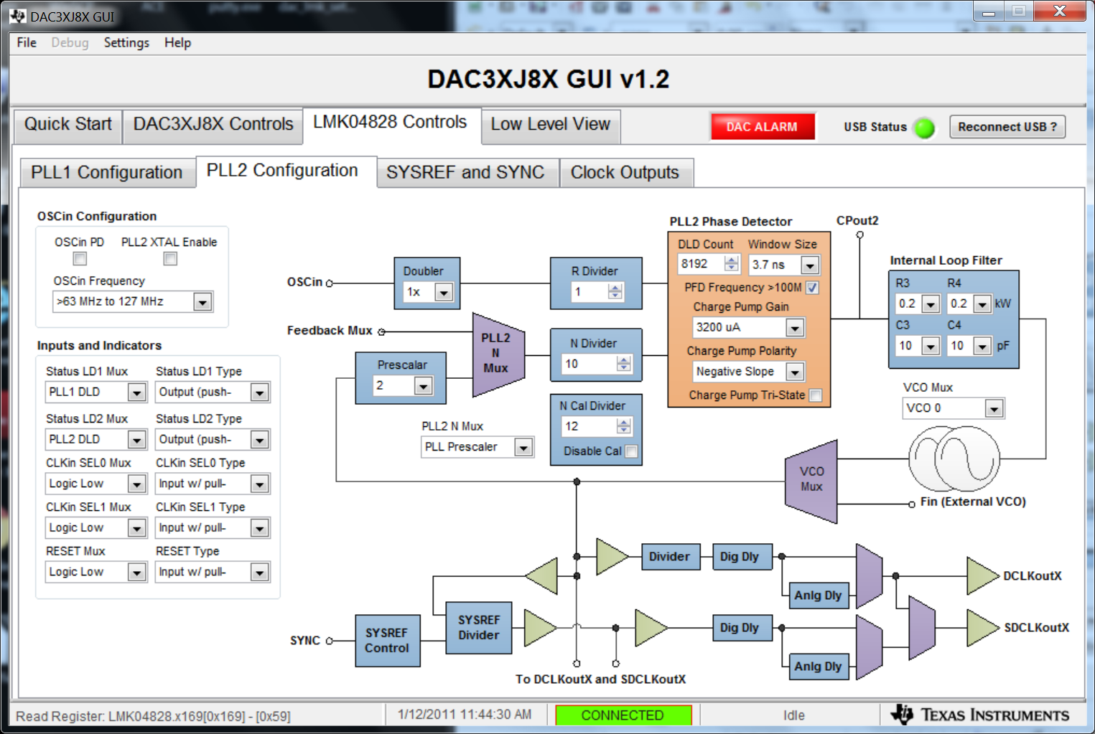
CLKout0 tuned to VCO1 /12 = 268.8 MHz , CLKout2 tuned to VCO1 /6 = 537.6 MHz and CLKout1 and 3 provides in accordance the SYSREF. (DCLKout0 Divider =12 and DCLKout2 Divider =6)
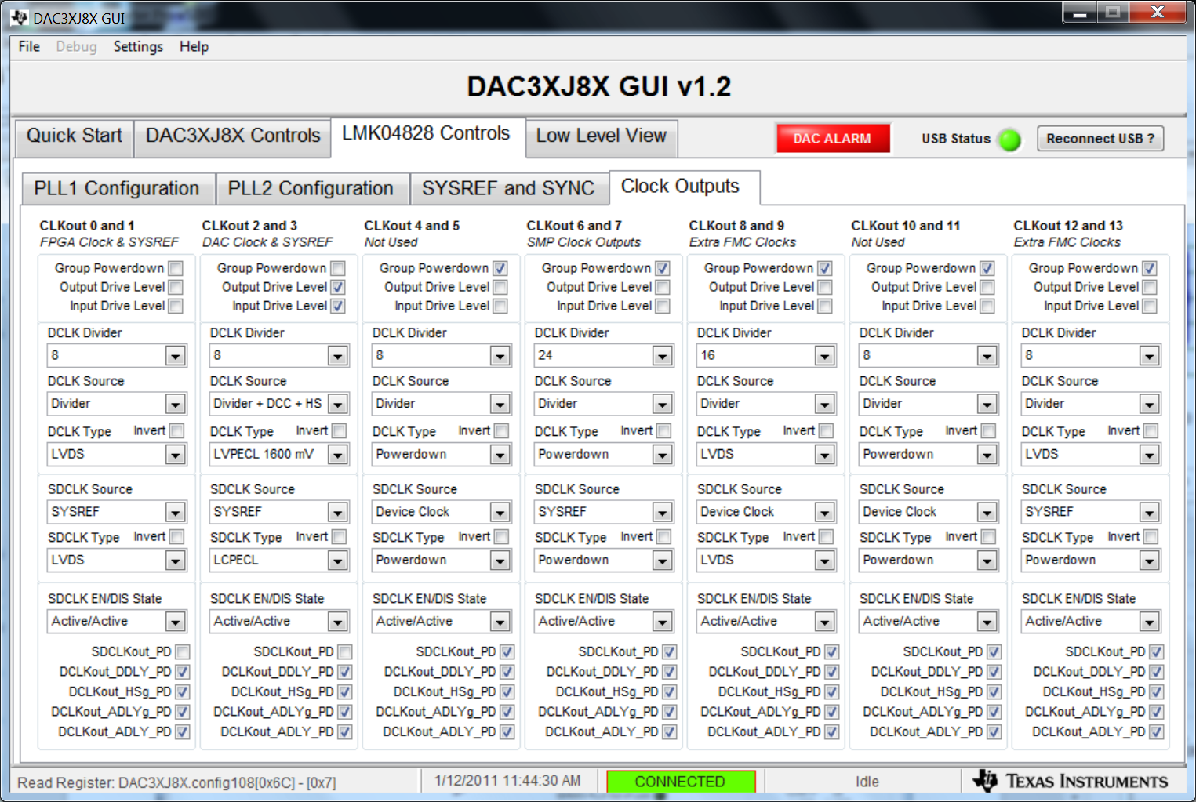
The DAC operated using it's internal PLL:
VCO Freq = 537.6 * M_Divider * DAC_VCO_Prescaler / N_Divider = 537.6 * 8 *2 / 2 = 4300.8 MHz , using L-band VCO (3.7 – 4.66 GHz). As a result the DACCLK (DAC Output Rate) = 4300.8 /2 = 2150.4 MHz . The PLL OUT OF Lock is lit !!!! (The PLL Enable check box is checked)
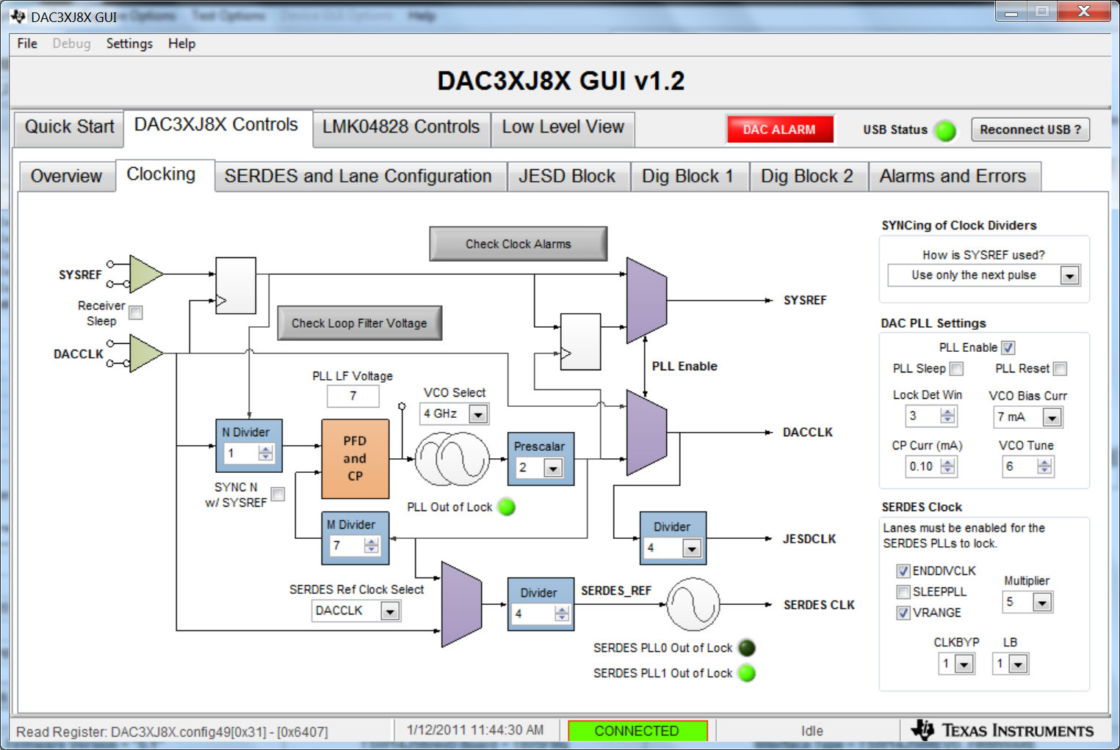
The LMF = 222 , the serdes rate is 10.752Gbps.

