DAC60508M POR PROBLEM

Scope picture during power up:

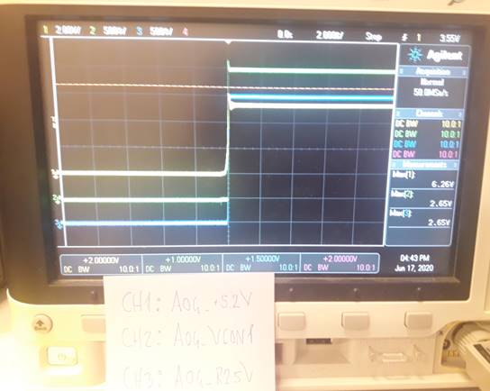Trace1 VIOp16

Trace2 OUT0p2

Trace3 REFp1

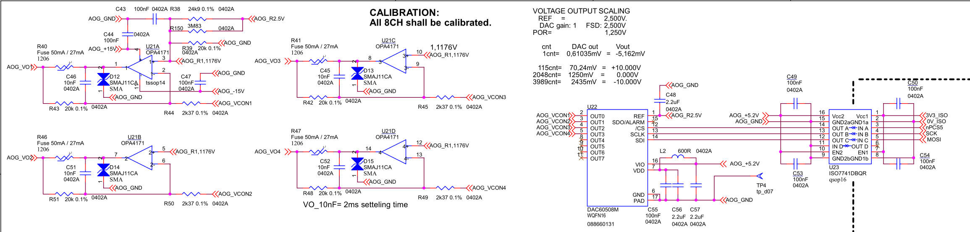

Design baseline:

