DAC7568ICPW Consultation On Component Issues
- Basic architecture of AO card components
As shown in Figure 1, the AO card has a 1oo2d architecture output, with an output current of 4-20mA. The A output circuit and B output circuit are redundant designs, and the DAC device output voltage value is controlled by SPI. The XTR111 in the later stage performs VI conversion based on the input voltage value, setting it to a 5-fold relationship.
- Work condition description
When circuit A is the source output, circuit B cannot be used as the source, that is, power off the B_24V and B_5V power sources;
When circuit B is the source output, circuit A cannot be used as the source, that is, power off the A_24V and A_5V power sources;
Figure 1 Basic Architecture of AO Card Components

- Problem description
When we switch the source output for about 20 seconds, sometimes there may be incorrect output current. We captured the SPI waveform of the DAC, which is normal, but the voltage value output by the DAC is incorrect, By testing the internal VREF source of DAC, it was found that there was either a bias towards larger or smaller values, as well as periodic triangular wave phenomena. The internal VREF test showed values of 4V, 2.38V, and 2.68V, which are randomly changing values. Based on the correspondence between the input voltage and output current of XTR111, the current conversion of TR111 is correct, which is a 5-fold relationship. When we use external reference sources, there may also be situations where the reference is incorrect.
We need to determine why abnormal voltage values occur in both internal and external
reference sources when switching sources and outputting? What is the reason?

- Test data and waveform after abnormalities
Taking channel 1 output data as an example, all 8 channels of the same DAC output have the same problem
- abnormal data 1（Channel 1）
VREF test | DAC input Code | DAC output voltage | AO output current(mA)
Internal VREF tested to 2.608V | 655.850 | 0.834V | 4.174074922
Internal VREF tested to 2.608V | 983.525 | 1.252V | 6.262455177
Internal VREF tested to 2.608V | 1311.200 | 1.67V | 8.350835431
Internal VREF tested to 2.608V | 1638.875 | 2.085V | 10.43183032
Internal VREF tested to 2.608V | 1966.550 | 2.503V | 12.48697642
Internal VREF tested to 2.608V | 2294.225 | 2.921V | 14.60959792
Internal VREF tested to 2.608V | 2621.900 | 3.339V | 16.69764248
Internal VREF tested to 2.608V | 3277.250 | 4.172V | 20.86533913
Internal VREF tested to 2.608V | 3441.088 | 4.381V | 21.90902571
Internal VREF tested to 2.608V | 3604.925 | 4.59V | 22

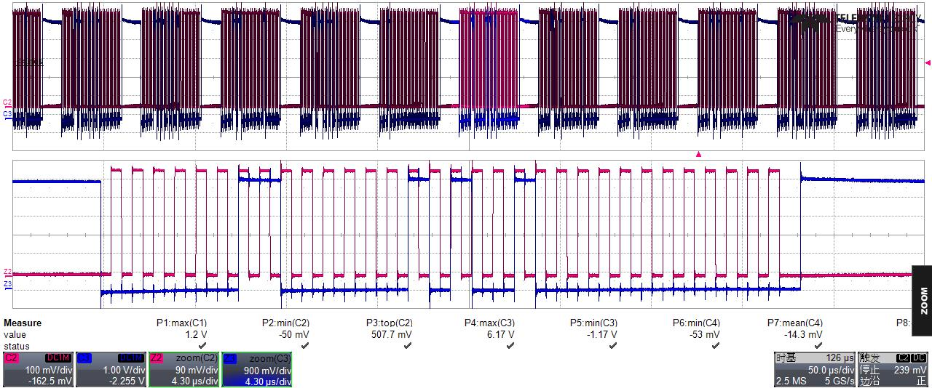
Test SPI waveform

The waveform analysis data is as follows:
DB31-DB24 | DB23-DB20 | DB19-DB8 | DB7-DB0 | Data analysis
Control command | channle set | Output Value | Don't Care | Data analysis
0000 0011 | 0000 | 0010 1001 0000 | XXXXXXXX | The first channel writes a current of 4mA, and the DAC writes a code value of 656

- abnormal data 2（Channel 1）

VREF test | DAC input Code | DAC output voltage | AO output current(mA)
Internal VREF tested to 2.856V | 655.850 | 1.597V | 7.984252689
Internal VREF tested to 2.856V | 983.525 | 2.400V | 12.00222782
Internal VREF tested to 2.856V | 1311.200 | 0.346V | 1.734554055
Internal VREF tested to 2.856V | 1638.875 | 1.139V | 5.696467536
Internal VREF tested to 2.856V | 1966.550 | 1.942V | 9.715114061
Internal VREF tested to 2.856V | 2294.225 | 2.746V | 13.73275349
Internal VREF tested to 2.856V | 2621.900 | 0.693V | 3.46474403
Internal VREF tested to 2.856V | 3277.250 | 2.288V | 11.44463264
Internal VREF tested to 2.856V | 3441.088 | 1.262V | 6.31046006
Internal VREF tested to 2.856V | 3604.925 | 0.235V | 1.176623178

- VREF test waveform
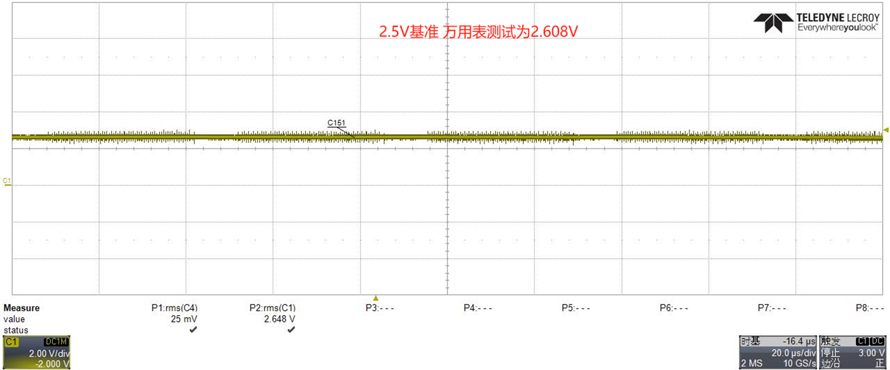
Internal reference voltage test 1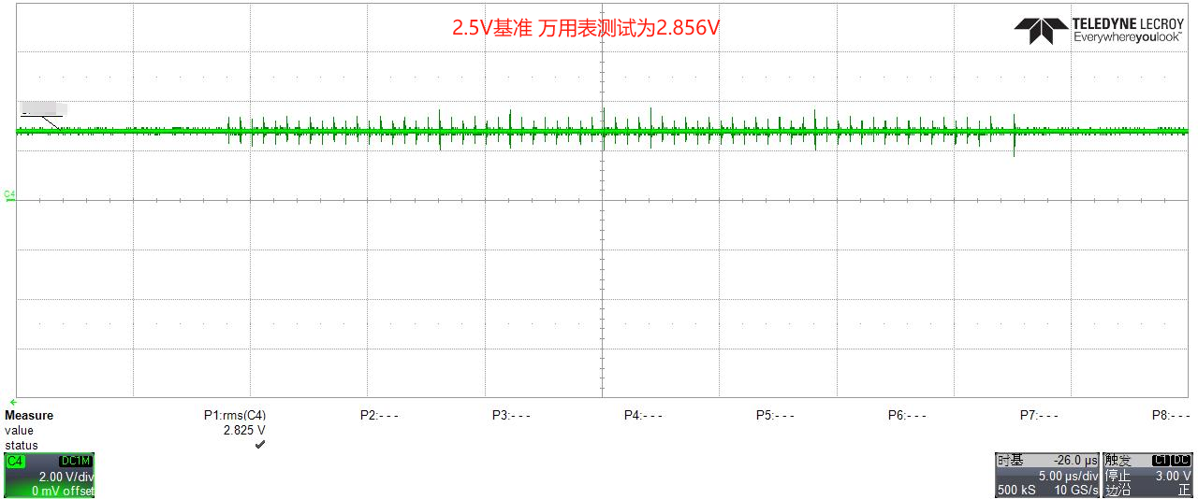
Internal reference voltage test 2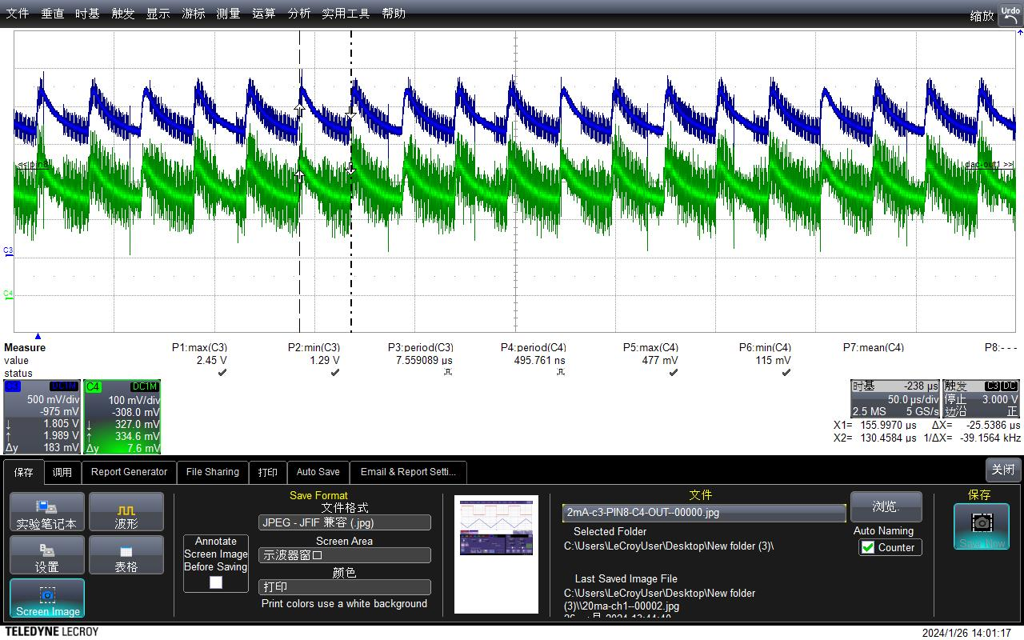
Internal reference voltage test 3（Green waveform）
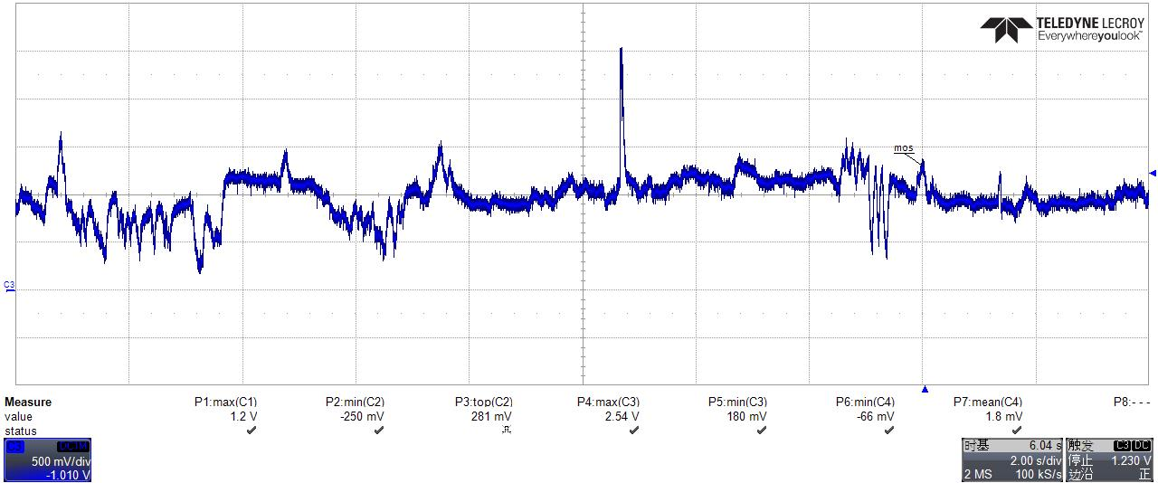
External reference voltage test 4

