DAC7716 Wave form and Schematic Diagram

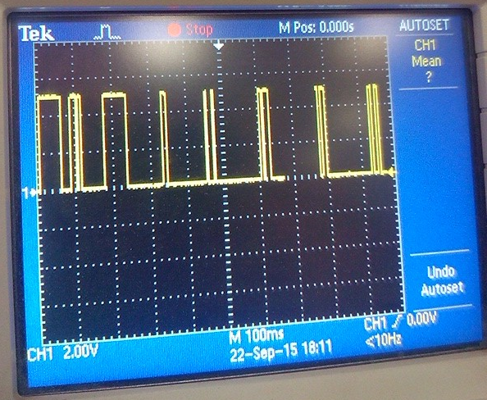

Fig 1. SDI

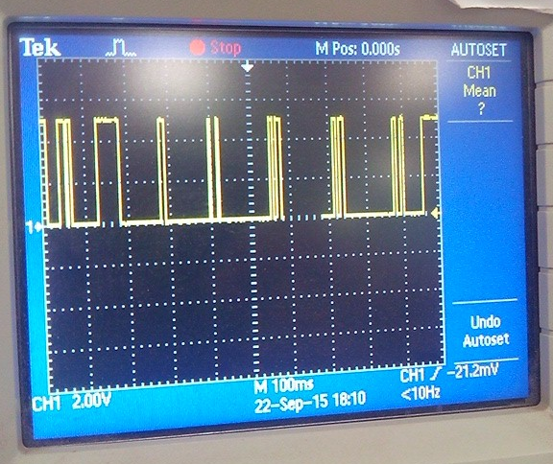

Fig2.SDO

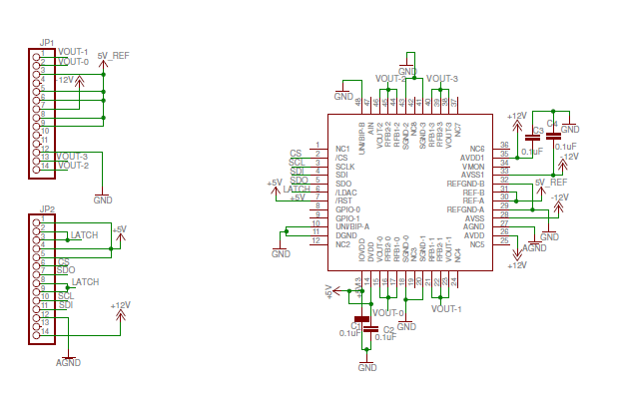

Schematic DAC7716

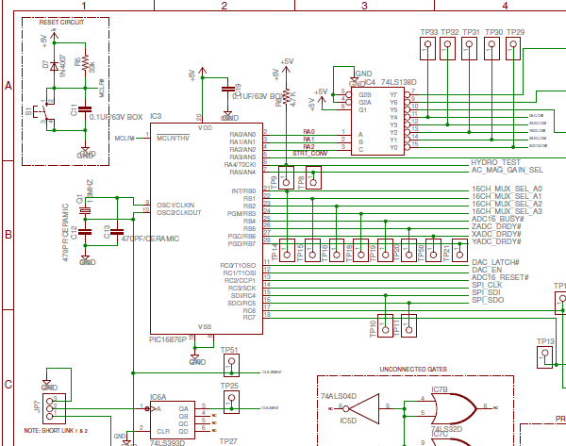

Fig3 Interfacing with PIC16F876A IC