Measure on outputs chan B and C. The time between both signals is 1.4 usec

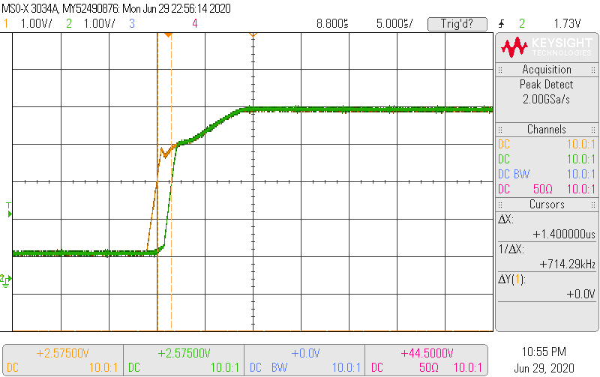

Programming the DAC80004 repetitive. The all channels are written repeatedly.

Channel | Data 1 (hex) | Data 2 (hex)
A | a000 | a000
B | 29a4 | bc2f
C | 29a4 | bc2f
D | 0000 | 0000

The last command 8 and channel F is used to enable SDO.
For debugging this time slot the channel selection, data, command and r_wrn can be programmed.
The data in the pictures is sampled with a period with 6.25 nsec
Time between 32 edge of data channel B and channel C is 1256.25 nsec

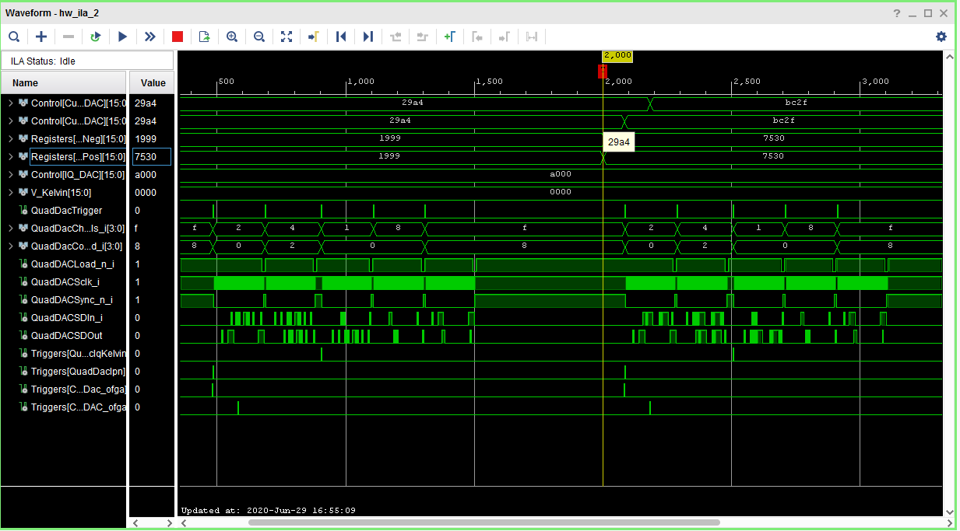
Chan B Command 0
Chan C Command 2
Chan A Command 0
Chan D Command 0
Chan F Command 8

Repetitive read back of channel B C with command 0

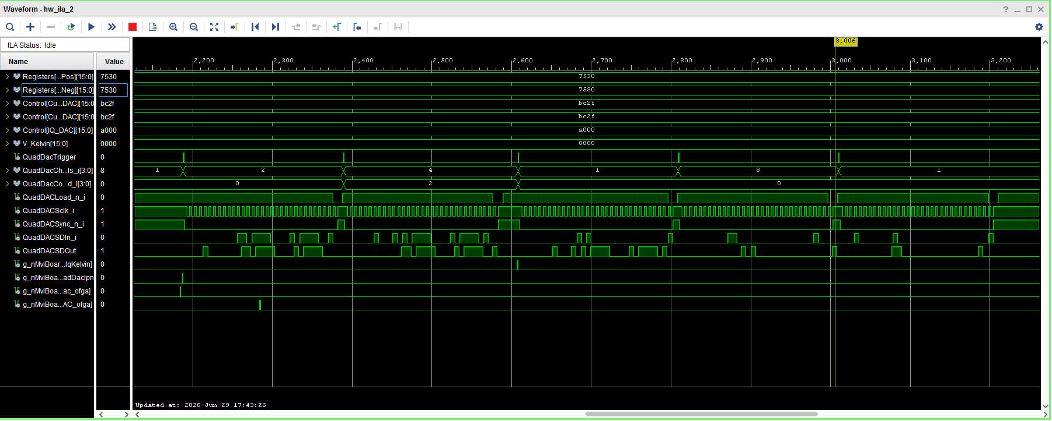
Program Chan B
Command 0
Data bc2f
Read Chan B Command 0
Serial shift data Chan B
Read back data Chan B

Programmed data is read back OK

Repetitive read back of channel C with command 0

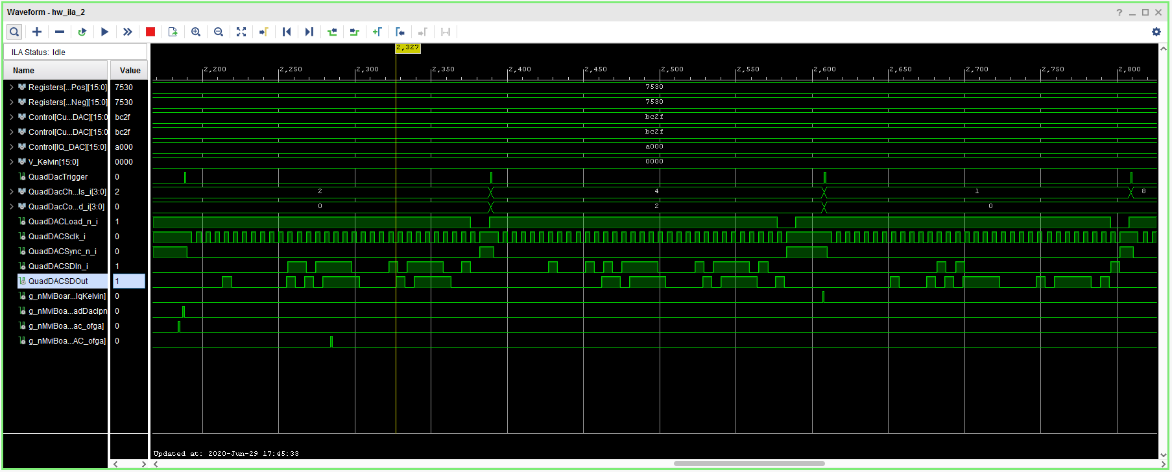
Program Chan C Command 2
Data bc2f
Program Chan B
Command 0
Data bc2f
Serial shift data Chan C
Read back data Chan C

Repetitive read back of command 6 to check all LDAC register bits are 0
During data-in shift of reading of the LDAC register bits D03-D00 are set to “1010”
Returned read back bits D03-D00 are “0000”

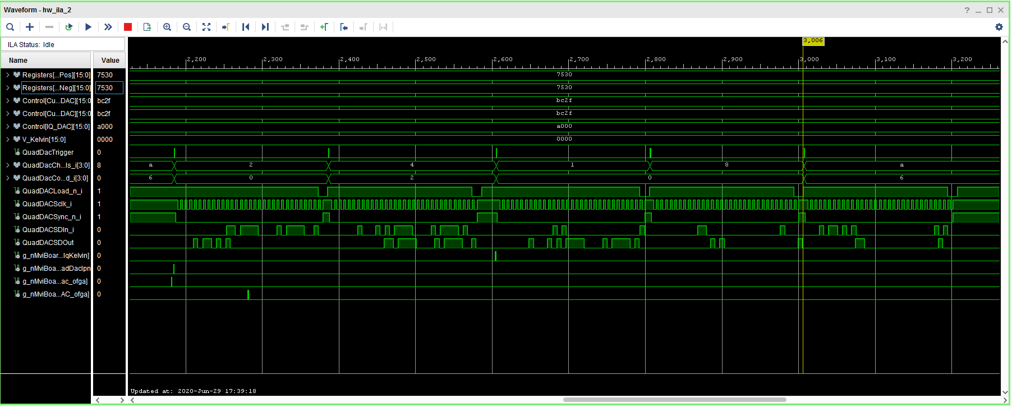
Read
Command 6
Data “1010”
Read back data reg 6

Timing measurements

Qdac Clk period : 37 nsec
Blue: Data
Red: Clk
Yellow : Sync_n

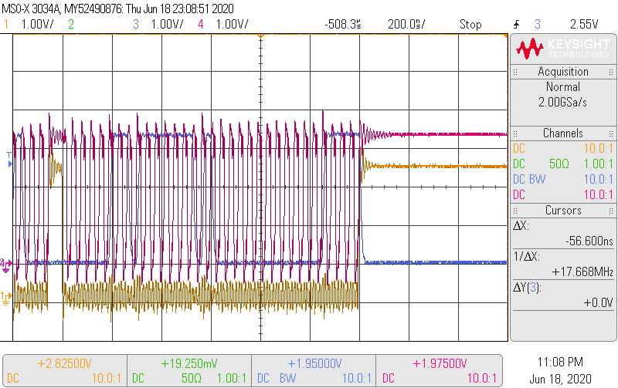 | 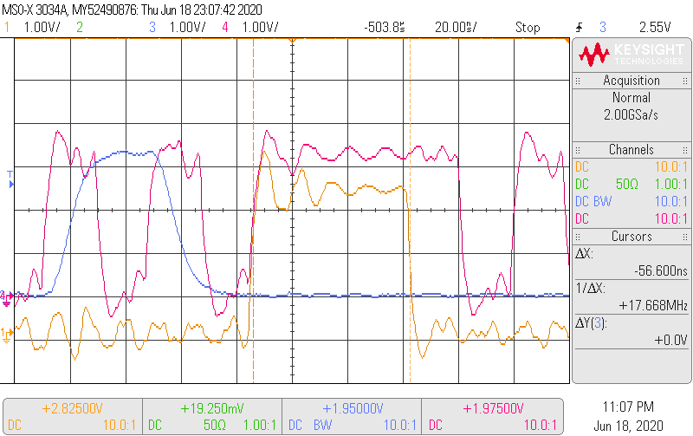  Sync high period : 56.6 nsec
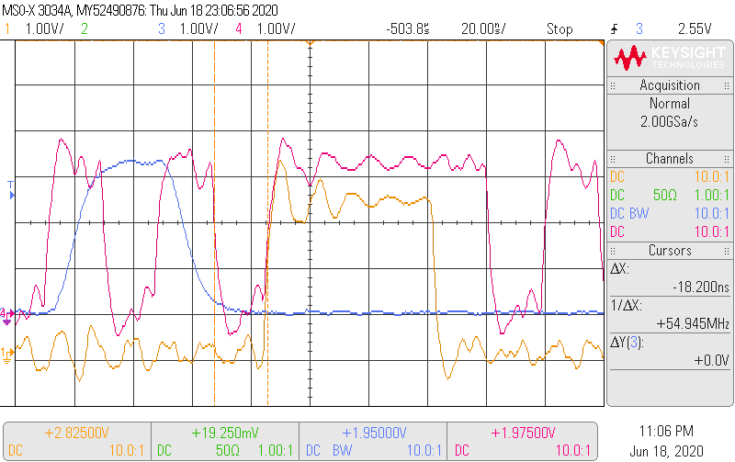  Time falling edge clk to rising edge sync_n : 18.2 nsec | 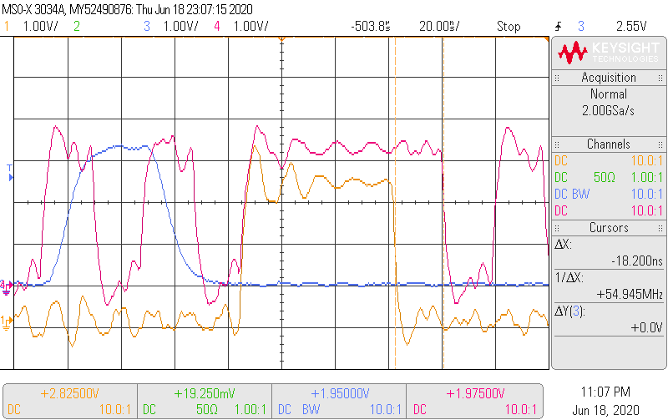  Falling edge sync_n to falling edge clk : 18.2 nsec
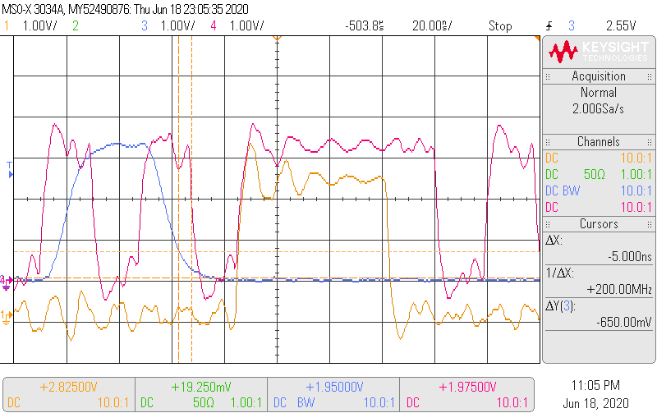  Setup time and level data ‘0’ | 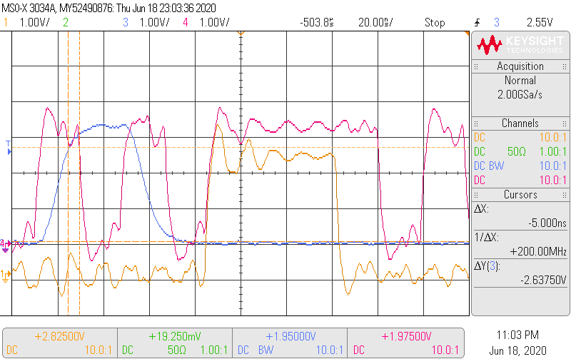  setup time and level data ‘1’

