Schematic
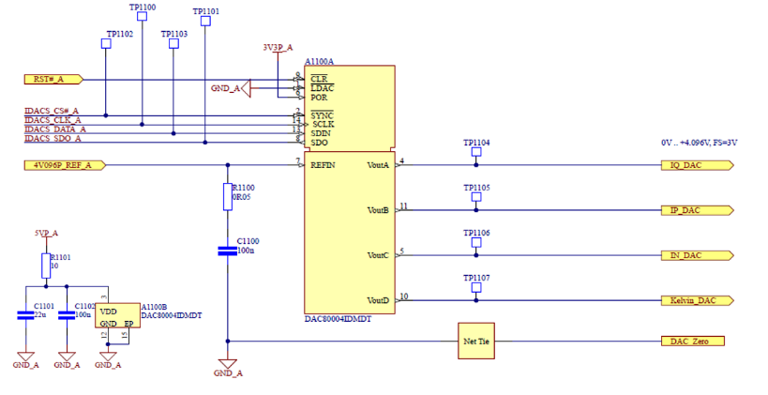

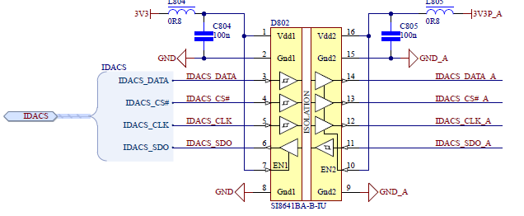
FPGA side

NOTE: the DAC POR is now connected to the 5VP_A with a modification on the PCB

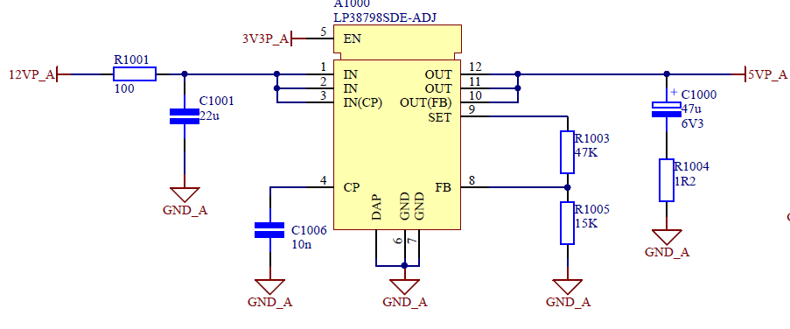

The 12VP_A and 3V3P_A are supplies from one external supply and switched on simultaneously

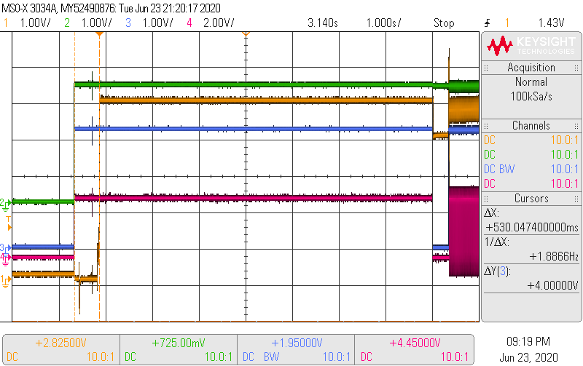

Blue: Initialization complete @ IO pin
Red: Clk @ IO pin
Yellow : 5VP_A
Green: Lock from PLL @ IO pin

NOTE: the grounding of the probes was not optimal

