DAC output @C36 (IOUTA_P) with 0x2=0x20c2

Mixer enabled;
Mixer gain = 0dB;
RBias = 1.91Kohm
coarse_dac_gain = 0xF

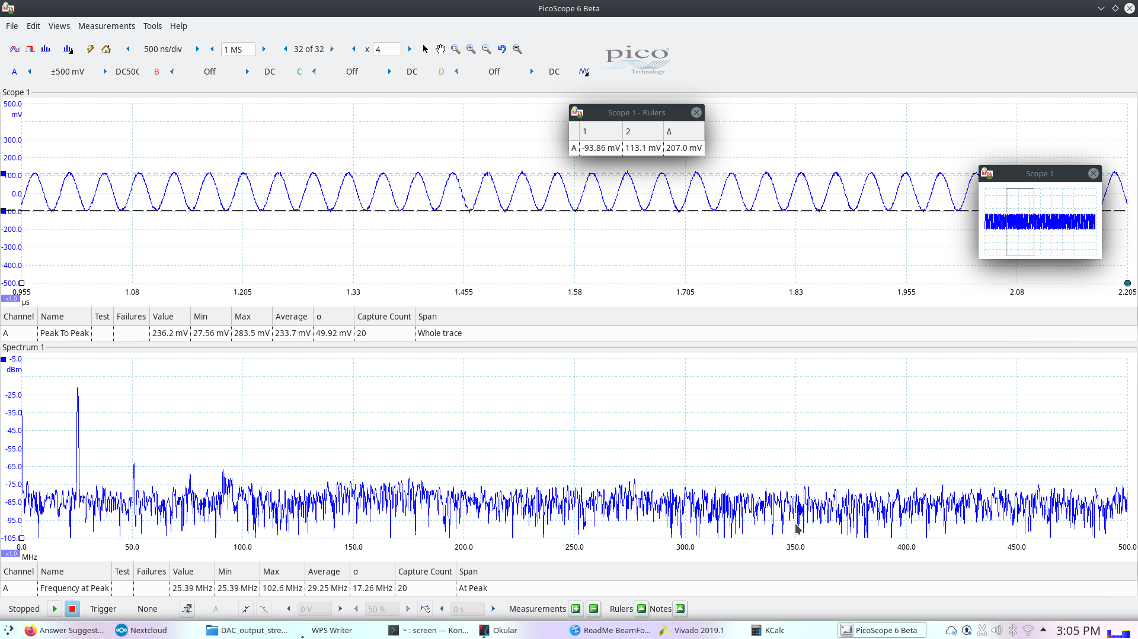

Measured result:
IOUTA_P = 222mV
IOUTA_N = 222mV
Vout = IOUTA_P + IOUTA_N
= 444mV

Expected output:
IOUT = 30mA * 50 - 6dB(mixer loss)
= 1.5V - 6dB
= 0.75V

DAC output @C36 (IOUTA_P) with 0x2=0x2082(Mixer Disabled)

Mixer disabled;
RBias = 1.91Kohm;
coarse_dac_gain = 0xF which means DACFSC = 30mA;

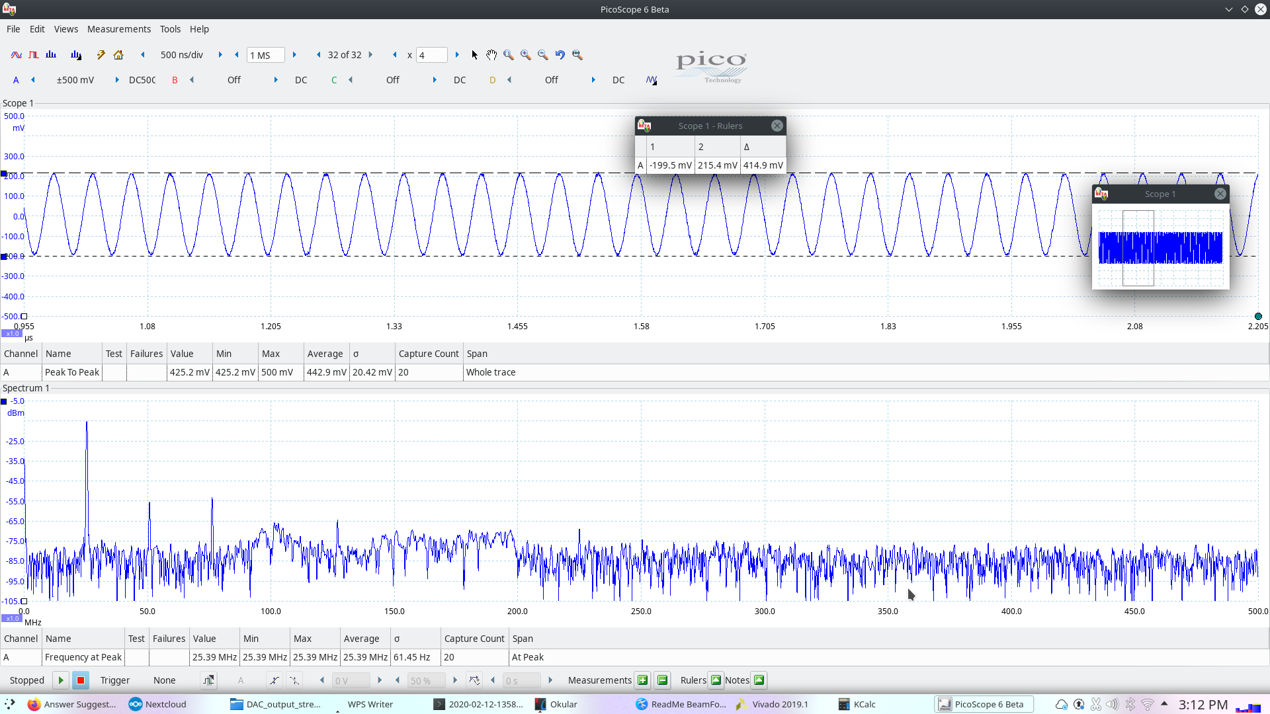

Measured result:
IOUTA_P = 410mV
IOUTA_N = 410mV
Vout = IOUTA_P + IOUTA_N
= 820mV

Expected output:
Vout = 30mA * 50ohm
= 1.5V

DAC output @C36 with 0x2=0x20e2(Mixer Enabled with 6dB gain)

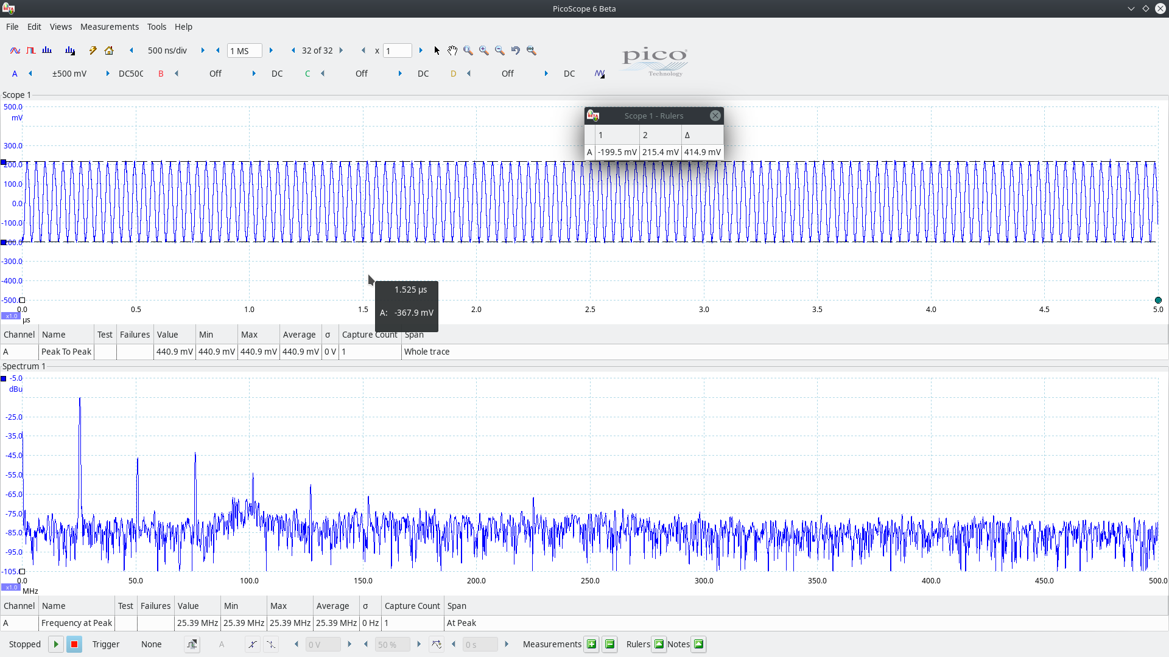

Measured result:
IOUTA_P = 410mV
IOUTA_N = 410mV
Vout = IOUTA_P + IOUTA_N
= 820mV

Expected output:
IOUT = 30mA * 50 - 6dB(mixer loss) + 6dB(mixer gain enabled)
= 1.5V - 6dB + 6dB
= 1.5V

