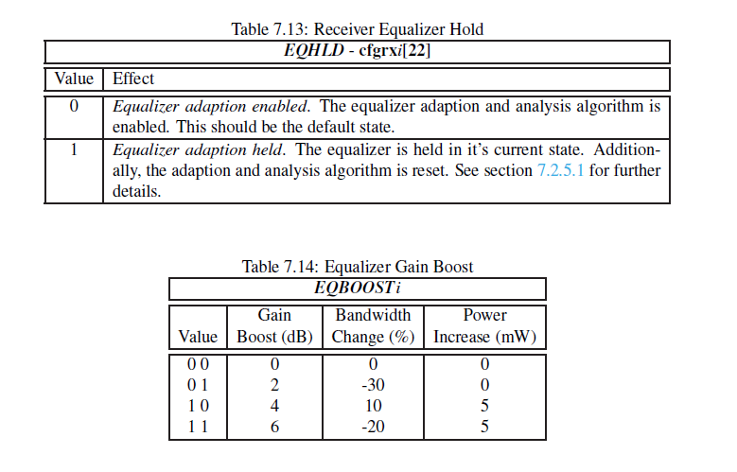

7.2.5.1 Pre and Post Cursor Equalization Analysis

When EQ is set to 010 or 011, the equalizer is reconfigured to provide analytical data about the amount of pre and post cursor equalization respectively present in the received signal. This can in turn be used to adjust the equalization settings of the transmitting link partner, where a suitable mechanism for communicating this data back to the transmitter exists. Status information is provided via stsrxi[8:7] (EQOVER, EQUNDER), by using the following method:

1. Enable the equalizer by setting EQHLD low and EQ to 001. Allow sufficient time

for the equalizer to adapt;

2. Set EQHLD to 1 to lock the equalizer and reset the adaption algorithm. This also causes both EQOVER and EQUNDER to become low;

3. Wait at least 48UI, and proportionately longer if the CDR activity is less than 100%, to ensure the 1 on EQHLD is sampled and acted upon;

4. Set EQ to 010 or 011, and EQHLD to 0. The equalisation characteristics of the

received signal are analysed (the equalizer response will continue to be locked);

5. Wait at least 150_103UI to allow time for the analysis to occur, proportionately

longer if the CDR activity is less than 100%;

6. Examine EQOVER and EQUNDER for results of analysis.

_ If EQOVER is high, it indicates the signal is over equalized;

_ If EQUNDER is high, it indicates the signal is under equalized;

7. Set EQHLD to 1;

8. Repeat items 3 - 7 if required;

9. Set EQ to 001, and EQHLD to 0 to exit analysis mode and return to normal adaptive

equalization. Note that when changing EQ from one non-zero value to another, EQHLD must already be 1. If this is not the case, there is a chance the equalizer could be reset by a transitory input state (i.e. if EQ is momentarily 000). EQHLD can be set to 0 at the same time as EQ is changed. As the equalizer adaption algorithm is designed to equalize the post cursor, EQOVER or EQUNDER will only be set during post cursor analysis if the amount of post cursor equalization required is more or less than the adaptive equalizer can provide.