Capture data: mode 4211, 1m between the eval boards

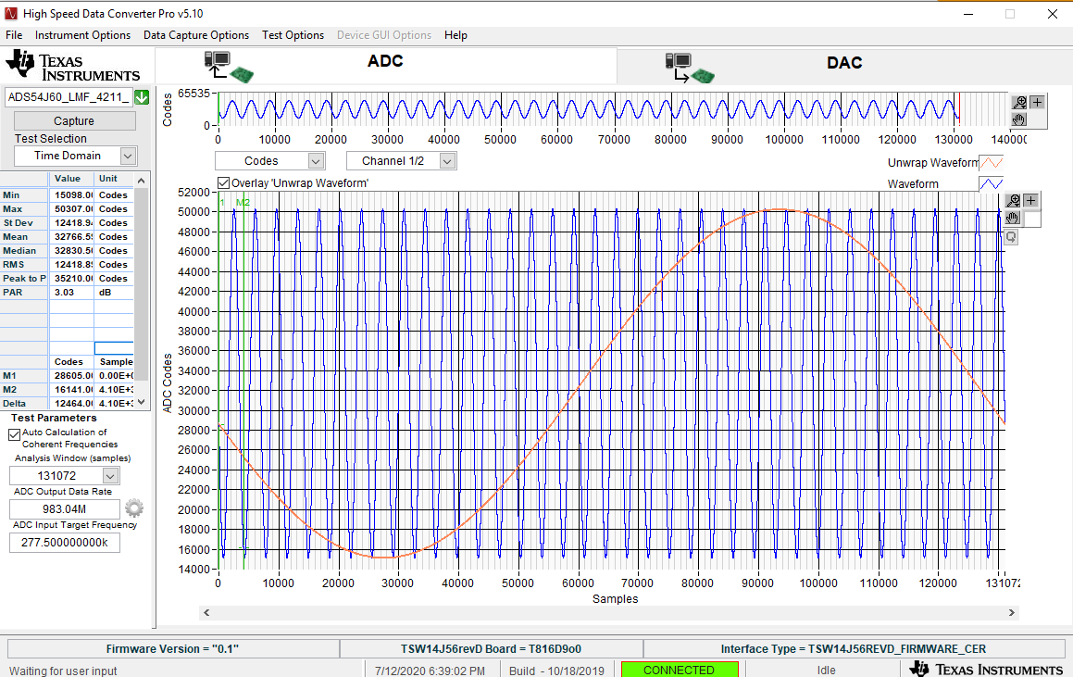

Sometimes I get “Timed out error” – what does it means?

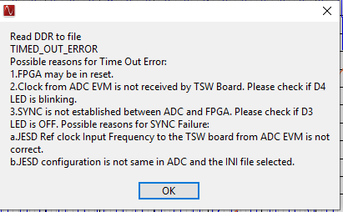

CER test is stuck on 1 cycle – why ?

