We have seen this issue reported by few customers in the past. The fix for this is, to uninstall LabVIEW RTE f2 and install LabVIEW RTE SP1. In latest HSDC Pro internal installers we have fixed this issue by packing LabVIEW RTE SP1. For HSDC Pro v4.90, it has to be fixed manually. Please find the details below,

Steps to uninstall LabVIEW Run time engine 2014 (32 bit) f2 and install SP1
1. Open Control Panel -> Programs and Features
2. Double Click on “National Instruments Software” and Select “NI LabVIEW Run-Time Engine 2014 f2” in the Popup and Click on Remove

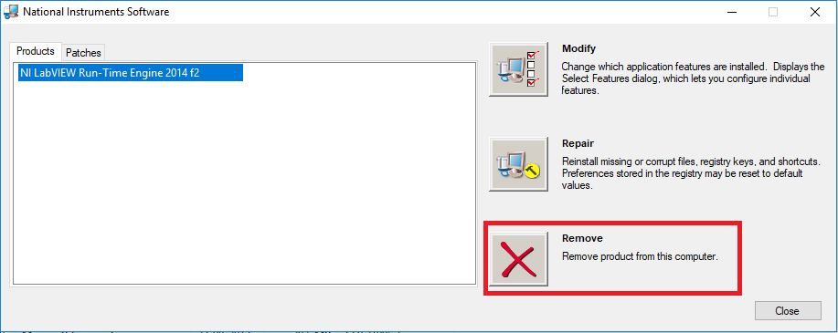
3. Install LabVIEW 2014 (32 bit) SP1 from the below link,
http://www.ni.com/download/labview-run-time-engine-2014-sp1/5198/en/

