IMD3 number of ADS54j60 is:

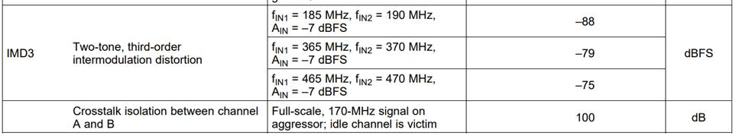

And fullscale is 1.9Vpp

With that I calculate (assuming Zin = 100ohm)

