Linesim schematics for JESD204B single channel
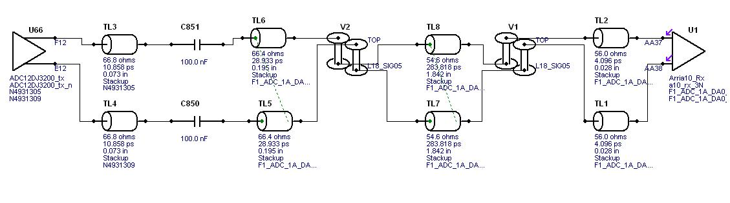
JESD204B Channel Output with a 100nF Capacitor in series with the channel path 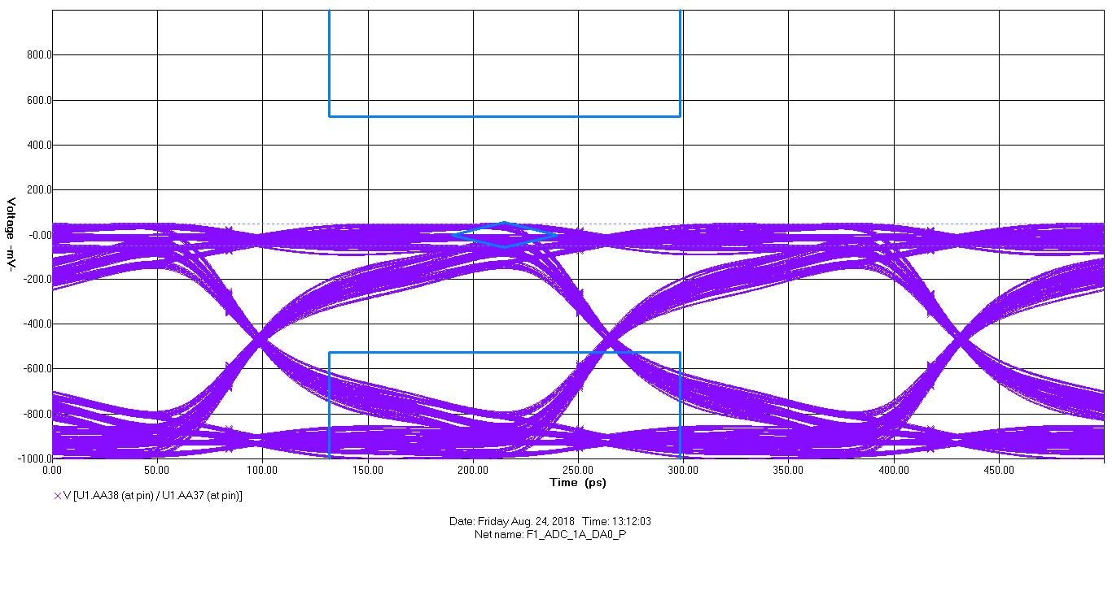

JESD204B Channel without Capacitor in series with the channel path
