The SERDES PLL provides the high speed clock for the high speed SerDes ports. The reference frequency of the SerDes PLL can be in the nominal range of 100-800MHz, and 300-800MHz is the optimal range. The reference frequency of the SERDES PLL is derived from main DACCLK clock path and divided down based on the serdes_refclk_div programming, as shown in below. Depending on the DAC3xJ84 configuration, the DACCLK can be either from the DAC PLL path or the direct, external clock path. The selection is based on clock path mux, and is configurable through SPI with mem_serdes_refclk_sel bit. Program mem_serdes_refclk_sel bit to 1b’1 for DAC PLL path, and program 1b’0 for the external clock path.
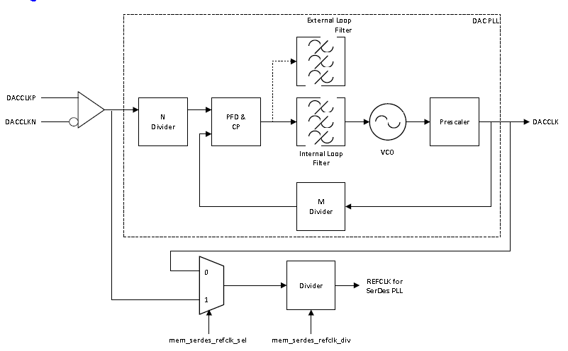
During normal operation, the clock generated by the SERDES PLL will be 4-25 times the reference frequency, according to the multiply factor selected via rw_cfgpll [8:1] (MPY). In order to select the appropriate multiply factor and SERDES refclk frequency, system designer first need to determine the SERDES line rate in the system and the required SERDES PLL output clock frequency to support the line rate. To calculate the line rate, refer to Equation TBD.
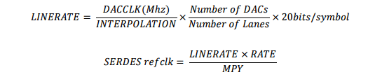
The relationship between the SERDES PLL output clock frequency and the lane rate is shown in table below. Having computed the PLL output frequency, the reference frequency can be obtained by dividing the product of line rate and SERDES rate setting by the multiply factor specified via MPY. The Equation below for SERDES refclk calculation, and refer to Table 4 for MPY programming information.
RATE | LINE RATE | PLL OUTPUT FRQUENCY
FULL | xGbps | 0.25x GHz
Half | xGbps | 0.5x GHz
Quarter | x Gbps | 1x GHz
Eigth | x Gbps | 2x GHz
Table 4
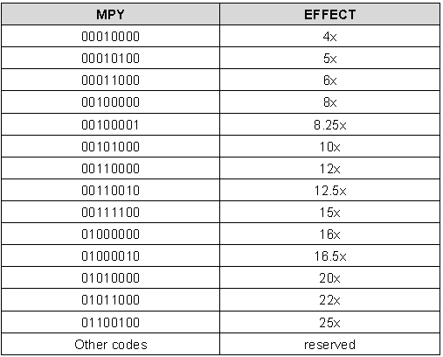

JESDCLK
The JESDCLK is used to the clock the JESD204B core inside of the DAC38J84. The JESD clock divider (JESDCLK_DIV) is a function of the DAC interpolation, the number of lanes (L) and the number of DACs (M). The JESDCLK divider can be calculated using the equation below:
$$JESDCLK_DIV=\frac{INTERPOLATION*L}{M}$$
Register CONFIG37 should be programmed for the calculated JESDCLK divider per the table below.
Calculated JESDCLK Divider (JESDCLK_DIV) | CONFIG37[15:0]
1 | 0x0000
2 | 0x2000
4 | 0x4000
8 | 0x6000
16 | 0x8000
32 | 0xA000

Depending on the JESD204B configuration setting of the JESD204B RX logic block, the reference clock to the JESD204B RX logic block will need to be adjusted accordingly. Please refer to Table below for details on the clock divider setting.

DAC3xJ8x JESD204B RX Logic Clock Divider Setting
Config37, bit15 to 13, clkjesd_div
 | Interpolation
LMF Mode | 1x Int | 2x Int | 4x Int | 8x Int | 16x Int
841 | 2 | 4 | 8 | 16 | 32
442 | 1 | 2 | 4 | 8 | 16
244 | NA | 1 | 2 | 4 | 8
148 | NA | NA | 1 | 2 | 4
821 | 4 | 8 | 16 | 32 | N/A
421 | 2 | 4 | 8 | 16 | 32
222 | 1 | 2 | 4 | 8 | 16
124 | NA | NA | 2 | 4 | 8

