1.       When exactly is the error seen? Is it when scaling the graph using the Graph palette?

a.       If yes, can we get to know the sequence of operations (Capture, Firmware download etc.,) after which they are seeing the issue?

b.      Is HSDC Pro in Idle state(Status bar shows “Waiting for user input”) or is it performing some operation when this scaling is done?

2.       Can we get a snapshot of System details (RAM and Processor information from Control Panel -> System and Security -> System).

We saw a similar issue being discussed in the below link (NI Forum). One suggestion provided here is to switch to LabVIEW 2014 (32 bit) **SP1** run time engine (the run time engine packaged with HSDC Pro is LabVIEW 2014 (32 bit) **f2**)

<https://forums.ni.com/t5/LabVIEW/DAbort-0x89B93EF0/td-p/3083427>

Steps to uninstall LabVIEW Run time engine 2014 (32 bit) f2 and install SP1

1.       Open Control Panel -> Programs and Features

2.       Double Click on “National Instruments Software” and Select “NI LabVIEW Run-Time Engine 2014 f2” in the Popup and Click on Remove

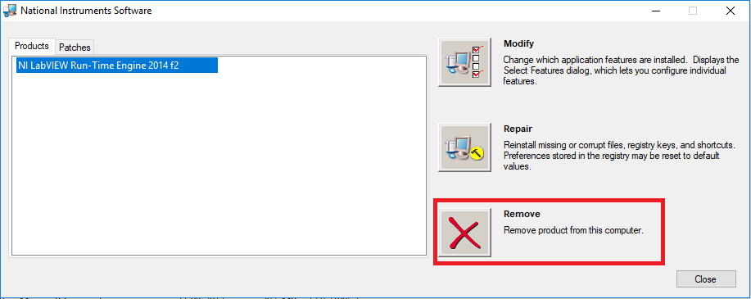

3.       Install LabVIEW 2014 (32 bit) SP1 from the below link,

<http://www.ni.com/download/labview-run-time-engine-2014-sp1/5198/en/>