The formula can be found at the following post:

https://e2e.ti.com/blogs_/b/analogwire/posts/whats-the-fuss-about-noise-in-rf-sampling-converters
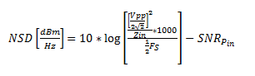(formula 1)
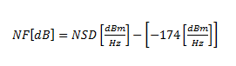 (formula 2)

NSD in HSDCPro doesn’t count Vpp term in formula 1.
So when you calculate NF, you need to add it back.

For Vpp = 1V, 10*LOG10((1/2/SQRT(2))^2/100*1000) = 0.9691 then NF = NSD + 174 + 0.9691
For Vpp = 0.8V, 10*LOG10((0.8/2/SQRT(2))^2/100*1000) = -0.9691 then NF = NSD + 174 - 0.9691

